 | APPOINTMENT PLANNER
 | Lorem ipsum dolor sit amet, consectetuer adipiscing elit. Maecenas porttitor congue massa. Magna sed pulvinar ultricies, purus lectus.
 | 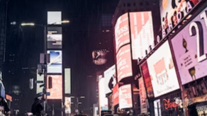 |  |  |  |  |  |  |  | 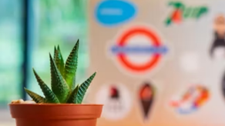
 |  | ⭐ NEW YORK MAGAZINE | 22/01/2024 09:30 |  |  |  | ⭐ POST OFFICE | 23/01/2024 12:45 |  |  |  | ⭐ HERBAL STAR | 29/01/2024 14:00
 |  | NEW BRANDING STYLES |  |  |  | ENVELOPES DESIGN IMPROVEMENT |  |  |  | DECORATIVE FLOWERS PACKAGING
 |  | Magazine to write about monochromatic colors trending. Monochromatic branding is often minimalist and refined. |  |  |  | Introducing new imaginative ways to make mailing envelopes. Patent pricing proposal. |  |  |  | Presentation of innovative solutions for packaging home flowers - gifts and permanent settings in homes. Proposal for a 6-month contract.
 | 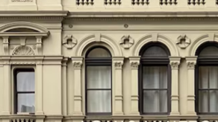 |  |  |  |  |  |  |  | 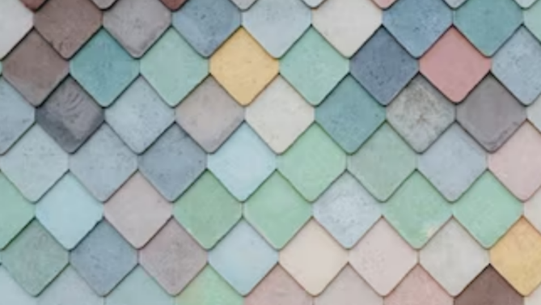
 |  | ⭐ NATIONAL INSTITUTE | 06/02/2024 11:00 |  |  |  | ⭐ STEPHEN DORSEY | 07/02/2024 08:00 |  |  |  | ⭐ HOUSE TOP | 13/02/2024 13:00
 |  | LOGO UPGRADE |  |  |  | 2024 PROJECTS REPORTING |  |  |  | COLORS IN CONSTRUCTION
 |  | Presentation of design ideas after the request for a national institute logo upgrade. The final selection and the start of creating advertising materials. |  |  |  | Making decisions on key areas where we want to implement projects in 2024. Budget proposal for team expansion. |  |  |  | What are the natural colors in construction that are in constant use, primarily for making roofs. Choose the ones we will use for promotional materials.
 |  |  |  |  |  |  |  |  |  | © TemplateLab.com

