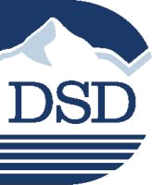
Davis School District
P.O. Box 588

Farmington, UT 84025
Important Information
About Your Pharmacy Benefit

 | BIN # 610602
 | PCN # NVT
 | GRP # DSS For Select Health
Dear Davis School District member: | # DSA For Aetna

Navitus Health Solutions is proud to be the pharmacy benefit manager for Davis School District’s Aetna and SelectHealth Insurance Plans. We look forward to partnering with you on your journey to better health by providing you with robust support and personalized care. That’s why we have reinvented your pharmacy benefits to work smarter and give you:

- Clarity to help you better understand your pharmacy benefits, access your prescriptions and improve your health
- Guidance to help you take medications correctly and get the care you need

- Peace of mind knowing that our pharmacists and clinicians are on your side every day

Plus, we know that when you’re healthier, you’re happier too. To start, you can:

Log In

You can log in to your member portal at https://members.navitus.com. You will have easy access to the tools you need to make the most of your prescription benefits, including our pharmacy locator, cost compare tool and educational resources to help you manage your health.

Call
If you have questions, you can contact Customer Care 24 hours a day, 7 days a week. They can be reached toll-free at 1.844.268.9789. Our knowledgeable team can help answer your benefit questions and advise you on how to take your medications correctly. They can also help you get additional care if needed.

Download the Navitus App
Access your benefits, locate a nearby pharmacy, view and manage your medications and more — all on our mobile app.

2652-1220L

© 2020 Navitus Health Solutions, LLC. All rights reserved.

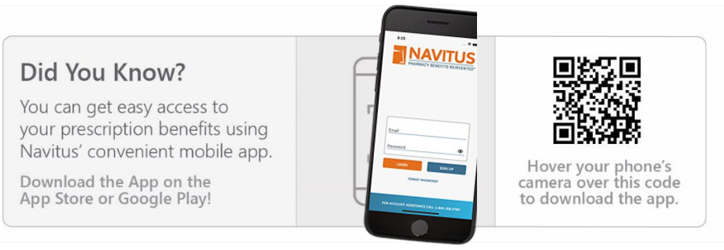

Additional Benefit Information

Mail Order Pharmacy
Please send mail order prescriptions to Costco Pharmacy. It is easy to begin using Costco Pharmacy. You can register online at www.pharmacy.costco.com. Please allow 10 to 14 calendar days from the day you submit your order to receive your medication(s).

You do not need to be a Costco member to use Costco Pharmacy.

Specialty Pharmacy
Navitus SpecialtyRx serves members who are taking medication(s) for certain chronic illnesses or complex diseases such as rheumatoid arthritis, multiple sclerosis, cancer and hepatitis C. To receive specialty medications through the pharmacy benefit, you will need to fill these prescriptions at Lumicera Health Services. Ordering new prescriptions through our specialty pharmacy partner, Lumicera Health Services is simple. Just call a patient care specialist at 1.855.847.3553 to get started. They will work with you and your prescriber to get your prescription set up.

Member Portal

You can go online to find information specific to your plan. You can do this on the secure member portal at https://members.navitus.com. You will need a member ID to log into the portal. Your member number will be your medical member ID with a 01 after it. Or you can call Navitus Customer Care to receive an individual member ID number. We can be reached toll-free at 1.844.268.9789.

We look forward to serving you on your journey to better health.

Sincerely,

Navitus Health Solutions

2652-1220L

© 2020 Navitus Health Solutions, LLC. All rights reserved.



Experience the Benefits of Mail Order Pharmacy Service

Why Choose Mail Order?

It’s convenient, cost-effective and easy to get started.

Take advantage of our mail order pharmacy service to get an extended days’ supply of your maintenance medications conveniently delivered to the location of your choice. With mail order service, you can make fewer trips to the pharmacy and avoid having to wait in line to pick up your medications. Plus, you may save money, too.

By filling your prescriptions through mail order, you can start experiencing these benefits:

- Receive greater convenience with an extended days’ supply of your medications delivered right to your door

- Save money and time with lower copays and fewer trips to your local pharmacy

- Experience easy refills and renewals

- Enjoy peace of mind knowing you have plenty of medication on hand to keep your health on the right track

Get Started Today!

It’s easy to begin using Costco Mail Order Pharmacy. You can register by scanning the QR code* below, visiting the website at pharmacy.costco.com or calling 1.800.607.6861. There’s no need to have a Costco membership to use the mail order pharmacy.

Please refer to your plan description for more details.

*This QR code may identify your IP/device information. However, your personal and health information is strictly confidential and will not be captured.
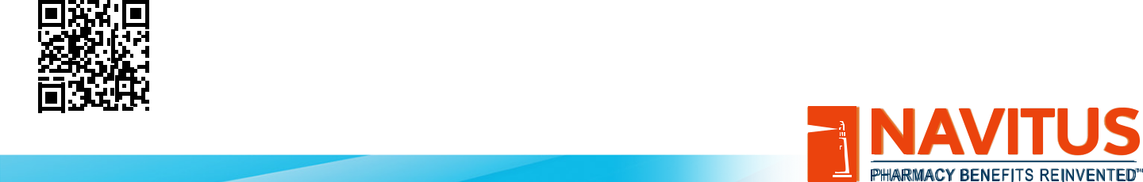

© 2021 Navitus Health Solutions, LLC. All rights reserved. 2892-0221PO



Compare Prices and Find Pharmacies Using Cost Compare

Did you know that not all pharmacies charge you the same amount for the same prescription?

Look up prices before you leave for the pharmacy and save. Cost Compare lets you:

- Check Rx prices at local pharmacies

- Estimate your cost in real time

- Search based on your prescription history

Have questions about your pharmacy benefits? Answers are just a click away!

Information about your pharmacy benefit and tools to help you get your prescriptions are available at your fingertips. Visit Navitus’ secure member portal at www.navitus.com or log onto your plan’s website to access your:
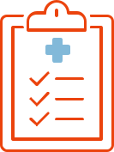



Cost | Medication | Pharmacy Search
Information | History | Pharmacy Search

Drug Search

Interaction Search


This portal is for active members only. Available features may vary by plan. Your out-of-pocket costs may vary based on drug costs, plan design and contracts.

© 2020 Navitus Health Solutions, LLC. All rights reserved. 2443-1020CL

