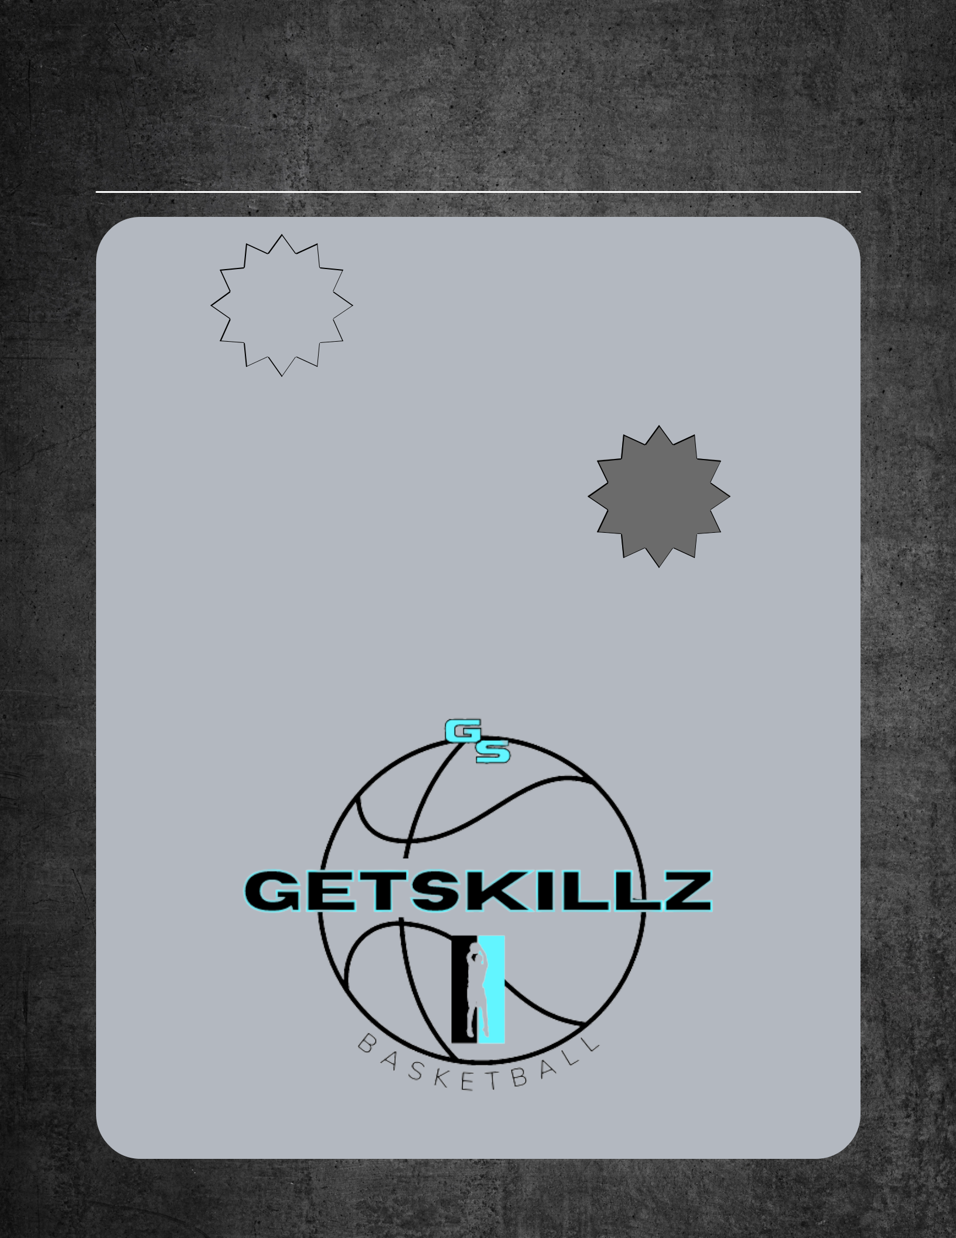
Grand Opening

Package specialsS

 | a | v |  | e
s | a |  |  |  | 0
s | a | 1 | 8 |  | 0
s | $ | 1 |  |  | 0

Buy 8, get 4

free

$360

OR

Buy 4, get 2

free

$200

s
a
$10v
e
0

ALL PACKAGES ARE SMALL

GROUP TRAINING SESSION

3RD-4TH, 5TH-7TH, 8TH-12TH

13101 Eckles RD Plymouth, MI 48170

I-96 & I-275

