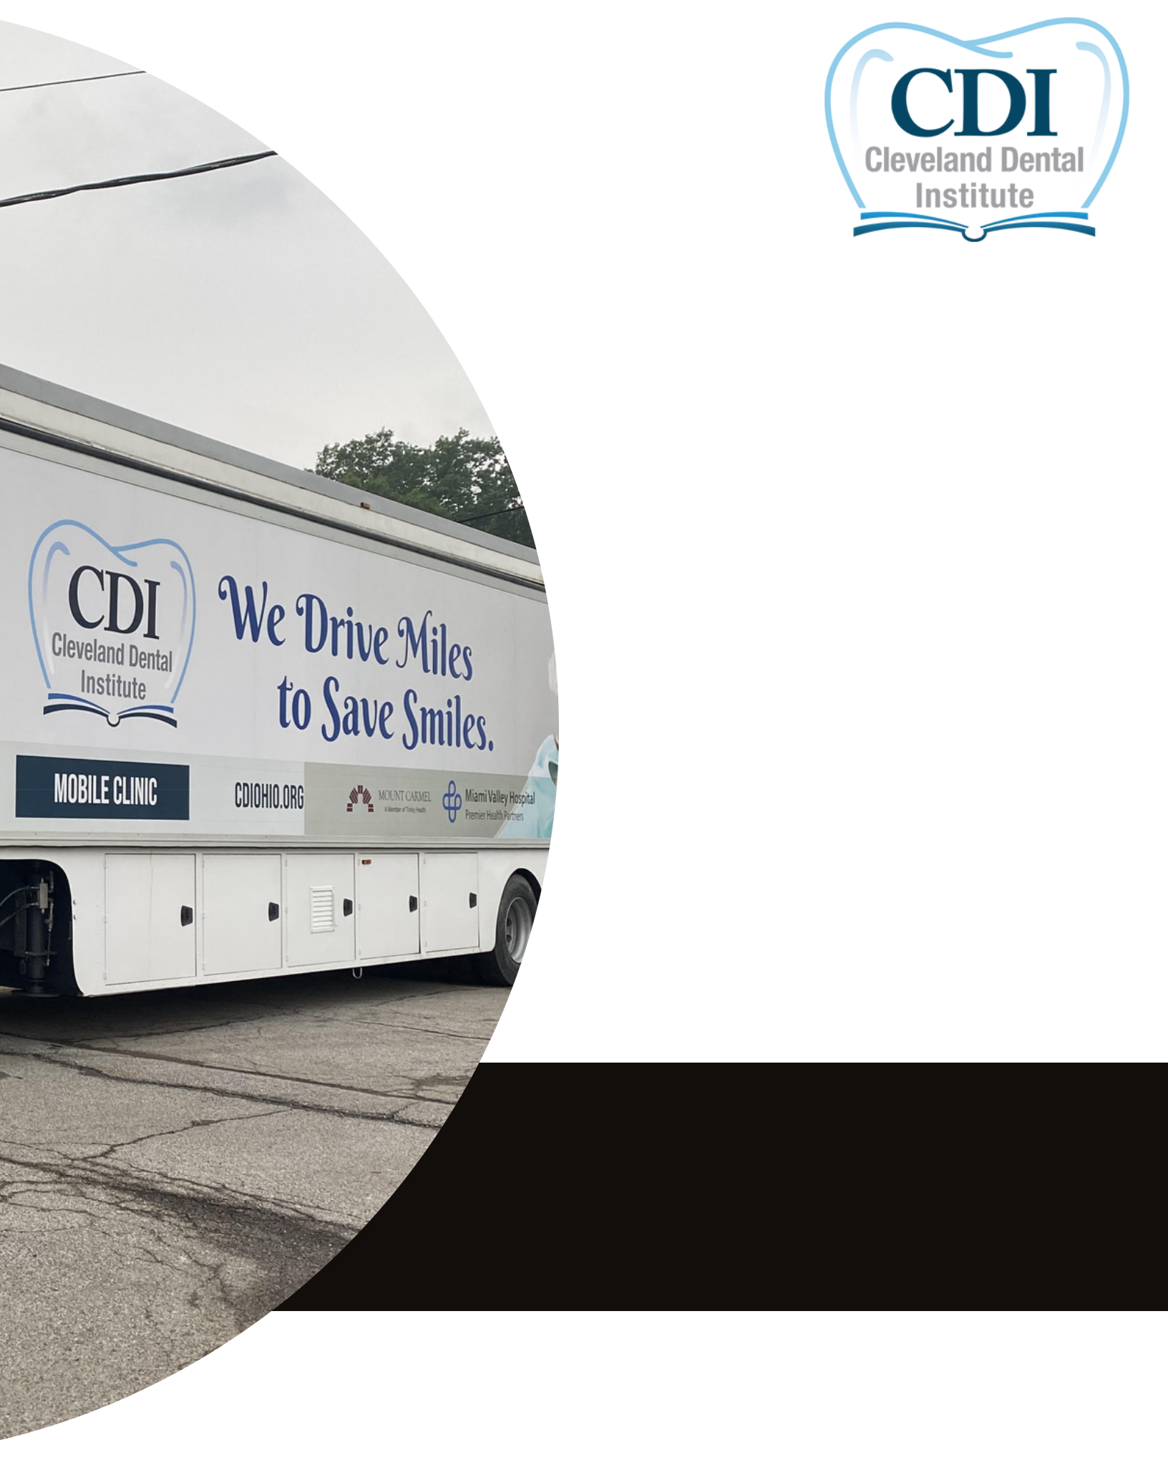
GRAND

OPENING

Join us in celebrating the

opening of the largest dental

mobile clinic in the east coast!

August 10, 2023

From 11:00am - 1:00pm

at our Ashtabula Clinic

2203 Lake Ave. Ashtabula, OH

44004

Cleveland Dental Institute is eager to help patients with limited access to dental care through our new 53 foot mobile clinic containing 8 dental chairs!

www.cdiohio.org

