
hughessupply.com

HUGHES LEESBURG
GRAND OPENING EVENT!

January 24, 2013 from 8:00 AM to 11:00 AM
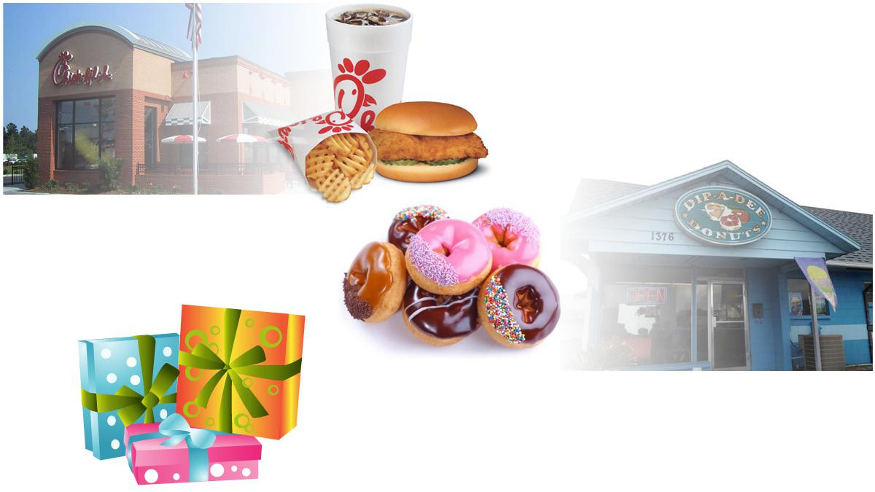

Breakfast including Chick-Fil-A
Sandwiches, Dip-a-Dee Donuts,

orange juice and coffee!

Door Prizes and

Giveaways!

Vendor Presentations and
Demonstrations!


hughessupply.com

HUGHES LEESBURG
GRAND OPENING EVENT!

January 24, 2013 from 8:00 AM to 11:00 AM

Breakfast including Chick-Fil-A
Sandwiches, Dip-a-Dee Donuts,

orange juice and coffee!

Door Prizes and

Giveaways!

Vendor Presentations and
Demonstrations!

