**DISCOVER ITALY**

Your Ultimate Guide to Unforgettable Adventures

**ITALY!**

**CIAO**

TRAVEL BOOKLET

**01**

**Cover page**

Unforgettable Adventures Await! Your Ultimate Travel Companion

**02**

**Table of contents**

An organized list of sections, highlighting

the diverse experiences awaiting the traveler

**04**

**Best Destination**

Discover Italy's enchanting landscapes, from historic Rome to picturesque Venice

**06**

**Food and Culinary**

Indulge in Italy's diverse flavors, from pasta perfection to regional delicacies

**08**

**Contact Us**

Plan your adventure - contact us for personalized travel tips to Italy

**03**

**Welcome to Italy**

Explore cultural wonders, from historic landmarks to vibrant traditions in Italy

**05**

**Art and Culture**

Immerse yourself in Italy's rich artistic heritage, witnessing masterpieces come

**07**

**Budgeting**

Navigate Italy economically with savvy tips for budget-conscious travelers

**CONTENTS**

**TABLE OF**

DISCOV﻿ER ITALY | **PAGE 2**

**ITALY**

**WELCOME TO**

Italy - a cultural gem in Southern Europe, boasts a rich history, art, and culinary delights, captivating visitors worldwide.

Italy - a country where rich history

and cultural treasures converge

to create a timeless tapestry. From the iconic Colosseum in Rome to the exquisite art of Florence, Italy boasts an unparalleled historical legacy. Dive into the enchanting world of Renaissance art and architecture, where masterpieces by Michelangelo and Leonardo da Vinci come to life, showcasing the country's enduring commitment to beauty and creativity.

Indulge your senses in Italy's culinary

haven, where each region offers a unique gastronomic experience. From the savory delights of Sicilian cuisine to the delectable pasta dishes of Bologna, Italian food is

a celebration of fresh ingredients, bold flavors, and culinary tradition. Prepare

to embark on a culinary journey that will tantalize your taste buds and leave you savoring the essence of la dolce vita.

DISCOV﻿ER ITALY | **PAGE 3**

DISCOV﻿ER ITALY | **PAGE 4**

**Best Destination**

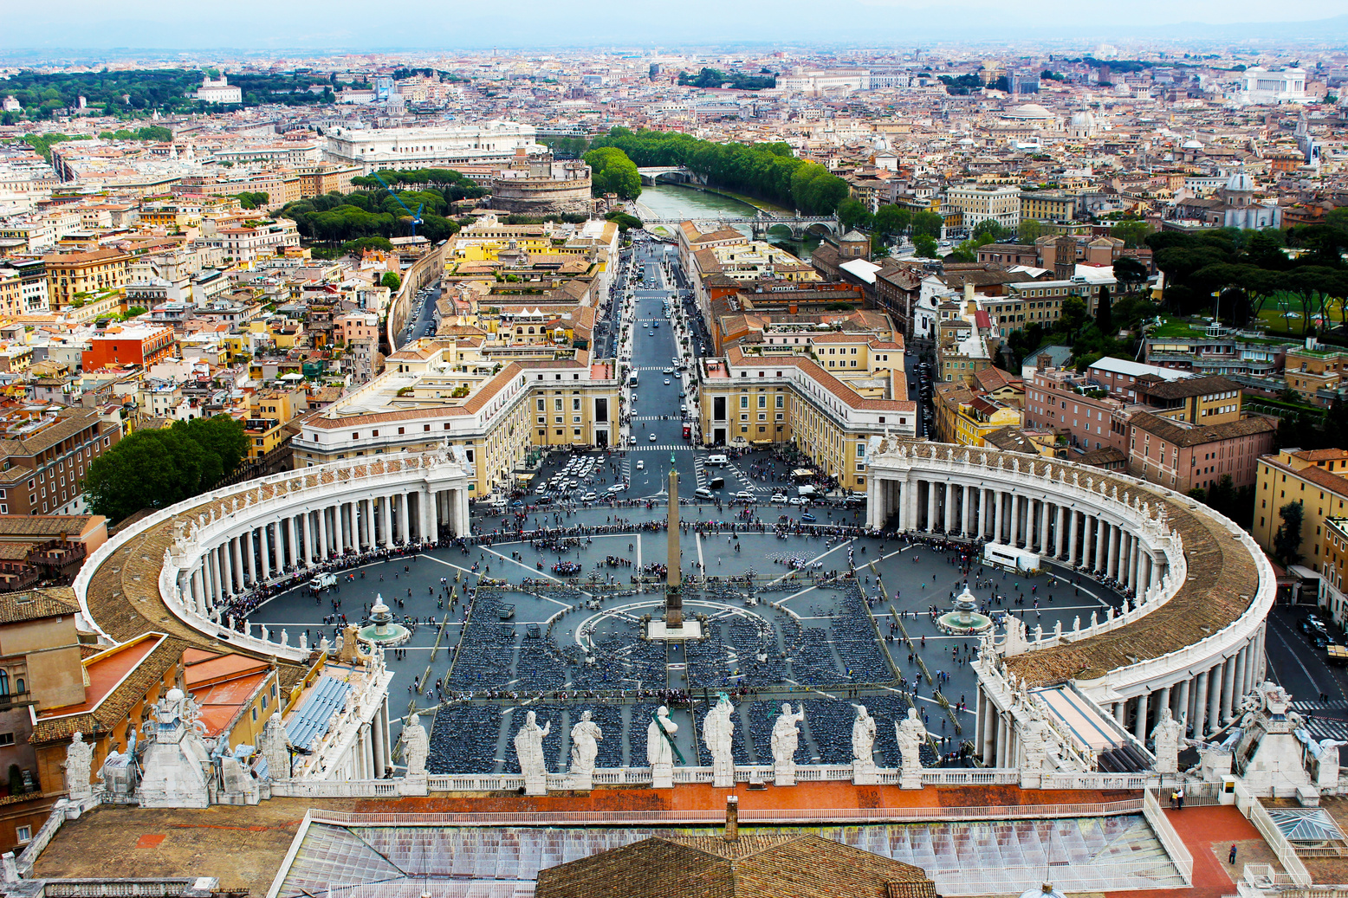

Rome, Italy's capital, is a rich repository of ancient history and architecture, boasting renowned sites like the Colosseum, Roman Forum, and Pantheon. The Vatican City, an independent enclave within Rome, hosts St. Peter's Basilica and the Sistine Chapel. Rome seamlessly blends ancient ruins, Renaissance art, and a dynamic modern culture.

**Rome, Lazio**

*(Central Italy)*

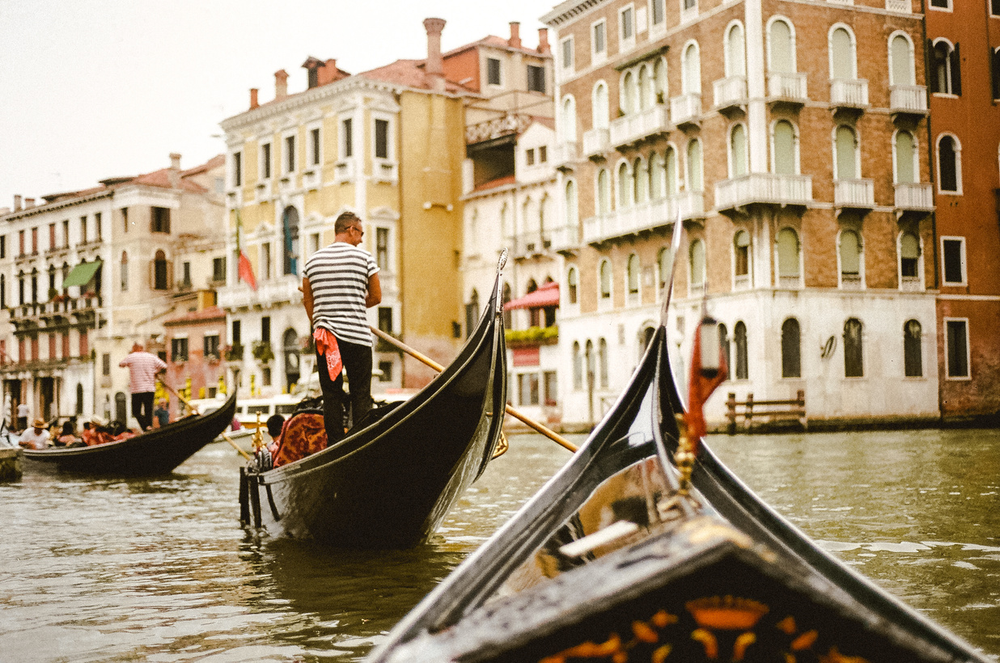

Venice, renowned for its scenic canals, historic architecture, and distinctive gondola transportation, features iconic landmarks like St. Mark's Basilica and the Doge's Palace. The Grand Canal, flanked by stunning buildings, is a must-visit. This romantic and enchanting destination captivates visitors with its timeless charm and allure.

**Venice, Veneto**

*(Northern Italy)*

DISCOV﻿ER ITALY | **PAGE 5**



**ART PLACE**

Nestled in the heart of Italy, Florence stands as an unrivaled art haven and cultural gem. Renowned for its rich Renaissance history, the city boasts an impressive array of museums, including the iconic Uffizi Gallery and the Accademia Gallery, home to Michelangelo's David. Stroll through the charming streets adorned with historic architecture, where every corner seems to whisper tales of artistic brilliance. Florence

is not merely a city; it's an immersive journey through the very soul of Italian creativity, inviting visitors to revel in the timeless beauty

that permeates its every cobblestone.

**CULTURAL HUB**

Venture south to Rome, the eternal city and Italy's cultural nucleus. Reverberating with millennia of history, Rome is a sprawling tapestry of art, architecture, and traditions. Marvel at the grandeur of the Colosseum, lose yourself in the Vatican City's artistic treasures and wander through the enchanting streets to discover hidden fountains and piazzas. From the exquisite frescoes of the Sistine Chapel to the grandeur of the Roman Forum, Rome is

a living testament to the enduring power of human expression. Immerse yourself in the heart of Italy's cultural legacy as you traverse the vibrant streets of this extraordinary city.

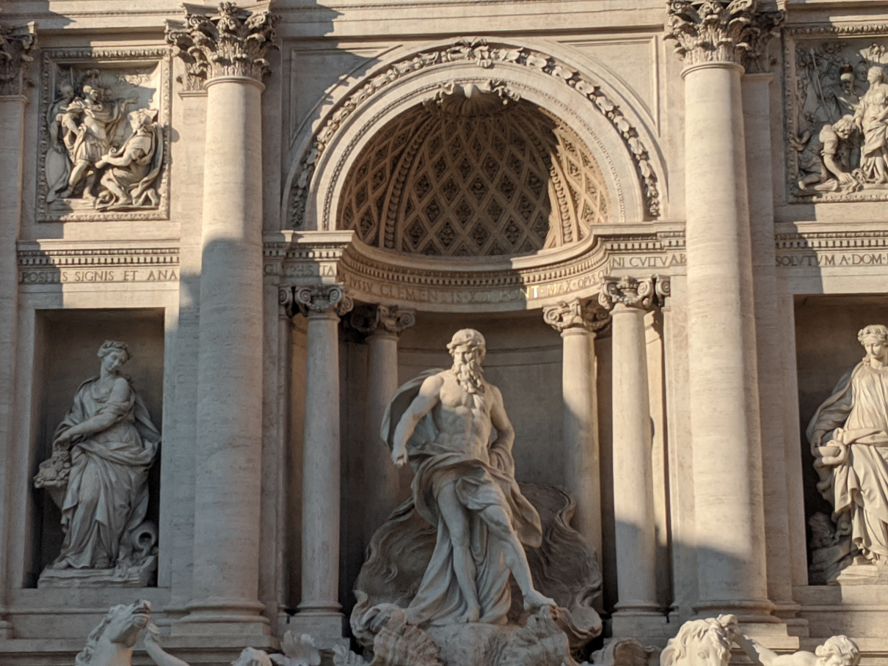

**Art &**

**Culture**

DISCOV﻿ER ITALY | **PAGE 6**

**PIZZA MARGHERITA**

Classic Neapolitan pizza with a thin crust, tomato sauce, fresh mozzarella, basil, and a drizzle of olive oil

**1**

**RISOTTO MILANESE**

Creamy saffron risotto from Milan, enriched with butter and Parmesan

—a luxurious, Northern Italian delight

**3**

**SPAGHETTI CARBONARA**

Al dente pasta tossed with a creamy sauce made of eggs, Pecorino Romano cheese, pancetta, and black pepper

**2**

**TIRAMISU**

Layers of coffee-soaked ladyfingers and mascarpone cream create a luscious, iconic Italian dessert delight

**4**

**Food & Culinary**

DISCOV﻿ER ITALY | **PAGE 7**

**Transportation**

**~$1,500**

This covers flights, local transportation, and possibly car rentals or train tickets for exploring various destinations

**Food and Dining**

**~$800**

Sampling local cuisines, dining out, and occasional snacks contribute to the overall cost of sustenance during the trip

**Sightseeing and Activities**

**~$500**

Entrance fees to museums, attractions, guided tours, and other activities add up to the expense of exploring Italy

**Miscellaneous and Souvenirs**

**~$300**

Unexpected expenses, souvenirs, and small indulgences contribute to the miscellaneous category in the overall budget

for 1 person

**Accommodation**

**~$1,500**

Small costs within this expense include nightly room rates, taxes, and any additional fees for amenities

**Estimated cost**

**$4600**

**Budgeting**

**Address**

12 Anywhere Street, Any City, ST, 345

**Hotline**

+123-456-7890

**Instagram**

templateLAB Official

**Facebook**

templateLAB Official

**Email**

info@templateLAB.com

**Website**

www.templateLAB.com

**Contact us**

**DISCOVER ITALY**