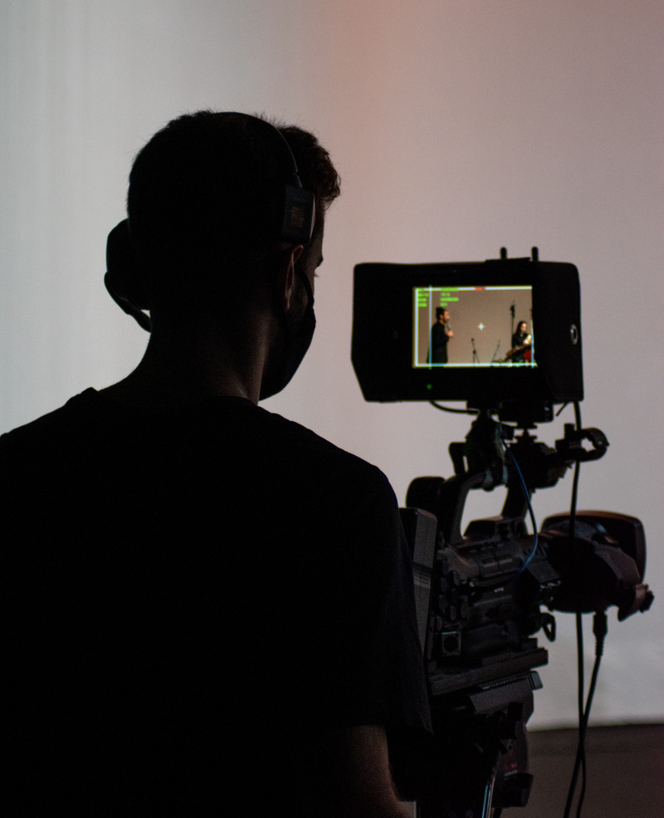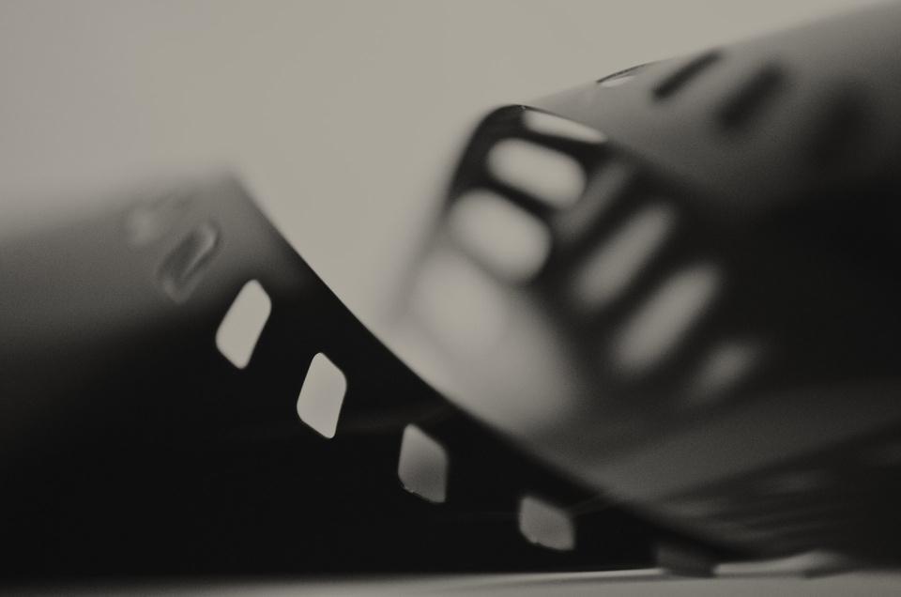

Time

**2:00 PM to 7:00 PM**

Venue

**Silver Screen Studios**

EVENT

BOOKLET

SHORT HISTORY OF FILMMAKING

***Saturday,***

***June 17, 2024***

CINEFEST

CINEFEST

*01*

**END**

**40 MINS**

**Showcase & Closing Remarks**

Screen participants' work, discuss learnings, and wrap up the filmmaking workshop

6:20 PM

- 7:00 PM

**MAIN CONTENT**

**60 MINS**

**Basics of Storyboarding**

Learn the art of visual storytelling by translating a script into storyboards

2:35 PM

- 3:35 PM

**90 MINS**

**Lights, Camera, Action!**

Hands-on session covering camera usage, framing, and capturing dynamic scenes

3:35 PM

- 5:05 PM

**75 MINS**

**Editing Essentials**

Dive into the world of editing, mastering

the basics to enhance your films

5:05 PM

- 6:20 PM

**OPEN**

**20 MINS**

**Icebreaker: Filmmaking Bingo**

Break the ice and ignite creativity with

a fun filmmaking-themed bingo game

2:15 PM

- 2:35 PM

**15 MINS**

**Welcome & Introduction**

Get acquainted, overview of the

workshop, and set the creative tone

2:00 PM

- 2:15 PM

**Schedule**

Time

**2:00 PM to**

**7:00 PM**

Date

**Saturday,**

**June 17, 2024**

Venue

**Silver Screen Studios**

**Dear**

Welcome to CineFest, an ode to the magic of filmmaking! Your presence amplifies the thrill of this cinematic exploration. As we embark on this journey of storytelling through film, your passion enriches our shared experience. Thank you for being part of this extraordinary gathering, your enthusiasm elevates the event.

Get ready to immerse yourself in the captivating world of filmmaking where every frame tells a story and

every story sparks imagination. Let the cinematic adventure begin!

CINEFEST

CINEFEST

*02*

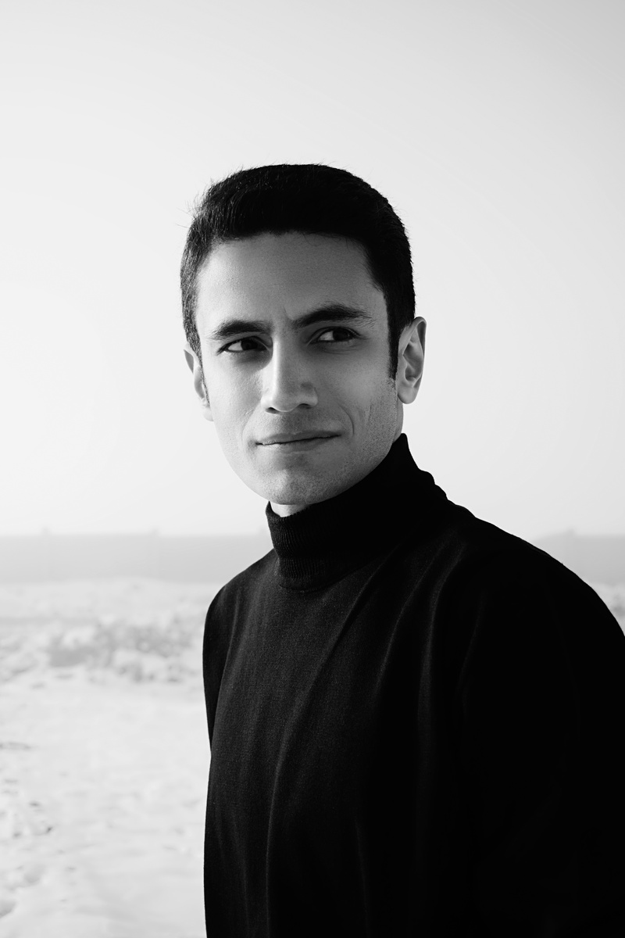

**Lucas Chang**

Script Continuity Supervisor

(Script Supervisor)

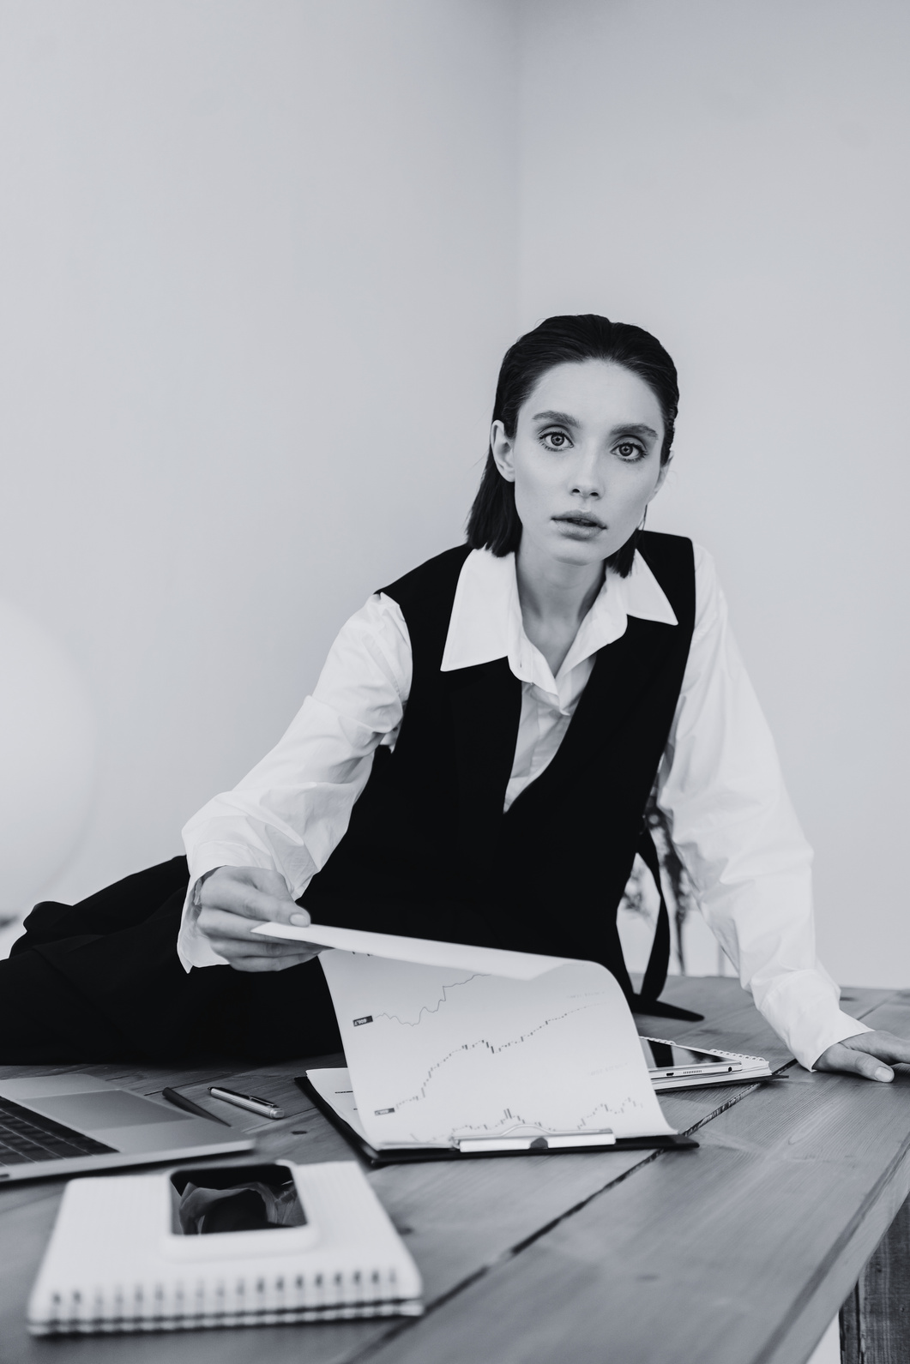

**Olivia Bennett**

Costume and

Apparel Stylist

(Costume Designer)

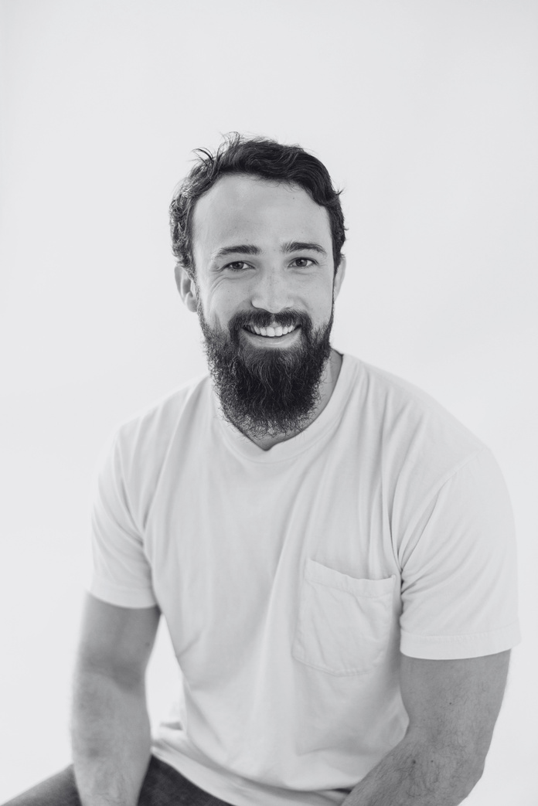

**Alex Turner**

Director of Cinematography (Cinematographer)

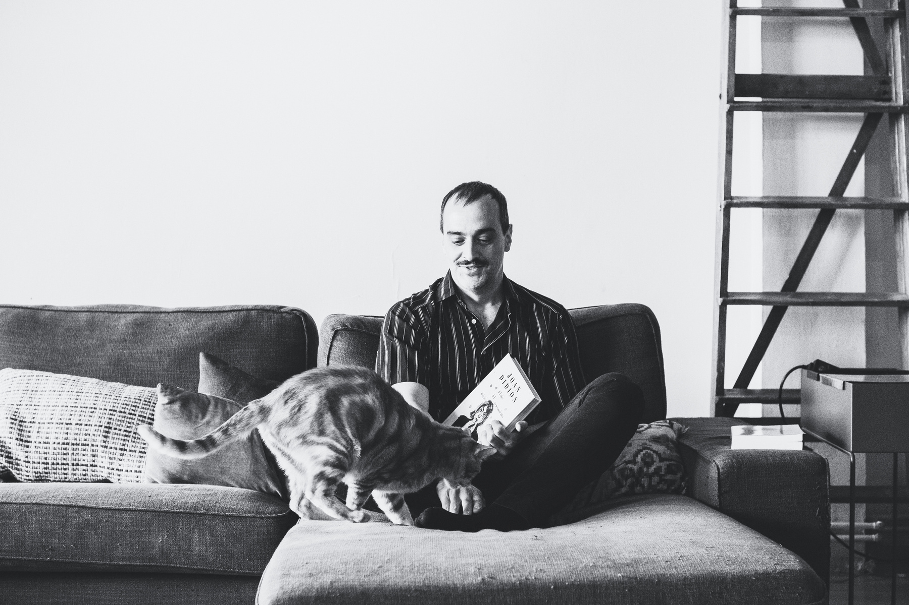

**Ryan Mitchell**

Audio Post

Production Engineer (Sound Mixer)

**Emily Thompson**

Artistic Production Coordinator

(Production Designer)

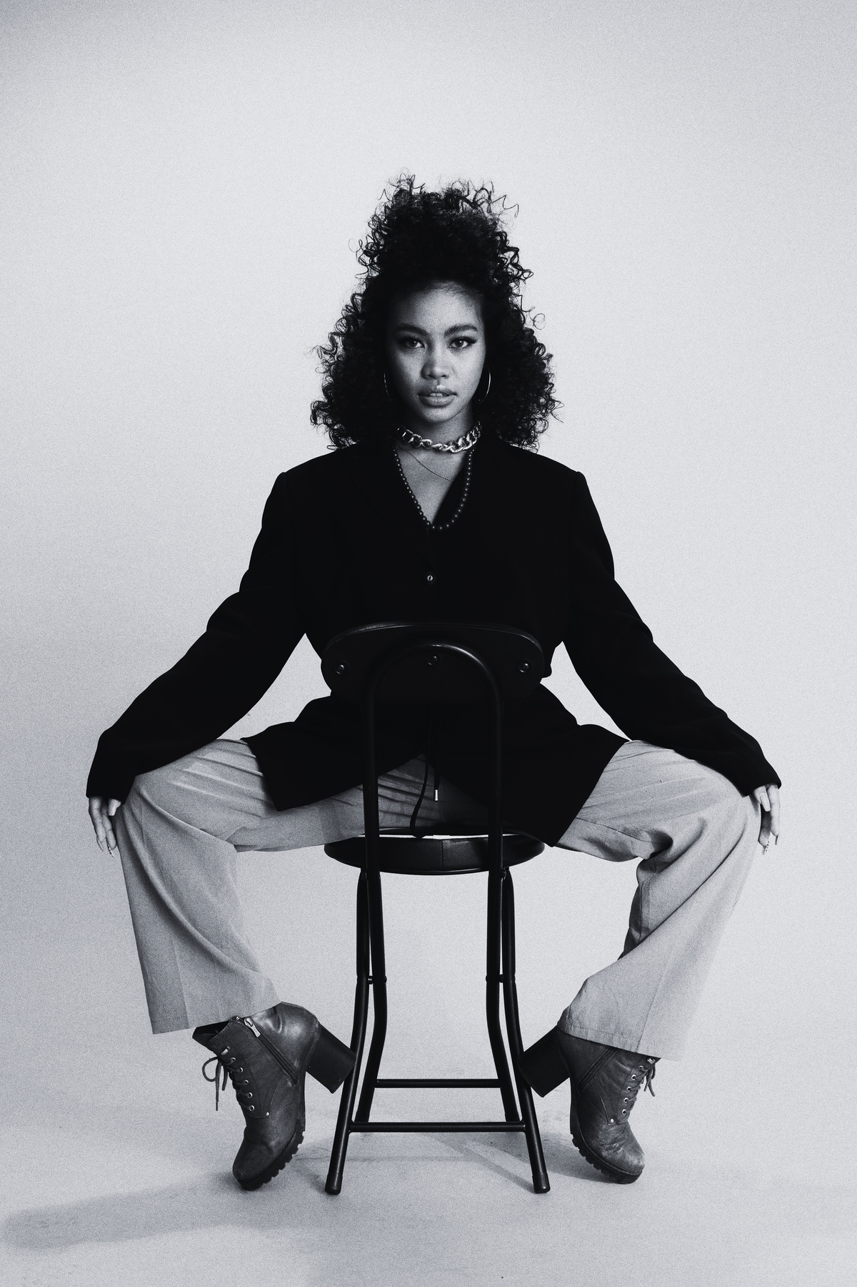

**Jordan Williams**

Motion Picture

Editing Specialist

(Film Editor)

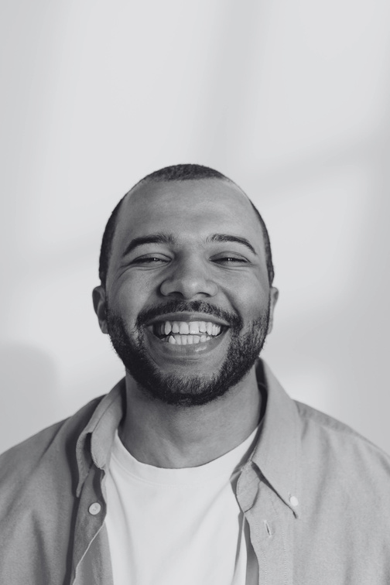

MEET OUR

SPEAKERS

CINEFEST

CINEFEST

*03*

**CINECRAFT SOLUTIONS**

**Equipment Rental**

High-end cameras, lighting, and sound gear for an immersive and professional filmmaking experience

**SCRIPTSYNC STUDIOS**

**Screenwriting Masterclass**

Industry experts guide aspiring filmmakers in crafting compelling narratives and engaging screenplays

**CINESOUND SOLUTIONS**

**Audio Mastery**

CineSound provides top-notch audio support, ensuring immersive experiences in filmmaking workshops

**POSTPRO INSIGHT**

**Post-Production Lab**

Editing software, color grading, and sound design tools for a polished cinematic masterpiece

**ACTORS AVENUE AGENCY**

**Acting Workshop**

Professional actors share insights and techniques, helping participants bring characters to life on screen

**SPOTLIGHT STRATEGIES**

**Marketing Mastery**

Spotlight Strategies brings creations to the forefront with expert marketing support for workshops

**THANK YOU TO OUR VALUED SPONSORS AND PARTNERS**

Your support ignited creativity at Cinefest,   
shaping cinematic dreams. With gratitude, we celebrate the sponsors who made our filmmaking workshop a vibrant tapestry of inspiration

SPONSORS

SHORT HISTORY OF FILMMAKING

CINEFEST

CINEFEST

*04*