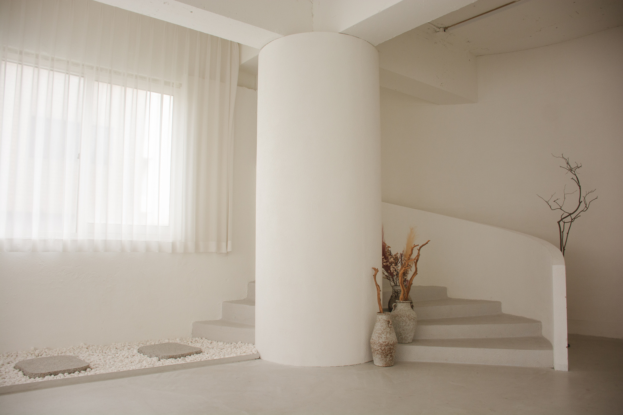

AIR B&B WELCOME BOOKLET

HOME

WELCOME TO OUR

TRANQUILCO

SINCE 2020

**WELCOME TO MY HUMBLE PLACE**

As the proud owner of this sanctuary, I cherish every moment spent crafting this house into a haven of tranquility. Each detail reflects

my commitment to creating a space where warmth and comfort intertwine seamlessly. From the carefully selected decor to the soothing color palette, every element has been chosen with   
intention and care.

My purpose in curating this space extends beyond mere

aesthetics. It is my heartfelt desire to provide you with more

than just accommodation but rather a cozy and healing refuge.

This house is not merely walls and furniture; it's an embodiment

of comfort, designed to nurture your spirit and provide respite

from the outside world. May you find solace in its embrace.

Thank you for choosing my home as your place to stay. Your

decision means the world to me, and I sincerely hope that your time here surpasses expectations. Welcome, and may your stay be filled with moments of serenity and delight.



OWNER TRANQUILICO

**ARIA LYNN**

MEET THE HOST

TRANQUILCO

AIR B&B WELCOME BOOKLET

**Connection name**

TranquilCo Official Welcome

**Wi-Fi Password**

xxx-xxx-xxx-xxx-xxx-xxx-xxx

MAY YOUR SOJOURN BE ABUNDANT WITH TRANQUIL AND JOYOUS INTERLUDES, BRIMMING WITH SERENITY AND DELIGHT, CREATING A TAPESTRY OF CHERISHED MEMORIES

Take a final stroll through the space to ensure no personal belongings are left behind, ensuring a smooth departure

**Check-Out Walkthrough**

**Key and Access Return**

Return keys and access cards

to designated spots, concluding your stay responsibly while maintaining security measures

**02**

**25/12**

**CHECK-OUT TIME: 1PM - 3PM**

**Appliance Accountability**

Confirm that all room appliances are turned off and in their original condition before

leaving the accommodation

**Trash Tidiness**

Use designated bins for waste disposal, maintaining a tidy space to create a positive, considerate experience for all

**Temperature Adjustment**

Set the thermostat for comfort, close windows to boost energy efficiency, and honor the host's dedication to a cozy setting

**Feedback Farewell**

Provide host feedback, emphasize positives, address concerns, maintain open improvement for satisfaction

**01**

**19/12**

**CHECK-IN TIME: 11AM - 1PM**

**Room Inspection**

Ensure a quick check of the room's condition upon arrival

to identify any existing damages or issues for a smooth stay

**Amenity Assessment**

Take note of amenities like toiletries, towels, and linens; report shortages promptly

for resolution

**Appliance Awareness**

Familiarize yourself with room appliances to prevent accidental damage and ensure a hassle-free experience during your stay

**Safety Check**

Ensure fire extinguishers, smoke detectors, and emergency exits work to prioritize safety during your visit for peace

**Cleaning Confirmation**

Ensure space cleanliness at check-in, promptly addressing concerns for a comfortable, hygienic environment

**Inventory Inspection**

Check cutlery, dishes, and entertainment stock to report missing items and ensure a

fully equipped, enjoyable stay

TRANQUILCO

SINCE 2020

CONTACT

INFORMATION

Your cherished contributions mean the world to us.

Kindly share your experiences to create warmth

**Host number - Aria Lynn**

+123-456-7890

**Website**

www.templateLAB.com

**Facebook**

templateLAB Official

**Email**

info@templateLAB.com

**Address**

2 Anywhere Street, Any City

TRANQUILCO

AIR B&B WELCOME BOOKLET

