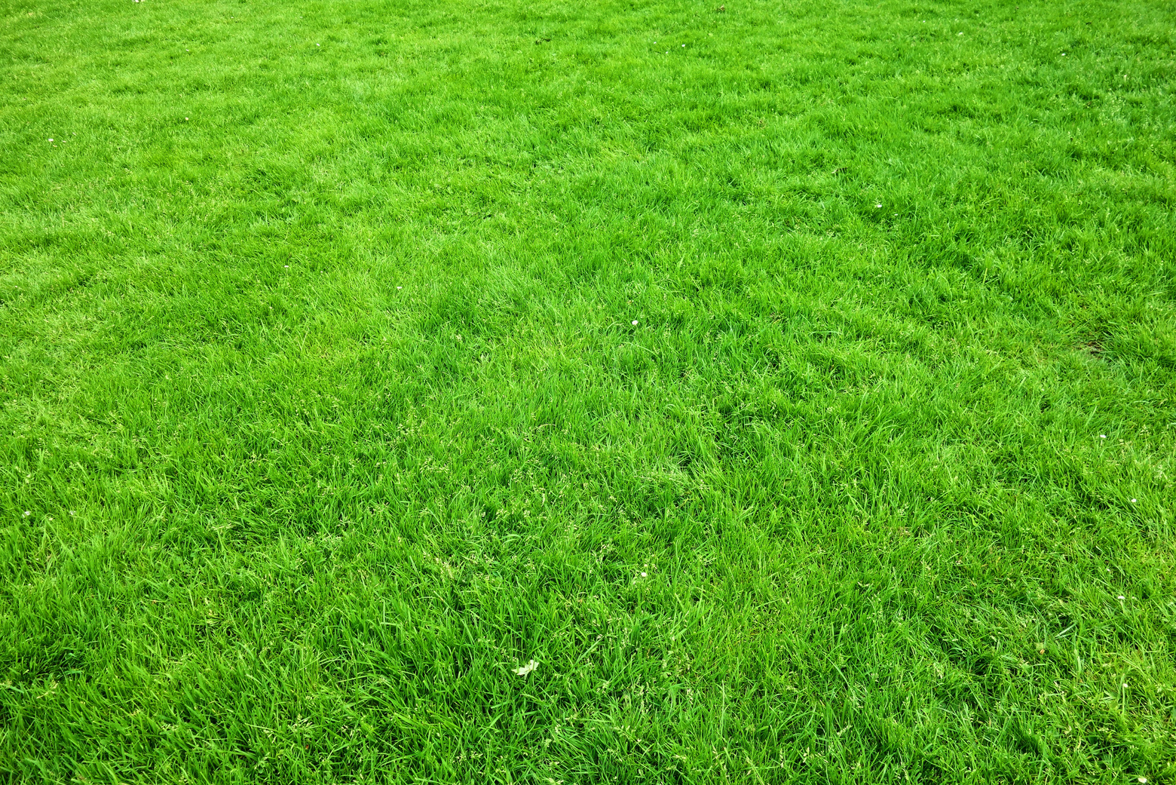

*www.templateLAB.com*

*123 Anywhere St., Any City, ST 12345*

**Contact for more information**

**+123-456-7890**

**Our awesome services**

**METICULOUS**

**TURF TENDING**

Enhance your lawn's charm

with Precision Greencare's

expert services, ensuring meticulous turf care

through precise mowing,

fertilization, and aeration

**TREE SCULPTURE SHAPING**

Precision Greencare's reveals tree beauty through artful pruning, precise shaping,

and effective disease management, fostering

a flourishing landscape

**FLORAL**

**OASIS DESIGN**

Revamp your outdoors

with Precision Greencare's

experts in landscape design,

lively flowerbeds, and

efficient irrigation, creating

a blooming floral oasis

**Lawn care business flyer**

FAUXFOLIAGE FINERY

Transform your lawn into a lush paradise! Our expert team offers top-notch

lawn care services for a greener, healthier, and more beautiful outdoor space