 |  | Gabriella Novotna |  |  |  |  |  |  |  |  |  |  |  |  |  |  |  |  |  |  |  |  |  |  | DECEMBER 2023
 |  |  |  |  |  |  |  |  |  |  | 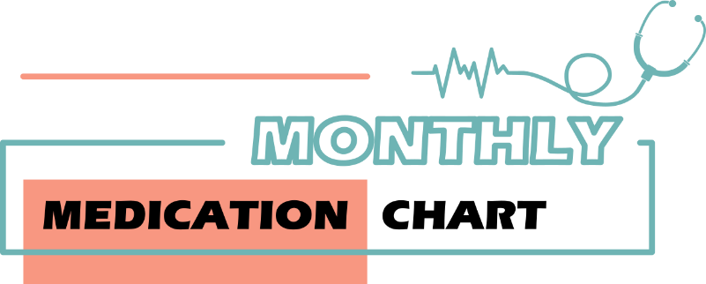
 |  | MEDICATION | TIME | 1 | 2 | 3 | 4 | 5 | 6 | 7 | 8 | 9 | 10 | 11 | 12 | 13 | 14 | 15 | 16 | 17 | 18 | 19 | 20 | 21 | 22 | 23 | 24 | 25 | 26 | 27 | 28 | 29 | 30 | 31
 |  | Drug name: | 8:00 AM | X | X | X | X | X | X
 |  | Nobrilium 500mg | 10:00 PM | X | X | X | X | X | X
 |  | Dosage:
 |  | 1 Tablet
 |  | Drug name: | 10:00 AM | X | X | X | X | X | X
 |  | Levropen 2mg/ml | 4:00 PM | X | X | X | X | X | X
 |  | Dosage: | 10:00PM | X | X | X | X | X
 |  | 1 spoon - 5ml
 |  | Drug name:
 |  | Dosage:
 |  | Drug name:
 |  | Dosage:
 |  | Drug name:
 |  | Dosage:
 |  |  |  |  |  |  |  |  |  |  |  |  |  |  |  |  |  |  |  | © TemplateLab.com

