 |  |  |  |  | 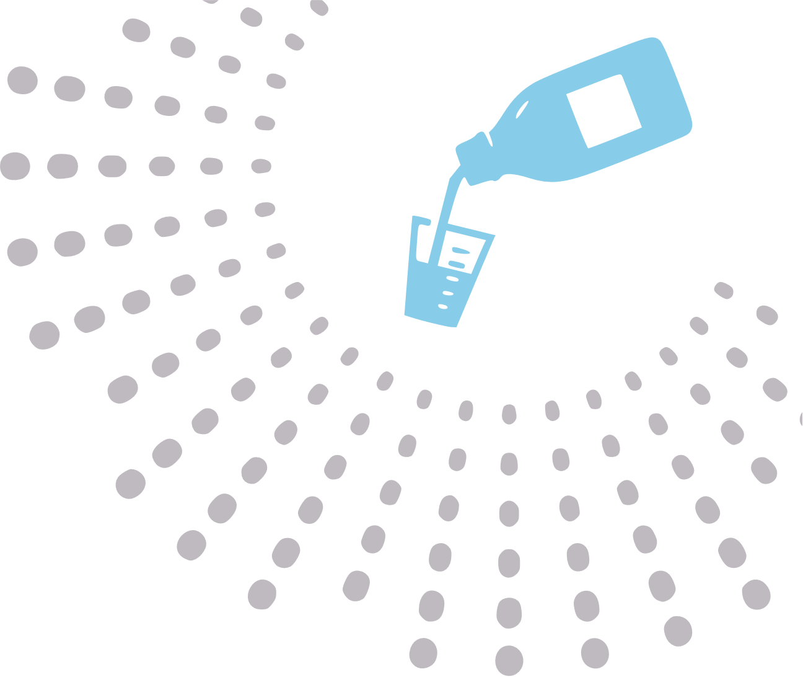
 |  | IBUPROFEN
 |  | Ibuprofen is a nonsteroidal anti-inflammatory drug (NSAID). It works by reducing hormones that cause inflammation and pain in the body. Ibuprofen is used to reduce fever and treat pain or inflammation caused by many conditions such as headache, toothache, back pain, arthritis, menstrual cramps, or minor injury.
 |  | A child's dose is based on the age and weight of the child. Carefully follow the dosing instructions. Take ibuprofen with food or milk to lessen stomach upset.
 |  | WEIGHT |  | CHILDREN'S LIQUID | TABLETS - JUNIOR | TABLETS - ADULTS
 |  | (pounds) | (kilogram) | (100mg/5ml) | (100mg) | (200mg)
 |  | 12-21 lbs | 5.5-9.9 kg | 2.5 ml | - | -
 |  | 22-33 lbs | 10.0-14.9 kg | 5.0 ml | 1 Tablet (100 mg) | -
 |  | 34-43 lbs | 15.0-19.9 kg | 7.5 ml | 1 Tablet (100 mg) | -
 |  | 44-55 lbs | 20.0-24.9 kg | 10.0 ml | 2 Tablets (200 mg) | 1 Tablet (200 mg)
 |  | 56-66 lbs | 25.0-29.9 kg | 12.5 ml | 2 Tablets (200 mg) | 1 Tablet (200 mg)
 |  | 67-88 lbs | 30.0-39.9 kg | 15.0 ml | 3 Tablets (300 mg) | 1 Tablet (200 mg)
 |  | >89 lbs | >40.0 kg | 20.0 ml | 4 Tablets (400 mg) | 2 Tablets (400 mg)
 |  |  |  |  |  | © TemplateLab.com

