 | 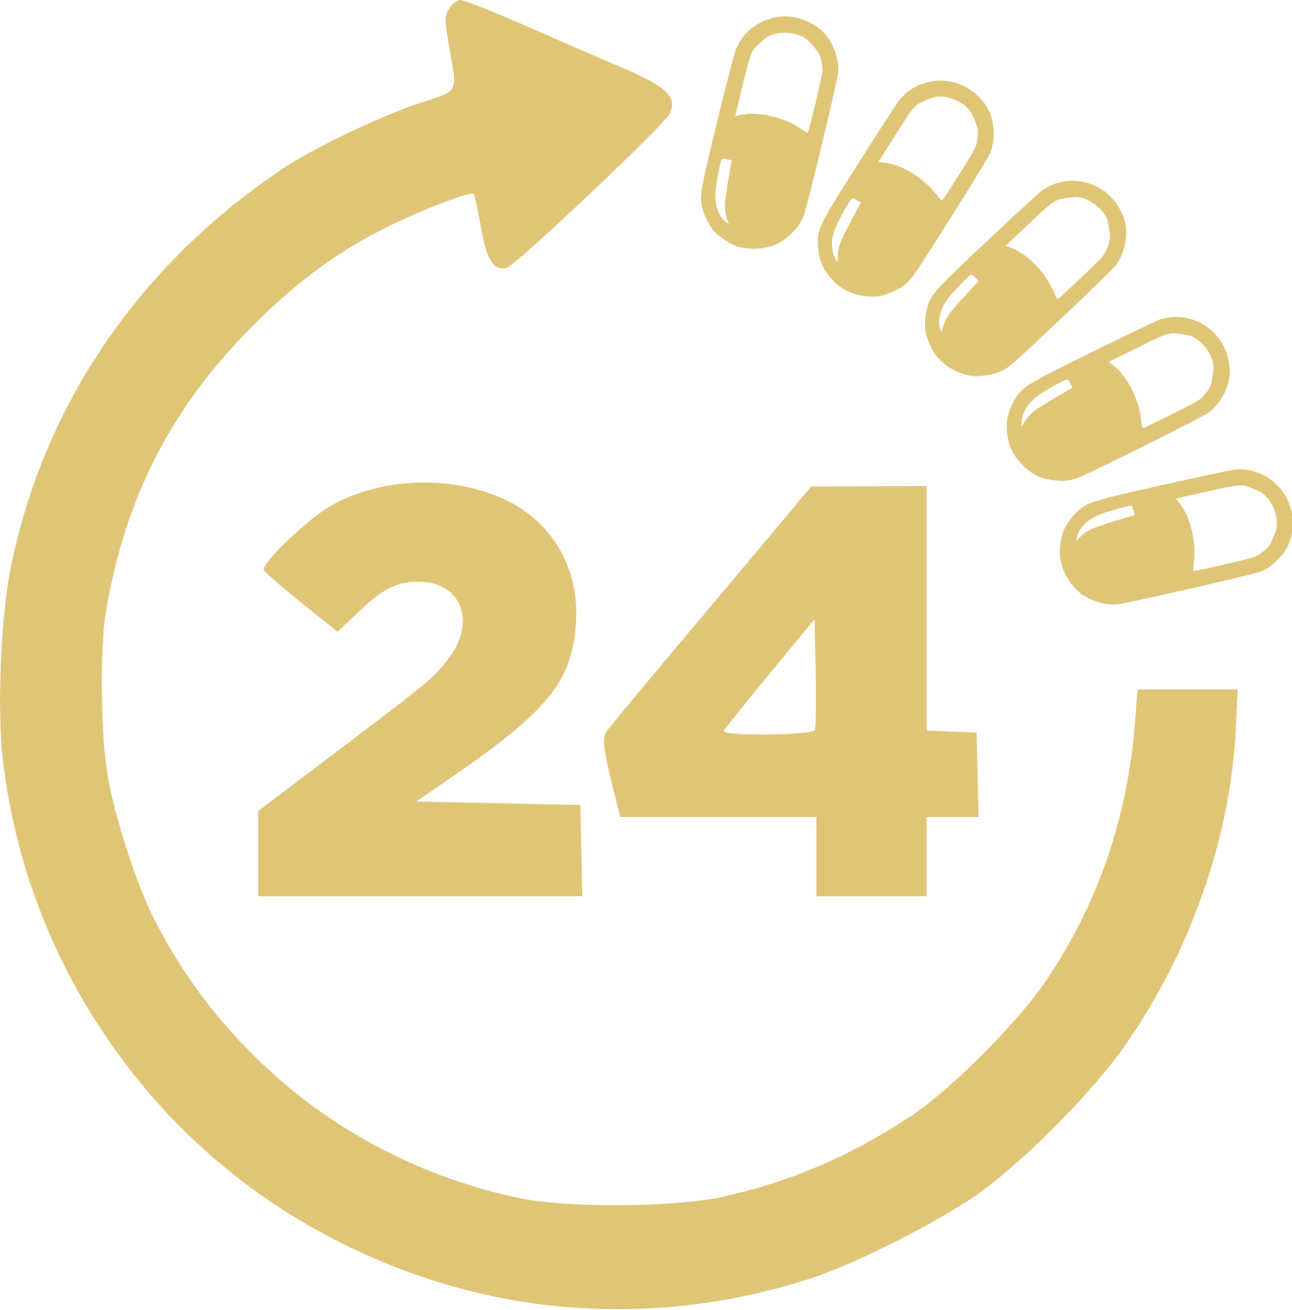
 |  | 24 HOUR MEDICATION SCHEDULE
 | TIME | MEDICATION | DOSAGE | M | T | W | T | F | S | S
 | 12:00 AM | Xenazine 25mg | 1 Tablet | X | X | X
 | 1:00 AM
 | 2:00 AM
 | 3:00 AM
 | 4:00 AM
 | 5:00 AM
 | 6:00 AM | Vortioxetine 5mg | 2 Tablets | X | X | X
 | 7:00 AM
 | 8:00 AM
 | 9:00 AM
 | 10:00 AM
 | 11:00 AM
 | 12:00 PM | Gentamicin 10 mg/mL | 10ml | X | X | X | X | X | X | X
 | 1:00 PM
 | 2:00 PM
 | 3:00 PM
 | 4:00 PM
 | 5:00 PM
 | 6:00 PM
 | 7:00 PM
 | 8:00 PM
 | 9:00 PM
 | 10:00 PM
 | 11:00 PM
 | Patient: | JANNIFER CRISP | Date: | 23/10/2023
 | MONDAY TUESDAY WEDNESDAY THURSDAY FRIDAY SATURDAY SUNDAY
 |  |  | © TemplateLab.com

