**LOCATION**

Graceful Haven Church

1 Anywhere ST., Any City 123

***SUNDAY 26 NOV 2023***

**THE**

**WEDDING**

**TIMELINE**

**06 P.M**

Wedding Ends

Tea and cake are served

**05 P.M**

Wedding Begins

**08:30 P.M**

Wedding Party

**07:30 P.M**

Toasts and Speeches

**07 P.M**

Dinner is served

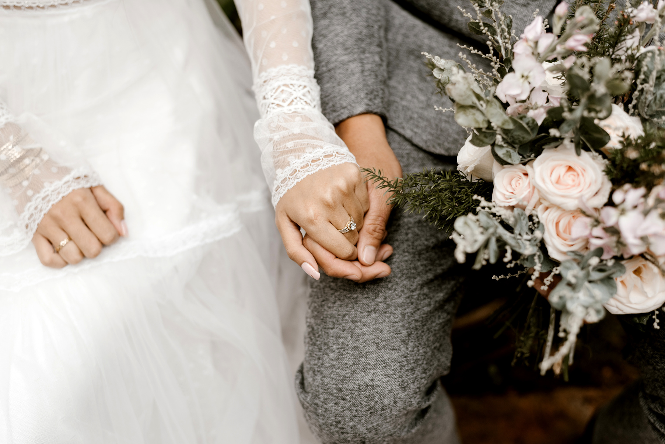

*"True love is a journey that never ends, where every step taken together only strengthens the bond"*

***DEAR OUR CHERISHED FAMILY & FRIENDS,***

We are thrilled to invite you to our upcoming wedding celebration, and we cannot contain our excitement as we look forward to sharing this remarkable day with every one of you. Your presence will mark the beginning of an extraordinary new chapter in our lives, and we want you to know how deeply appreciative we are of the joy and love you have brought into our journey thus far.

Your unwavering support and friendship have been a constant source of strength, and as we stand on the brink of this new adventure as a married couple, we are eager to create countless more cherished memories together. We are profoundly grateful for your willingness to join us in this celebration and for the blessings you've brought into our lives. We can't wait to see you there and to share this joyous occasion with all of you.

With all our love and anticipation,

***JAYDEN & SARAH***

***JAYDEN & SARAH ARE GETTING MARRIED***

**WEDDING**

NEWSPAPER

Wednesday 15 November 2023

The Daily Chronicle Editorial