**The Enigmatic Museum of Artworks**

In the heart of our bustling city lies a sanctuary of beauty and history - The Museum of Artworks. Stepping through its grand oak doors is like entering a portal to the past, a place where the elegance of a bygone era is meticulously preserved.

As you traverse the hallowed halls, a mesmerizing tapestry of art unfolds before your eyes. The first gallery, adorned with gilded frames and velvet curtains, transports you to the Renaissance period, where the likes of da Vinci and Raphael reign supreme. The aura of this age lingers, from intricately carved sculptures to meticulously crafted tapestries.

Venture deeper into the museum, and the ambiance transforms into the Romantic era. Dark, rich woods, and candelabras create an intimate atmosphere that whispers the tales of Keats, Byron, and Shelley. Paintings by Turner and Delacroix come to life, their vivid colors telling stories of passion and expression.

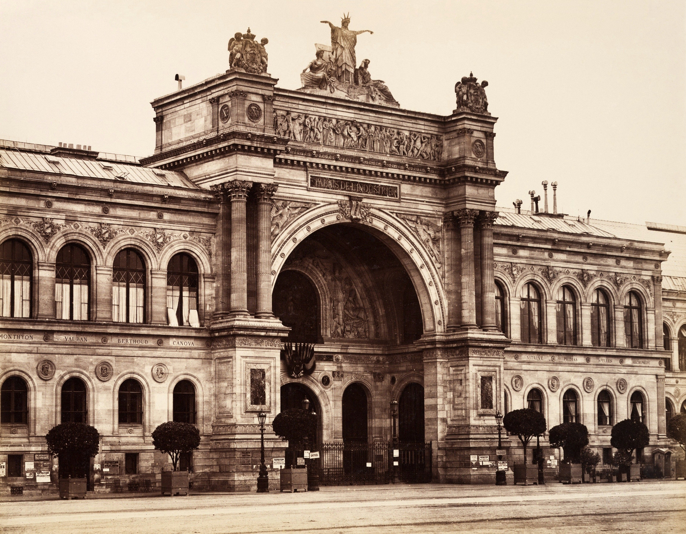

**A Journey Through Time: The Enigmatic Museum of Artworks**

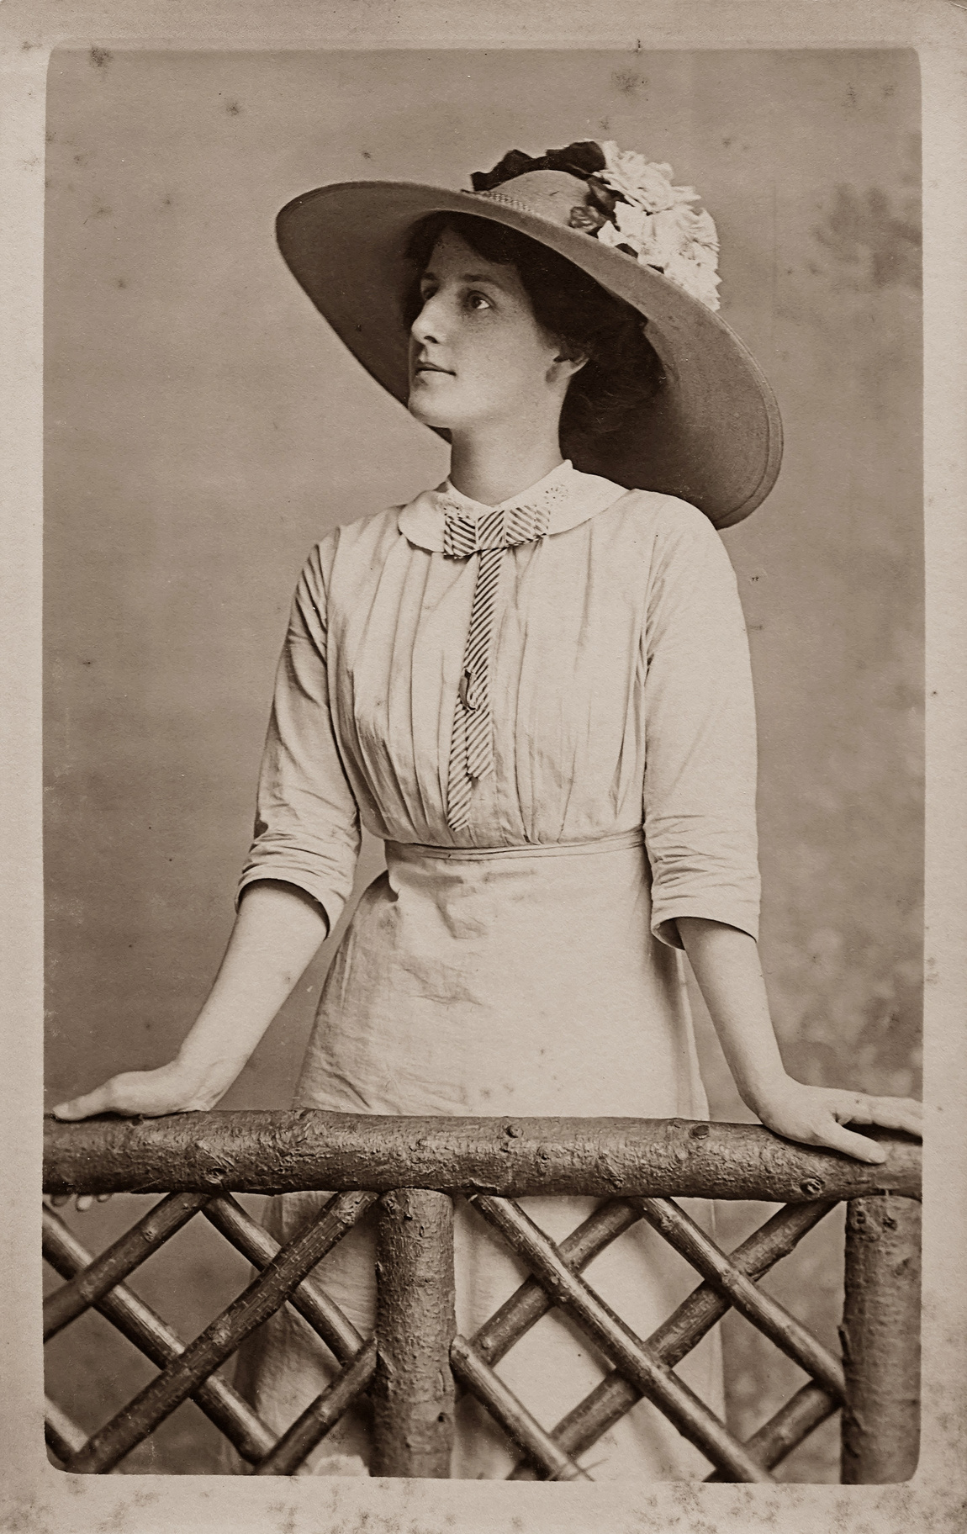

**Whistling Wheels**

**The Iron Behemoth Roaring Down the Rails**

**Capturing Elegance**

**The Enigmatic Elegance of Aristocratic Beauty**

**PAGE 1 - 3**

**PAGE 4 - 5**

**OLD NEWSPAPER**

**THE SUNDAY NEWS**

Edition #30

September 20, 2030