WRITTEN BY

By Krystal Smith, Staff Writer

EDITED BY

Sam Jonhson

Instead of flowers, the family kindly requests that donations be made to the Literary Legacy Foundation in Eleanor Edison's name to continue the work of her passion and her values.

A celebration of Eleanor Edison's life will take place at

LOCATION

15:00 SUNDAY

Freedom Church

12 Nov 2023

FOR MORE INFORMATION

OR TO LEAVE CONDOLENCES, PLEASE SCAN THIS QR CODE

I

t is with heavy hearts that we announce the peaceful passing of Eleanor at the age of 80.

Eleanor Edison was born on 7/7/1943 and touched the lives of all who had the privilege of knowing her. She left behind a legacy of love, kindness, and resilience that will forever be cherished.

Eleanor Edison's journey through life was marked by remarkable achievements and unwavering dedication to family, friends, and community. She was a loving Parent, Spouse, Sibling, or Friend, who provided unwavering support and guidance to those fortunate enough to share her life. Her passion for the country's literature was an inspiration to all. Her memory will live on through the lives she's touched and the indelible mark she's left on the world.

Eleanor Edison

July 7 1943 - November 10 2023

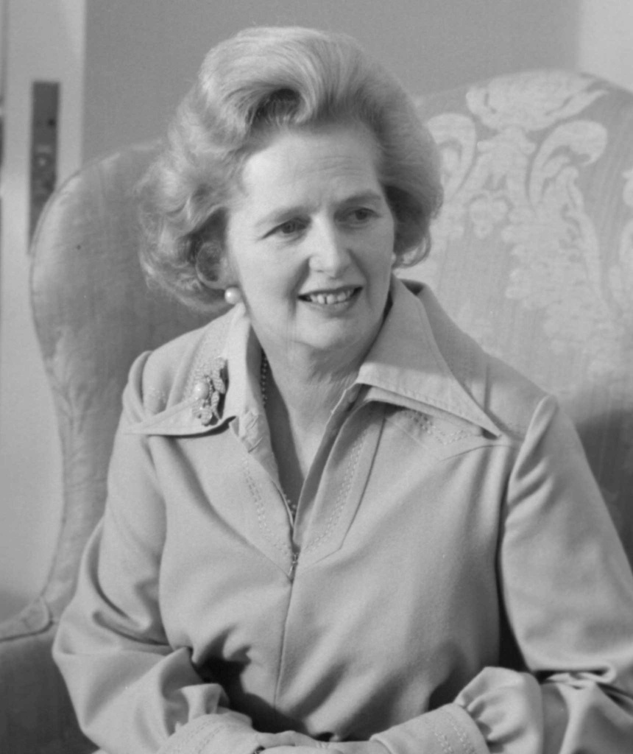

NEWSPAPER OBITUARY

IN LOVING MEMORY

THE DAILY CHRONICLE EDITORIAL

6TH OCTOBER 2023