*02*

*www.templateLAB.com*

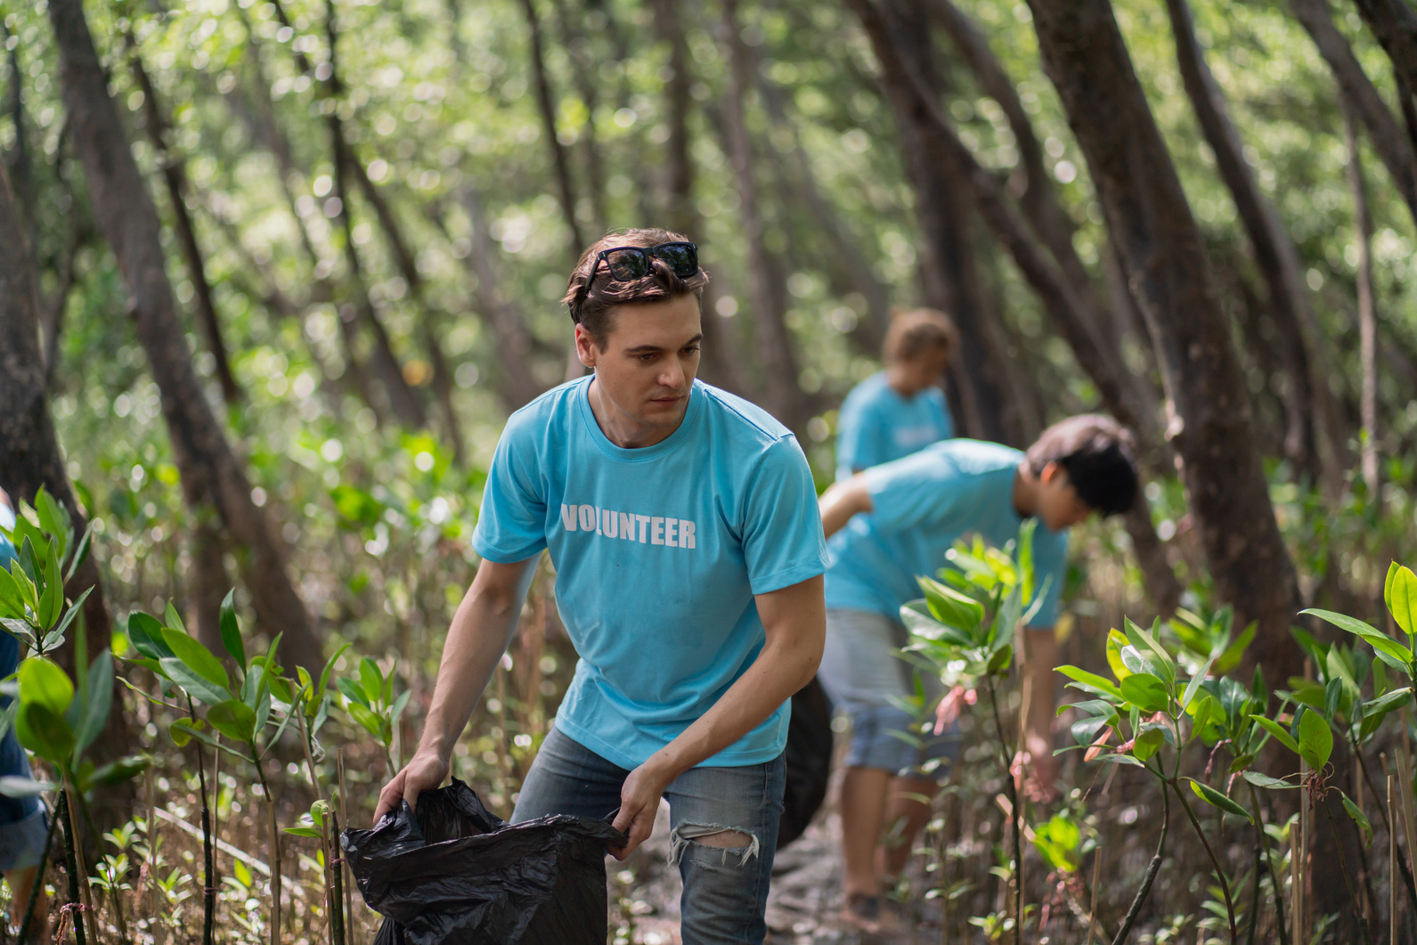

**Local school principal Mark Anderson added,**

*“Engaging students actively*

*in environmental initiatives*

*is vital for teaching them the*

*importance of preserving our*

*beloved planet we call home”*

**Environmental activist Jane Carter stated**

*“Our community's response*

*to environmental issues is heartening. Together, we can make a significant impact on local conservation efforts”*

In this seamless collaboration and collective effort, we've observed the profound influence of our combined actions on our local environment. The unwavering commitment of our community has resulted in tangible enhancements to air and water quality, the preservation of vital ecosystems, and the advocacy for sustainable practices in our region. Our mutual obligation and resolute dedication to preserving the natural world remain an enduring wellspring of motivation, compelling us to persist in our relentless endeavors to improve our planet and ensure the welfare of future generations.

B

olstering our environment and ensuring the enduring health of

our planet has been the bedrock of our community's remarkable unity. Within our dynamic community, a blend of residents, impassioned activists, and local organizations have banded together to build a powerful partnership, working in concert to address the most pressing and substantial environmental challenges within our region. This extraordinary combined endeavor underscores our shared duty and steadfast dedication to protecting the natural world for generations to come, exemplifying our community's resolute commitment to environmental preservation.

WRITTEN BY

***By Jane Smith, Staff Writer***

EDITED BY

***John Smith***

**ENVIRONMENT**

**NEWSPAPER ARTICLE**

*Wednesday, November 1, 2023*

*ABC Newspaper*