Book:

Color:

Drinks:

Snack:

Animal:

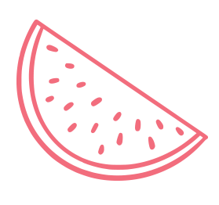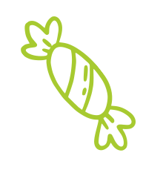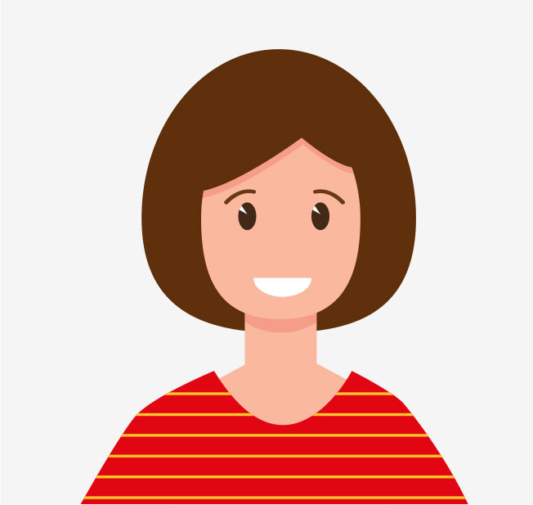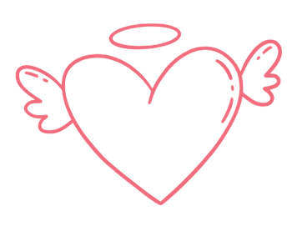

Toy:

Movie:

Food:

Favorites:

3 things I love about myself:

When I grow up I want to be:

My favorite

School subject is:

Years old

I am

My Name is

ALL ABOUT ME