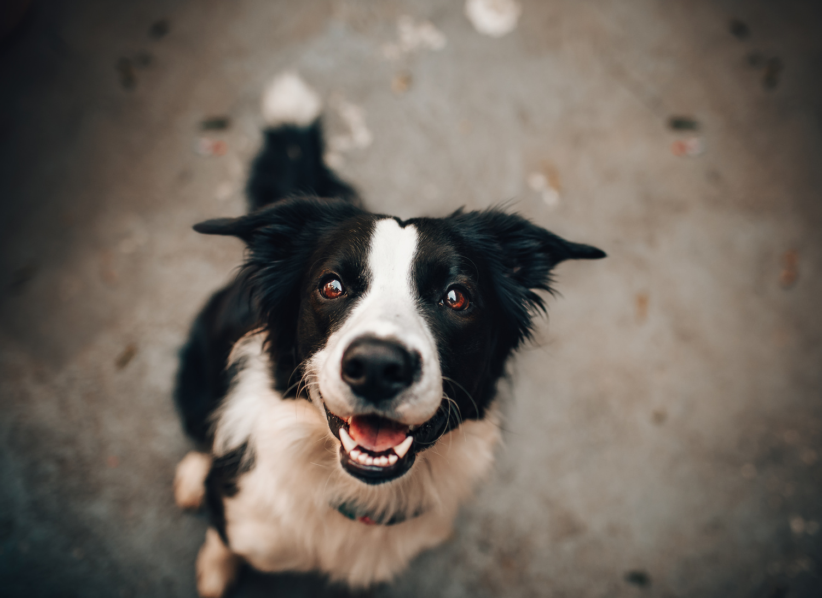

**IF YOU HAVE ANY INFORMATION**

**PLEASE CALL - AUTHUR**

**+123-456-7890**

**LAST SEEN AT**

**Whispering Willow Park**

**MISSING DOG**

REWARD

**$500**

**TOMMY**