 |  | 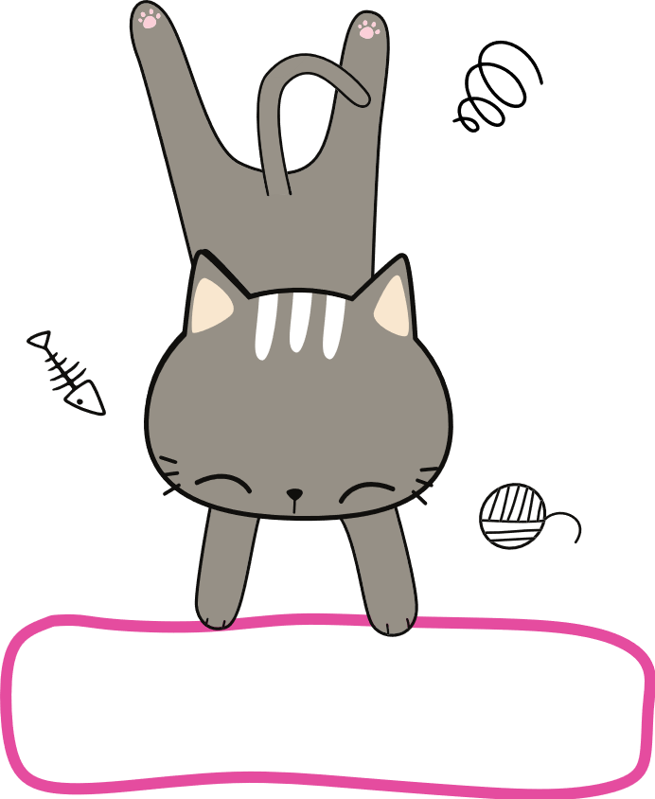  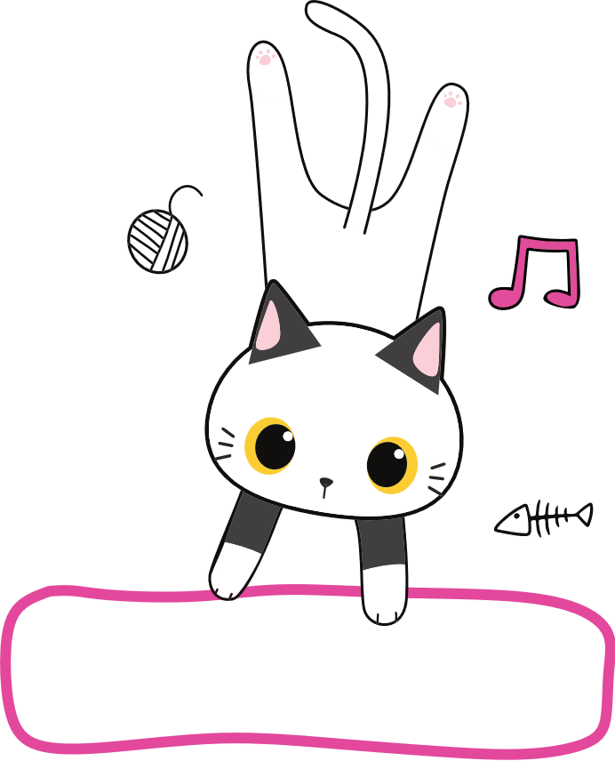  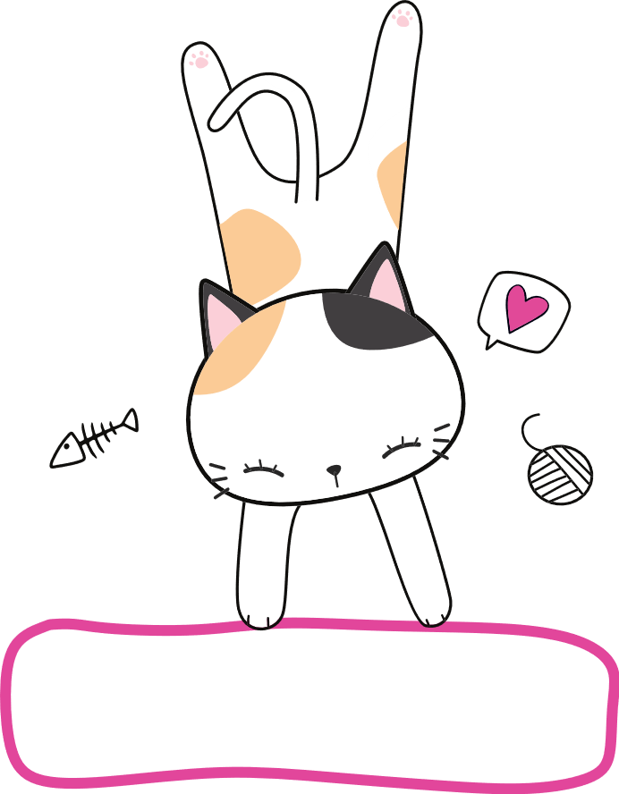  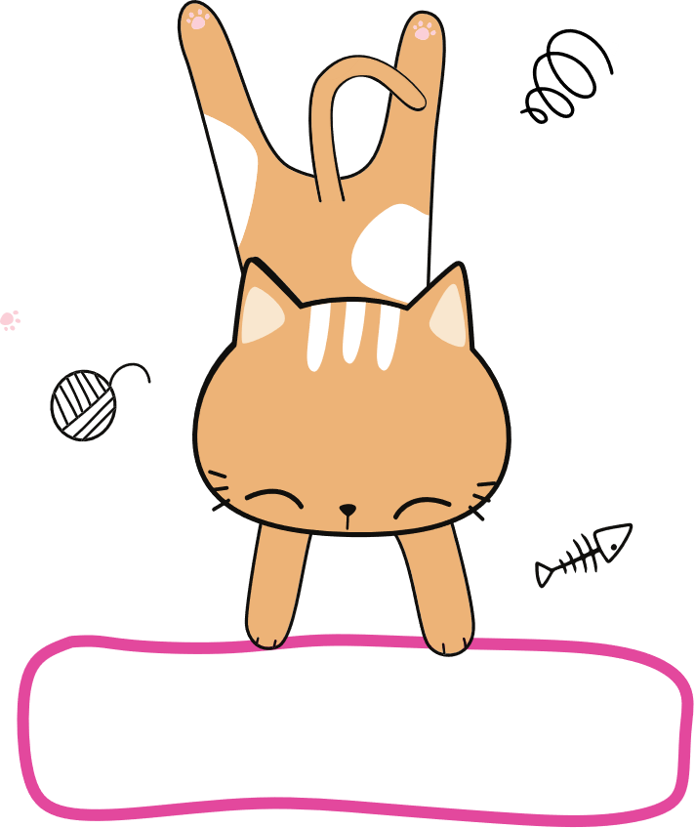  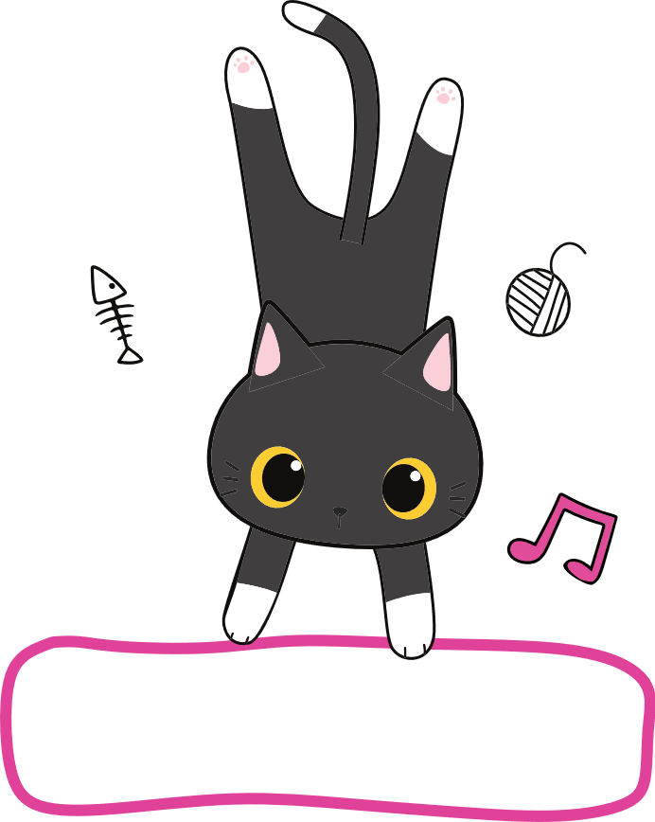 |  |  |  |  |  | 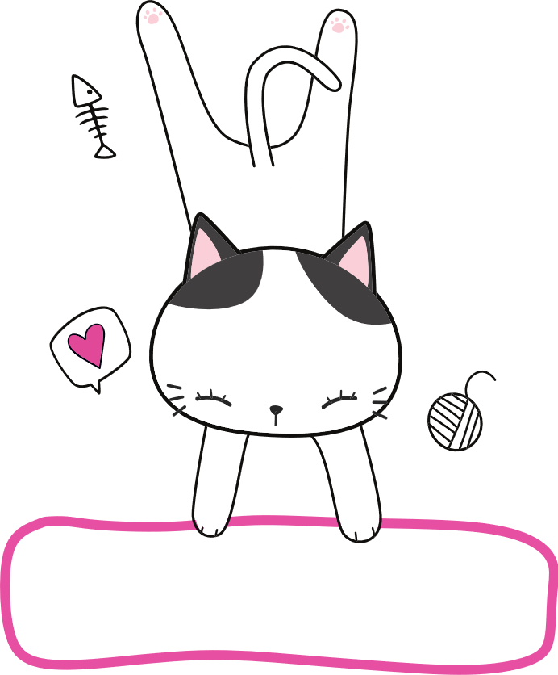  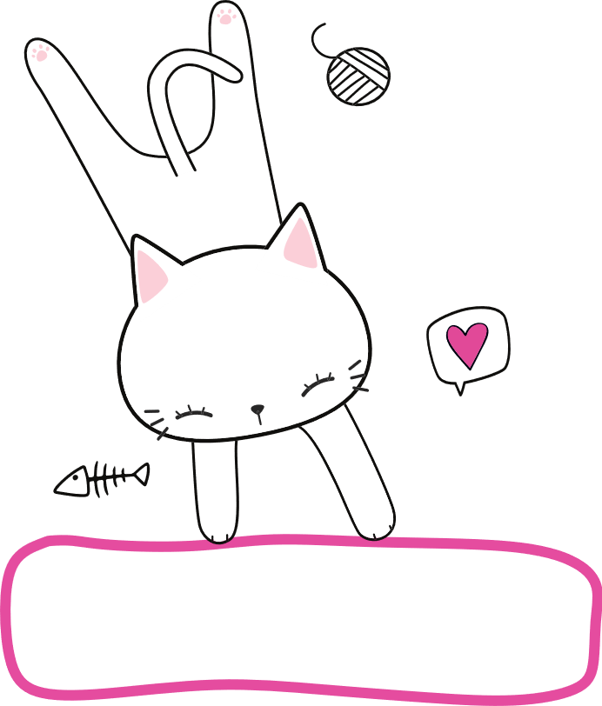
 |  | MONDAY | TUESDAY | WEDNESDAY | THURSDAY | FRIDAY | SATURDAY | SUNDAY
 | 06:00
 | 07:00 | Get up
 | 08:00 | Breakfast
 | 09:00 | Clean up
 | 10:00 | Math
 | 11:00 | Grammar/Spelling
 | 12:00 | Writing
 | 13:00 | Lunch
 | 14:00 | History (online)
 | 15:00 | Piano lessons
 | 16:00 | Outdoor activities
 | 17:00 | Homework
 | 18:00 | Cartoons
 | 19:00 | Dinner
 | 20:00 | Bath |  |  |  |  |  |  | © TemplateLab.com
 | 21:00 | Go to bed
 | 22:00
 | 23:00

