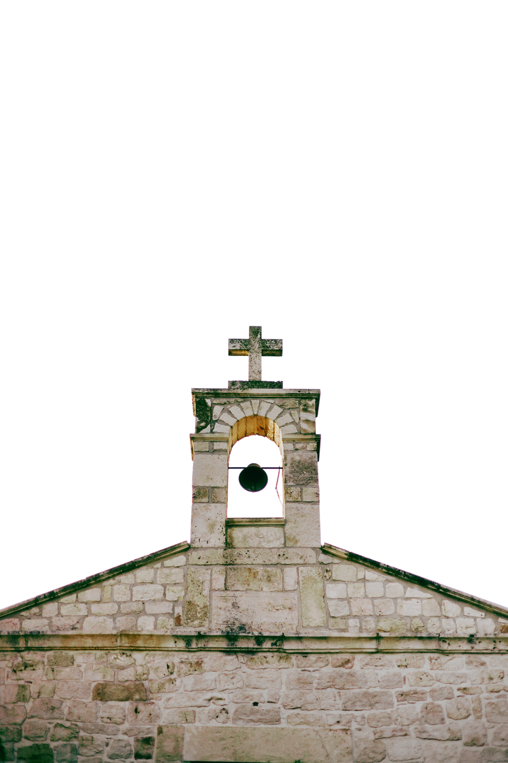

Finding Peace in the Storm

FIRST PRESBYTERIAN CHURCH

1234 Grace Lane, Presbyterian Town

+123-456-7890

www.templatelab.com

Connect with Us

- Psalm 27:1

The LORD is my light and my salvation; whom shall I fear? The LORD is

the stronghold of my life;

of whom shall I be afraid?

First Presbyterian Church is a community of believers united by our faith in Jesus Christ. We welcome all who seek to grow in grace, love one another as Christ loved us, and serve in our world as bearers of the Good News.

About First

Presbyterian Church

Thursdays, 7 PM in the Fellowship Hall.

BIBLE STUDY

Wednesdays, 6:30 PM in the Youth Room.

YOUTH GROUP

This Week at

First Presbyterian

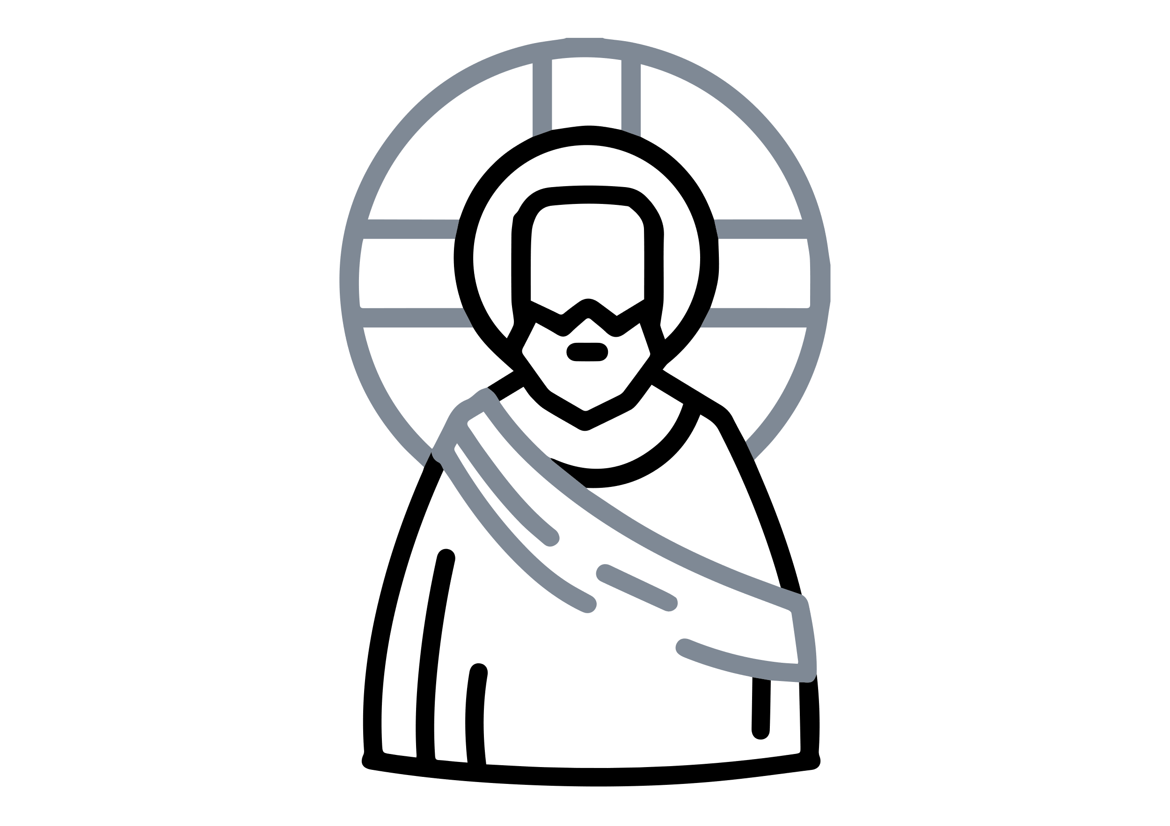

Share a sign of Christ's peace

with those near you

Passing of the Peace

Pastor John Doe

Assurance of Pardon

Led by the congregation

Prayer of Confession

Led by Elder Jane Smith

Call to Worship

Pastor John Doe

Welcome and Announcements

Selection by our Organist

Prelude

ORDER OF WORSHIP