Sunday workshop program

**Revolution**

**City Church**

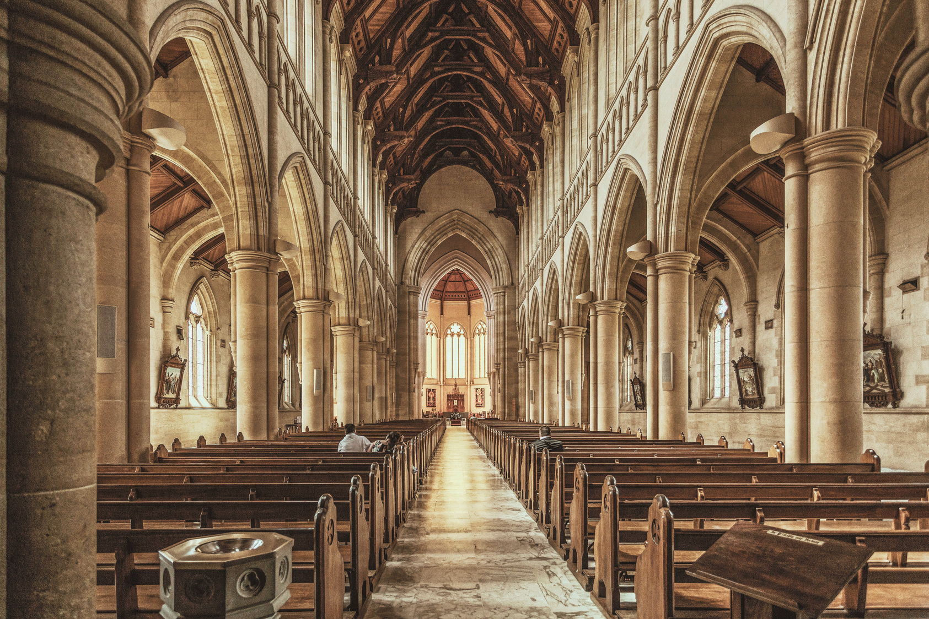

**123 Anywhere St., Any City, ST 12345**

**hello@templatelab.com**

**templatelab.com**

**123-456-7890**

**123-456-7890**

**Contact Us**

**Revolution City Church**

**- Martin Luther King Jr.**

*Darkness cannot drive out darkness; only light can do that. Hate cannot drive out hate; only love can do that.*



"Build Your Kingdom Here"

**Closing Song**

"Radiate Love Living Out Divine Love

in Everyday Life", by Pastor Jane Doe

**Message**

1 John 4:7-12, by Elder Tom Smith

**Scripture Reading**

Led by Pastor Jane Doe

**Community Prayer**

"This is Amazing Grace"

**Opening Song**

**ORDER OF SERVICE**

Can't make it in person? No worries. Join our live-streamed services every Sunday on our website or catch up later on our YouTube channel. Wherever you are, we're there for you.

**ONLINE**

**SERVICES**

New to Revolution City Church?   
We're glad you're here! Join us for our newcomers' meetup every Sunday after the service. You'll get a chance to meet our pastor and learn more about our community. Let's connect and make   
you feel at home.

**NEWCOMERS**

Welcome to Revolution City Church.   
We are a vibrant, inclusive community committed to living out Jesus' revolutionary message of love. Our vision is to create   
a space where love is the default, where acceptance is unconditional, and where everyone feels at home.

**WELCOME & VISION STATEMENT**