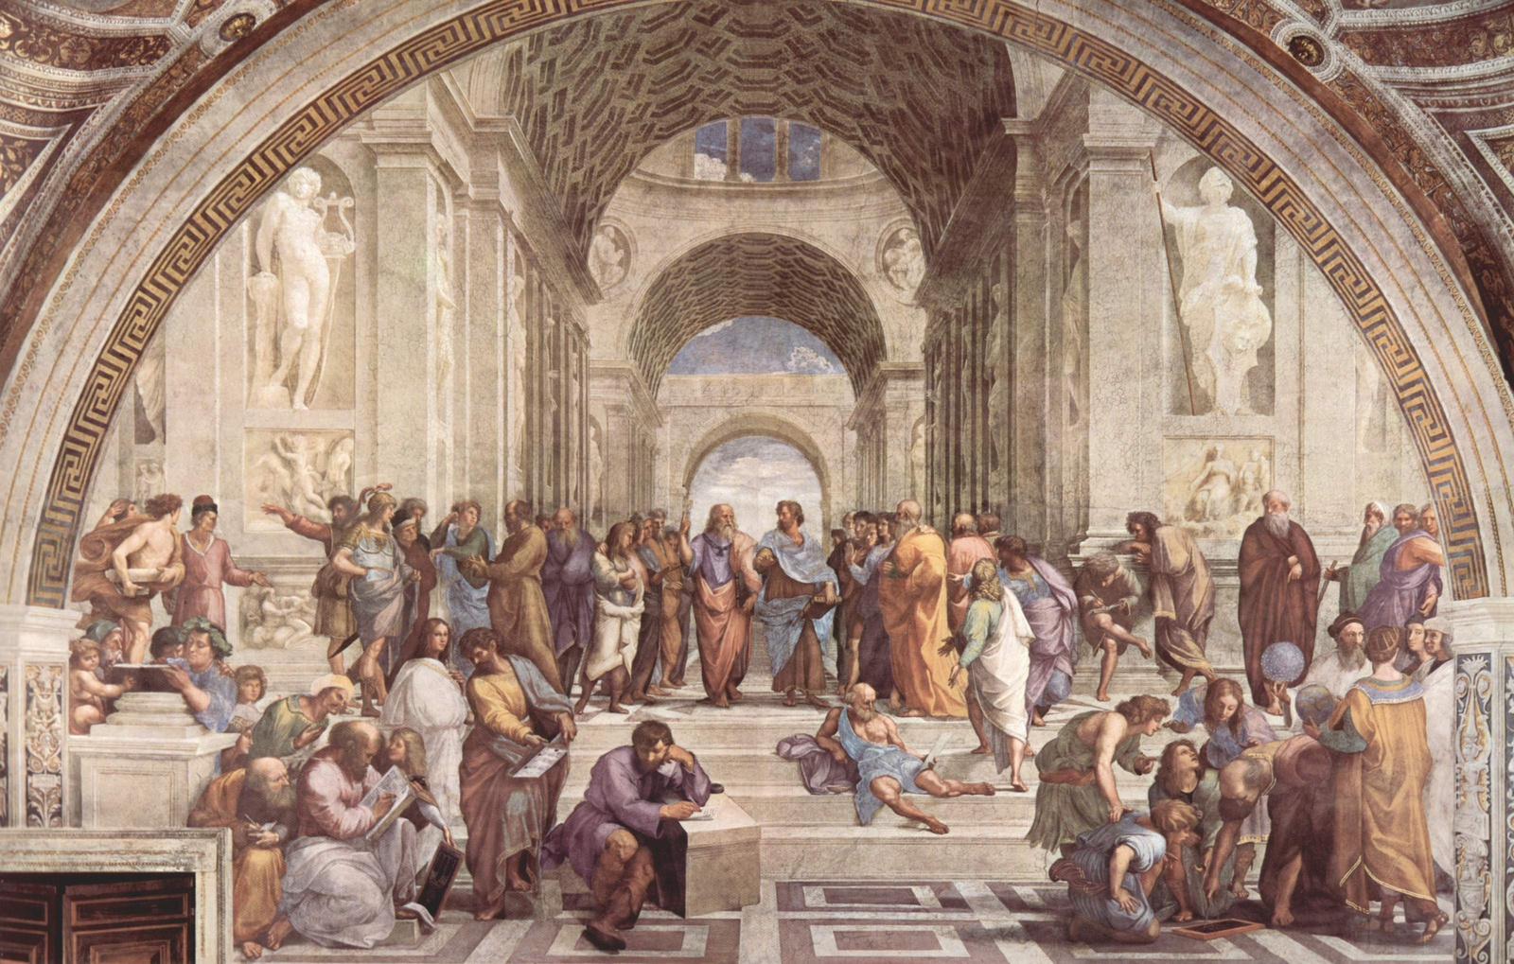

ROOTED IN TRADITION, GROWING IN FAITH

The Eleventh Sunday

after Pentecost

**ST. AUGUSTINE’S EPISCOPAL CHURCH**



Join our outreach programs!

Details on our website.

**VOLUNTEER OPPORTUNITIES**

Website: www.staugustines-episcopal.org

Phone: (123) 456-7891

Social Channels:

Facebook: @StAugustinesEpi

Twitter: @StAugustinesEC

**CONNECT & SERVE**

**Last Tuesday 7 PM**

**MONTHLY HEALING SERVICE**

**Thursdays at 7 PM**

**CHOIR**

**REHEARSAL**

**Fridays at 6:30 PM**

**YOUTH**

**GROUP**

**Mon-Fri, 8 AM**

**MORNING PRAYER**



**WEEKLY GATHERINGS**

"Now Thank We All Our God"

**Post-Communion Hymn**

**Communion**

All baptized Christians are invited

Fraction Anthem sung

**The Breaking of the Bread**

Sung by the choir

**Sanctus & Benedictus**

Hymn "Bread of the World"

**Presentation & Preparation of Gifts**

**THE CELEBRATION OF**

**THE EUCHARIST**

"Living the Baptized Life" by Father Lawrence White

**Reflection**

Luke 12:32-40, proclaimed by Deacon Peter Collins

**Gospel Reading**

Sung by the congregation

**Alleluia & Verse**

Ephesians 4:17-32, read by Mr. Harold Davis

**Second Scripture**

Psalm 98, sung responsively

**Response**

Jeremiah 7:1-11, read by Miss Olivia Turner

**First Scripture**

**WORD OF GOD**

Read by Father Lawrence White

**The Collect of the Day**

Recited together

**Collect for Purity**

Sung by the choir and congregation

**Gloria**

Led by Deacon Peter Collins

**Confession of Sin**

Celebrant: "Blessed be the one, holy, and living God."

**Opening Acclamation**

"Fugue in G Minor" by J.S. Bach

**Prelude**

**BEGINNING THE WORSHIP**

