"WELCOMING ALL TO THE HOUSE OF OUR LORD"

**August 13, 2023**

First Baptist Church

of Hometown

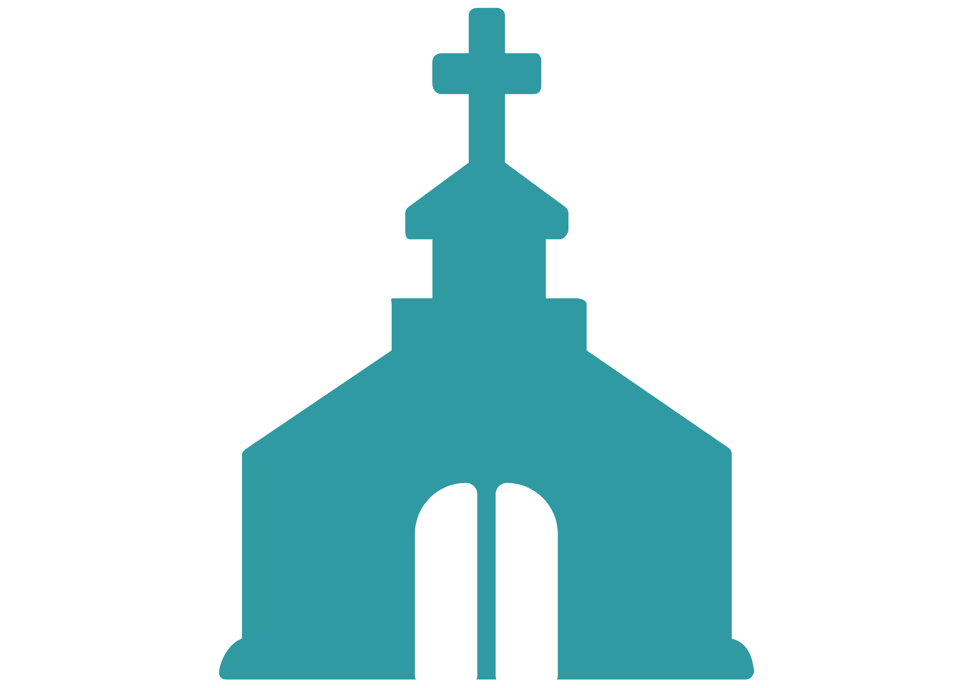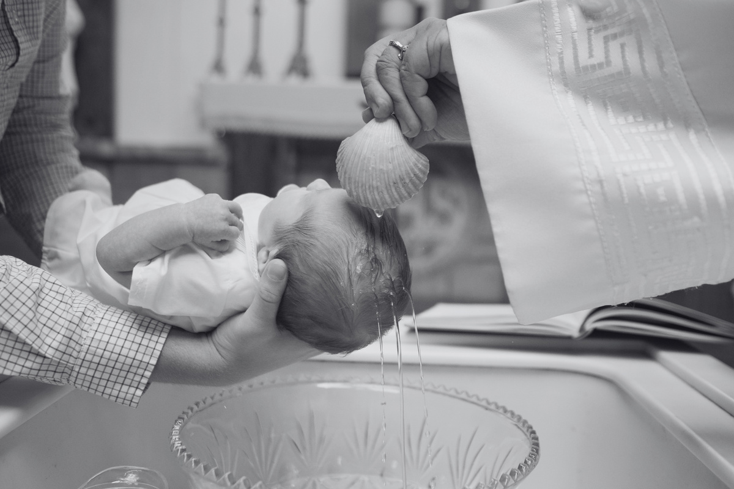

Address: 456 Baptist St, Hometown, USA

Phone: (123) 789-0123

Email: info@firstbaptisthometown.org

Website: www.firstbaptisthometown.org

Stay Connected



To disciple believers, evangelize the lost, and show   
Christ's love through acts of service and compassion.

Our Mission

To be a beacon of hope in our community, drawing people closer to God through our words, actions,   
and service.

Our Vision

Established in 1923, First Baptist Church of Hometown has faithfully served our community, spreading the Gospel's good news and extending a hand of fellowship and service to all.

About First Baptist Church of Hometown

Church Picnic

Don't forget our annual Church Picnic on August 27th

at Hometown Park. All are welcome!

Our next Baptism Class is on August 20th, 6 PM.

Contact Deacon Paul to sign up.

Baptism Class

Registration is open for Sunday School! Ages 4-12,

starts next month.

Sunday School

Join us every Wednesday at 6 PM for our community

prayer meeting.

Prayer Meeting

Upcoming Events

***- Proverbs 3:5-6***

***"Trust in the Lord with all your heart and lean not on your own understanding; in all your ways submit to him, and he will make your paths straight."***

Pastor John Doe

*Benediction*

"Come Thou Fount" - Hymnal #98

*Hymn of Response*

"Embracing God's Love" by Pastor John Doe

*Sermon*

"Blessed Assurance" - Hymnal #45

*Hymn of Praise*

John 3:16-21, read by Brother James Black

*Scripture Reading*

Deacon Mary White

*Prayer of Invocation*

Pastor John Doe

*Welcome & Greeting*

"O Worship the King" - Hymnal #21

*Opening Hymn*

Order of Service