 |  | PERSONAL ACTION PLAN
 |  | Name: |  |  |  | Date:
 |  | John Doe |  |  |  | 10/08/2023
 |  | ENTER EXERCISE PROGRAM
 |  |  |  | Positive Outcome |  |  | Resources
 |  |  | Being physically active can improve your brain health, help manage weight, reduce the risk of disease, strengthen bones and muscles, and improve your ability to do everyday activities. Adults who sit less and do any amount of moderate-to-vigorous physical activity gain some health benefits. |  |  | 1,5 hours (including travel time) x 3 times each week  New snickers  Membership fee 250 USD
 |  |  | 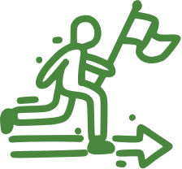 | Detailed explanation of actions |  | 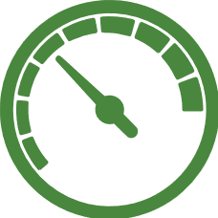 | Measurement
 |  |  | * Establish my current fitness level and abilities.  * Design an exercise program with my fitness trainer.  * Assemble additional equipment.  * Start slowly and build up.  * Be flexible and listen to your body.  * Maintain and track progress. |  |  | BMI each Friday.
 |  |  |  |  |  |  | Challenges
Not keeping a proper sleep schedule.
Exercise too much.
Stress.
 |  |  |  | Relevance |  | 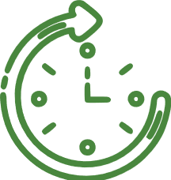 | Time frame
 |  |  | Maintaining a good level of physical fitness gives betters health through increased energy and vitality, making you feel better about yourself and about your life. |  |  | 5 months, starting September 1st, 2023.
 |  |  |  |  |  |  | © TemplateLab.com

