 | EMERGENCY
 | ACTION PLAN
 | 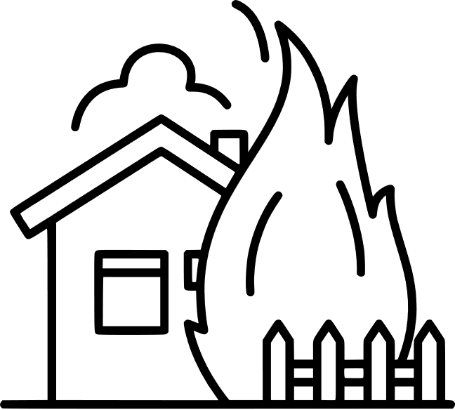
 |  | Turn off lights and appliances.  Activate the closest fire alarm system.  Close all windows and seal the room.  Safeguard the children. |  |  | Crawl beneath smoke to escape a home fire. If you have enough time, take your pet with you, but never endanger yourself.
 | FIRE | Use nearest available exit route. If you live in apartment building with elevators, use the stairs “Don’t Use Lifts”. Leave all your things where they are and save yourself. |  |  | If you can access fire extinguisher operate the same if you are trained else remember to GET OUT, STAY OUT and CALL Fire Brigade on 101.
 |  | Listen to area radio and television stations and Weather radio for possible flood warnings and reports of flooding in progress. |  |  | Be prepared to evacuate at a moment’s notice. When a flood or flash flood warning is issued for your area, head for higher ground and stay there.
 | FLOOD | Turn around – don’t drown! Avoid walking and driving through flooded waters. They could be deeper than you think. |  |  | Keep children and pets away from flood water. Be especially cautious at night when it is harder to recognize flood danger.
 | 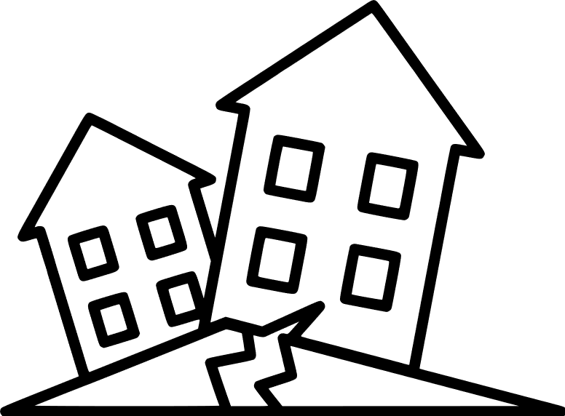
 |  | Wherever you are, drop down to your hands and knees and hold onto something sturdy. If you’re using a wheelchair or walker with a seat, make sure your wheels are locked and remain seated. |  |  | Cover your head and neck with your arms. If a sturdy table or desk is nearby, crawl underneath it for shelter. If no shelter is nearby, crawl next to an interior wall (away from windows).
 | EARTHQUAKE | Wherever you are, drop down to your hands and knees and hold onto something sturdy. If you’re using a wheelchair or walker with a seat, make sure your wheels are locked and remain seated. |  |  | Cover your head and neck with your arms. If a sturdy table or desk is nearby, crawl underneath it for shelter. If no shelter is nearby, crawl next to an interior wall (away from windows).
 | 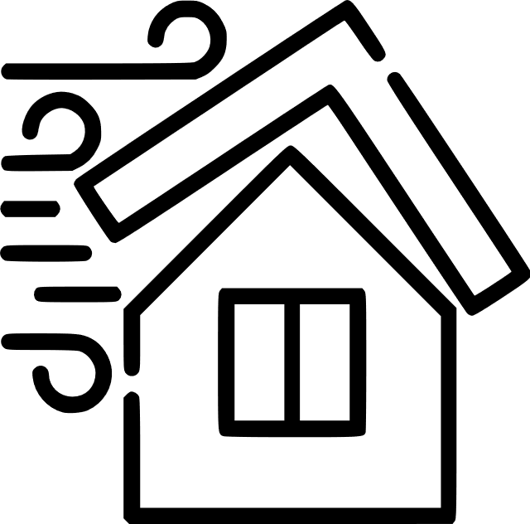
 |  | It is important to create a kit of supplies that you could take with you if you are forced to evacuate. This kit will also be useful if you are able to stay in your home, but are still affected by the storm. |  |  | Know how to secure your home in the event of damaging winds. Cover all of your windows, either with hurricane shutters or wood. Reinforce your garage doors.
 | HURRICANE | Know the cycle of a cyclone - Approach, Arrival & Aftermath. Prepare ahead of time and listen to the directions of officials for the approach. Secure your home, or find a safe shelter for its arrival. |  |  | Bring in all outdoor furniture, garbage cans, decorations, and anything else that is not tied down. Stay away from windows and doors and close, secure and brace internal doors.
 | EMERGENCY  CONTACTS | FIRE DEPARTMENT: 250-642-5422
 |  | BC HYDRO EMERGENCY LINE: 21-888-769-3766
 |  | DEPARTMENT OF HEALTH: 250-000-6658
 |  | POISON CONTROL CENTER: 532-889-8772
 |  |  |  |  |  | © TemplateLab.com

