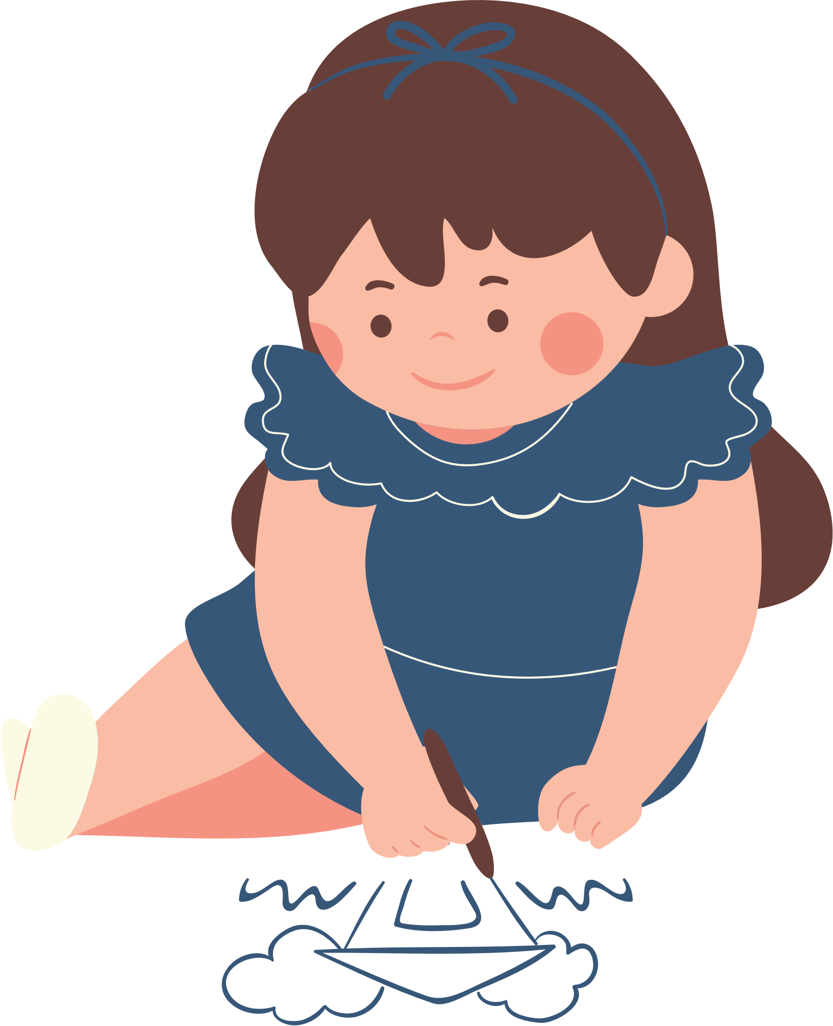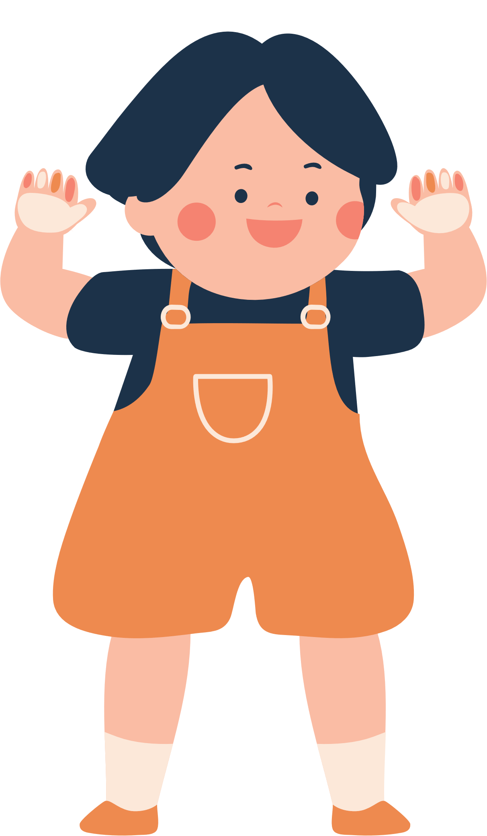

**STORY MAP FOR KIDS**

**Setting**

**Characters**

**Beginning**

**Middle**

**End**