Exposition

The story introduces Sarah and Tom, best friends on Halloween night, who live in a neighborhood with a haunted house. This haunted house is rumored to be inhabited by a friendly ghost.

Sarah and Tom, feeling adventurous, dare each other to enter the haunted house, even though they're both a little scared.

As they step inside, they encounter spooky sounds and sights that increase their fear. Eventually, they meet Casper, the friendly ghost, who asks for their help to find his lost toy. The pair agrees, and they navigate through the house, overcoming their fears and various obstacles along the way.

Rising Action

Climax

Sarah, Tom, and Casper finally find the toy in the attic, facing their biggest fear yet in the dark and creepy space.

Falling Action

Casper thanks Sarah and Tom for their help and friendship. The atmosphere in the haunted house becomes less spooky and more welcoming, as the trio has overcome their fears together.

Resolution

The story concludes with Sarah, Tom, and Casper leaving the haunted house, having faced their fears and formed a new friendship. The tale ends with the lesson that friendship and courage can help overcome challenges and fear, even in a spooky haunted house on Halloween night.

**HALLOWEEN STORY MAP**

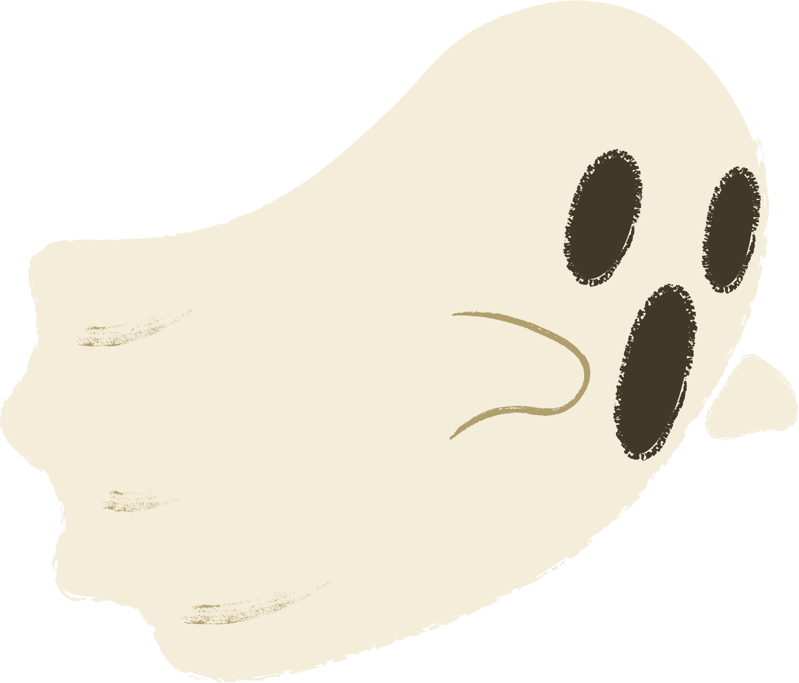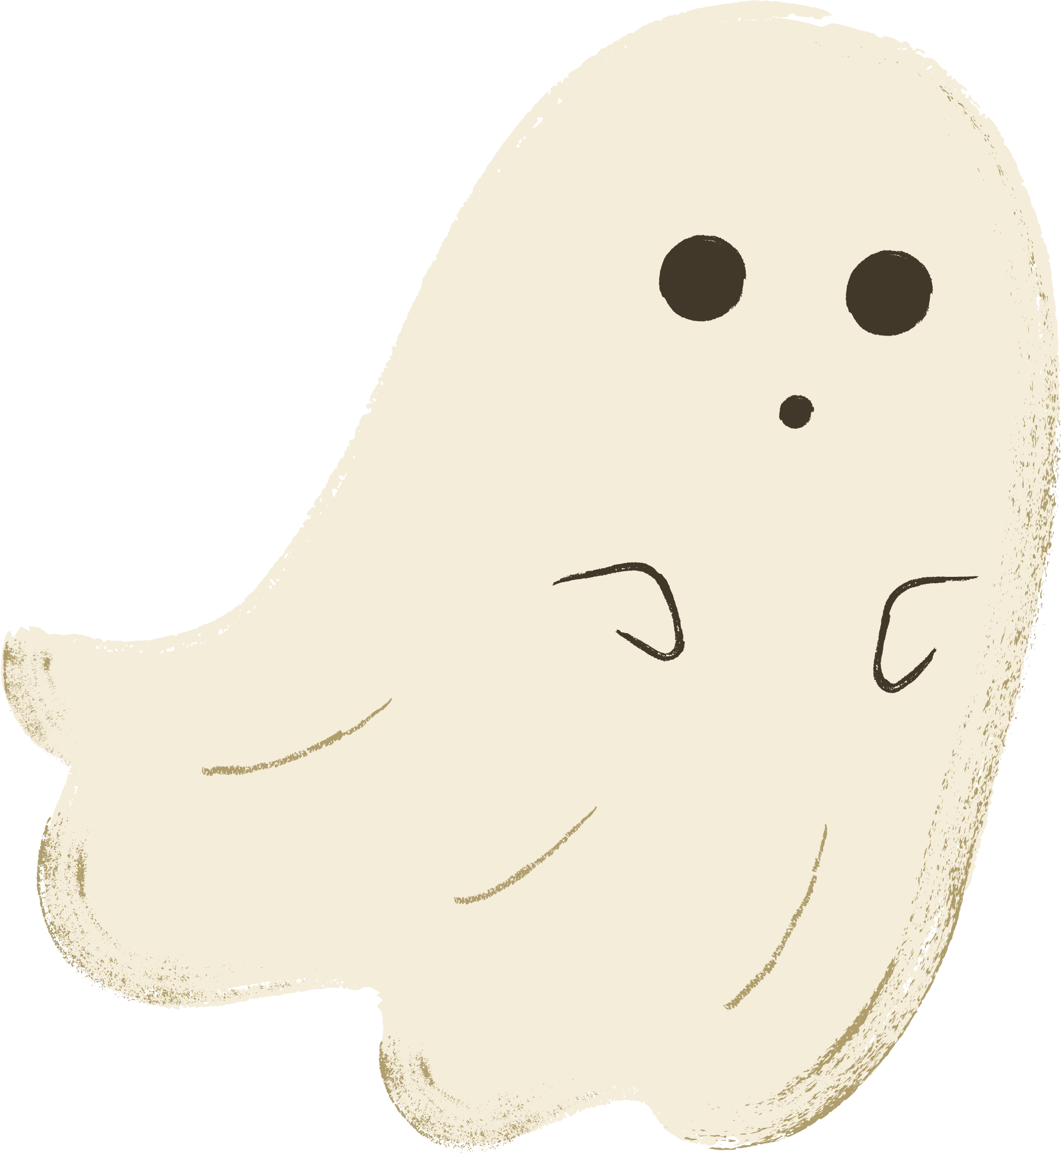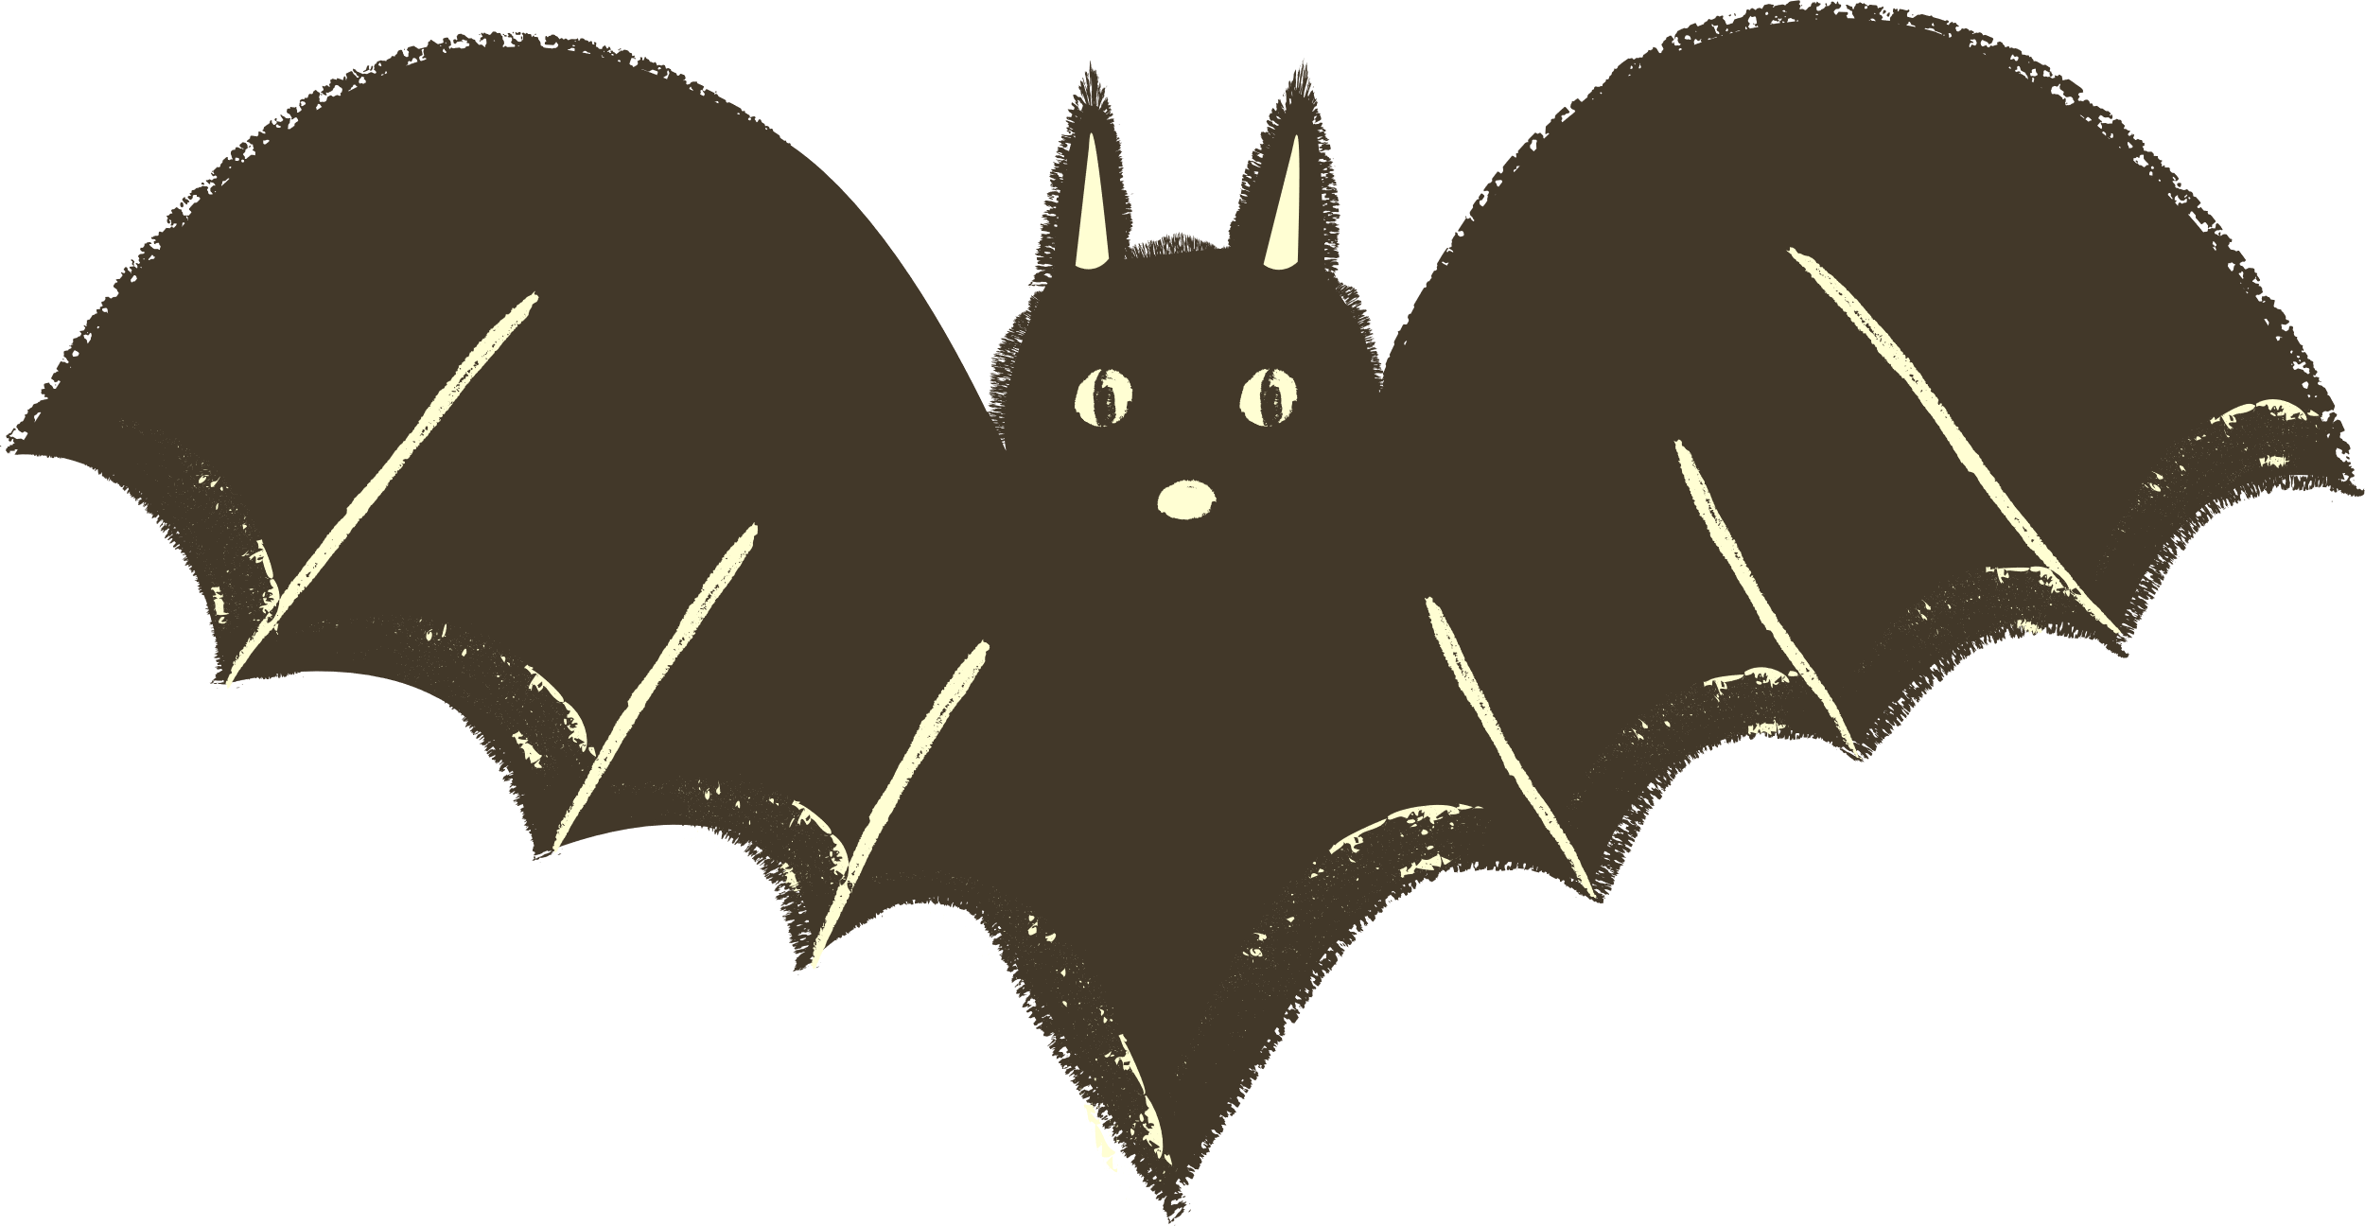

Setting

A haunted house on Halloween night

Characters

**Protagonist:** Sarah, a curious and brave girl

**Friend:** Tom, Sarah's cautious friend

**Ghost**: A friendly ghost named Casper

Title

The Haunted House Adventure

