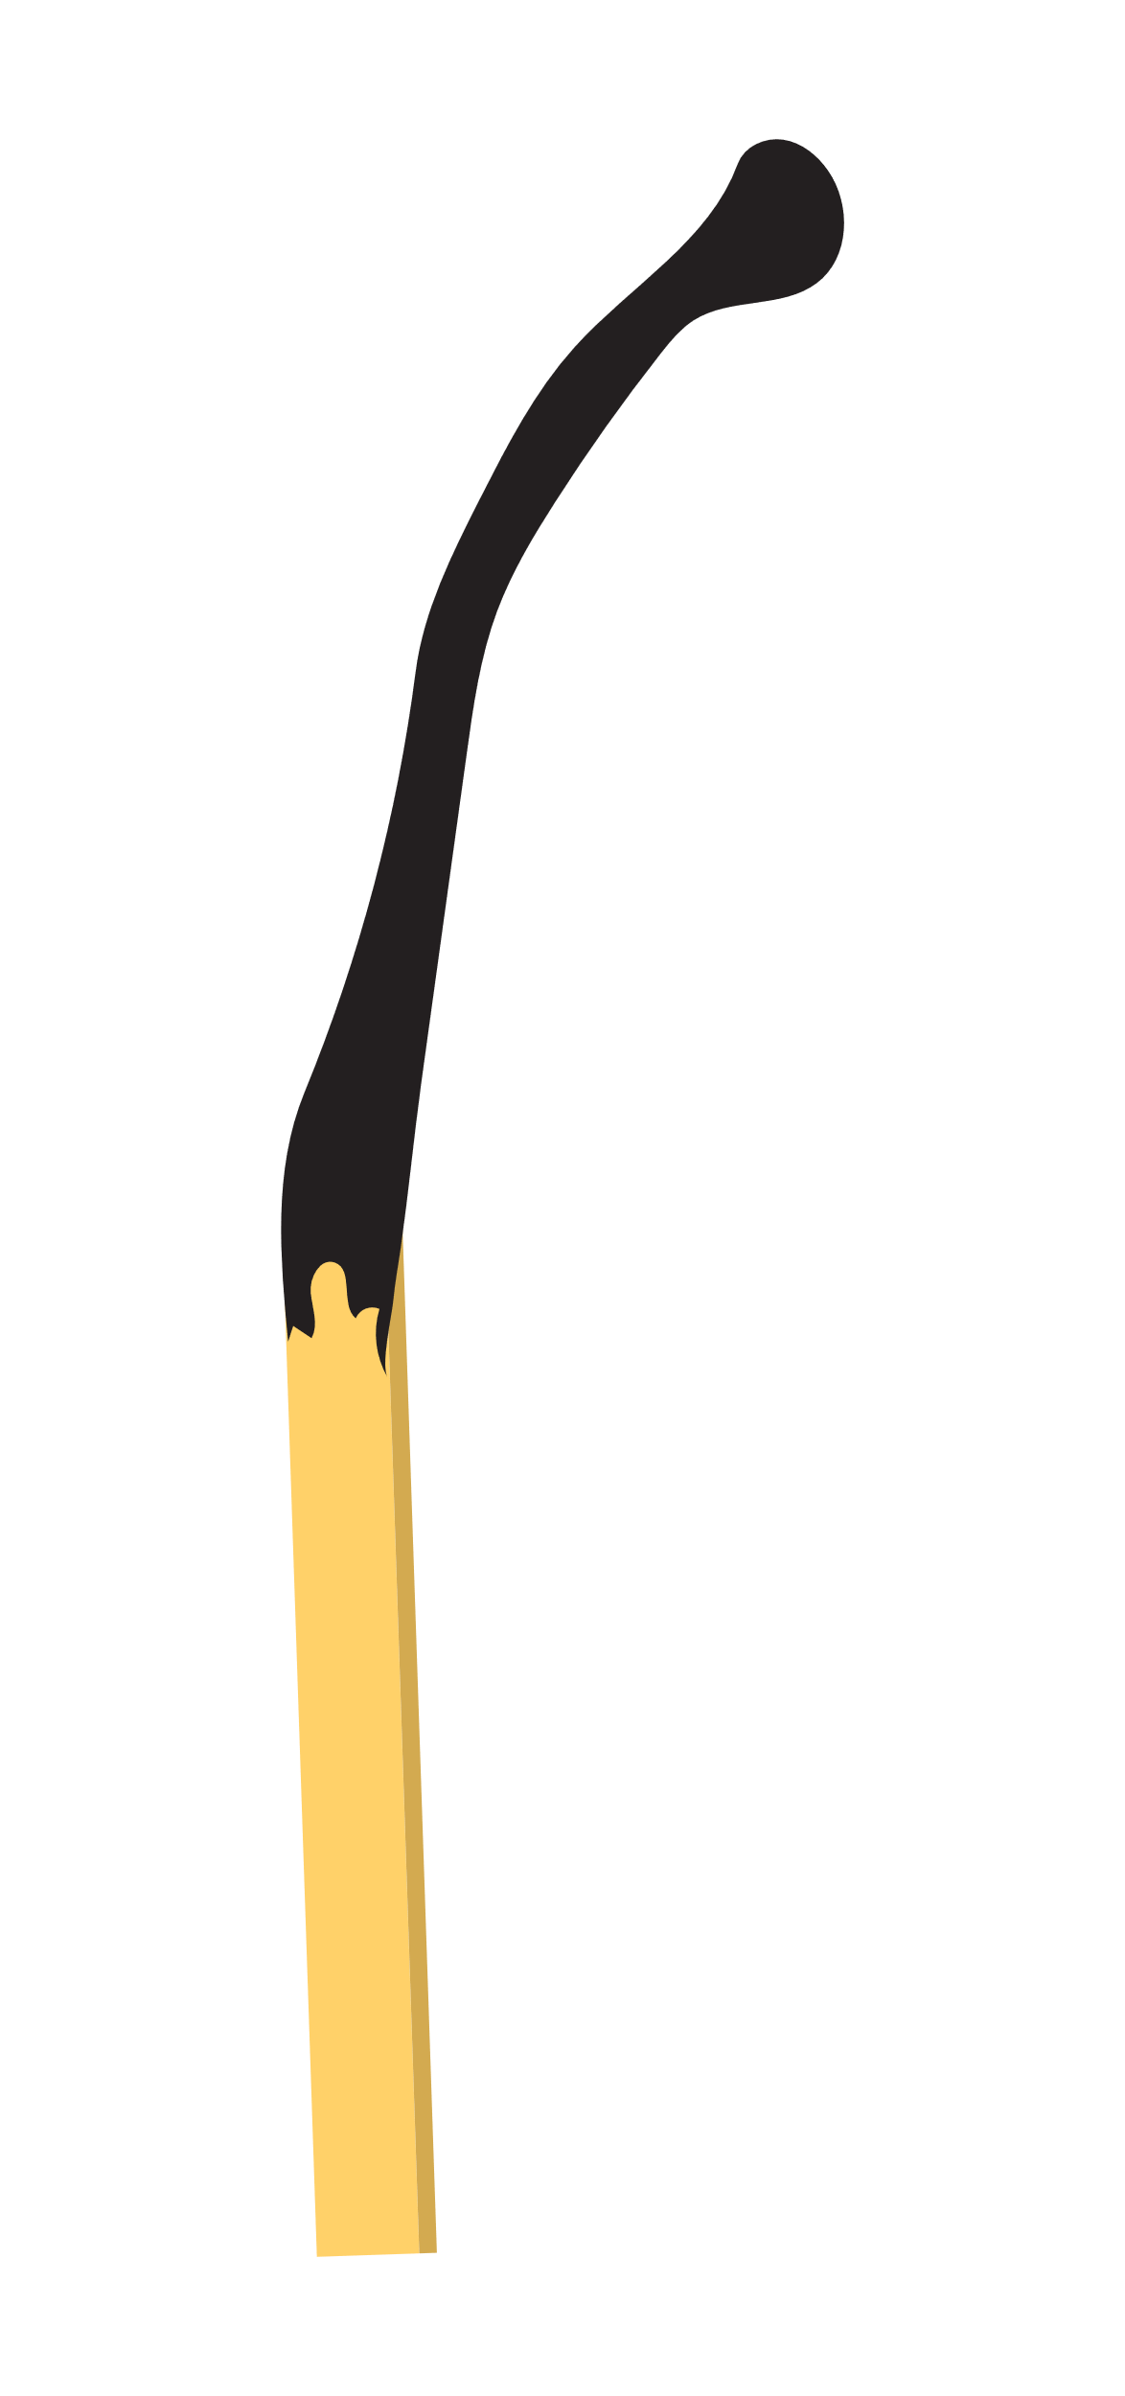

**EXPOSITION**

**RISING ACTION**

**CLIMAX**

**RESOLUTION**

**FALLING ACTION**

**BEGINNING**

**MIDDLE**

**END**

**PLOT MOUNTAIN DIAGRAM**



**EXPOSITION**

Little Red Riding Hood is introduced as a young girl who is asked by her mother to bring food to her grandmother who lives in the woods. The wolf is also introduced as a character who is hungry and looking for food.



**RISING ACTION**

Little Red Riding Hood meets the wolf in the woods and tells him where she is going. The wolf tricks her and goes to the grandmother's house first, where he eats her and dresses up in her clothing. When Little Red Riding Hood arrives, the wolf pretends to be her grandmother and eats her too.



**CLIMAX**

A woodsman hears the commotion and saves Little Red Riding Hood and her grandmother from the wolf's stomach by cutting open the wolf's belly.



**FALLING ACTION**

Little Red Riding Hood and her grandmother recover from the experience, and the woodsman kills the wolf. They vow to be more careful in the future and never trust strangers.



**RESOLUTION**

Little Red Riding Hood and her grandmother live happily ever after, having learned a valuable lesson about the dangers of the woods and the importance of caution.

**"LITTLE RED RIDING HOOD"**

