

Plot mountain DIAGRAM

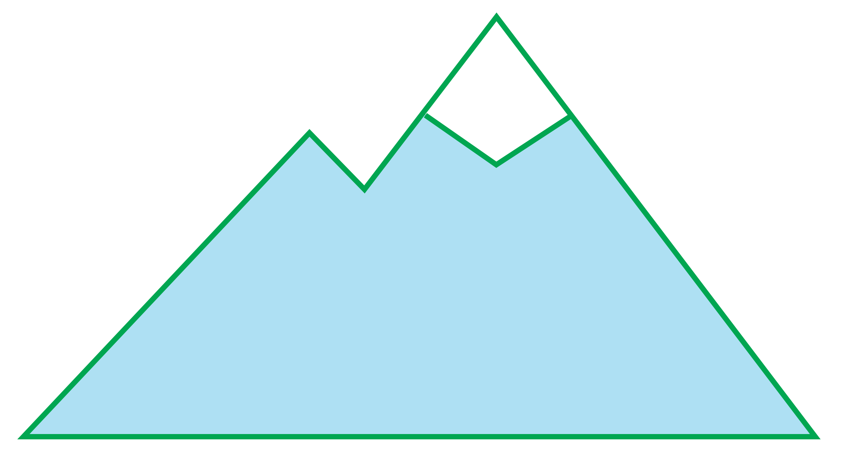

RESOLUTION

FALLING ACTION

CLIMAX

END

MIDDLE

BEGINNING

RISING ACTION

EXPOSITION