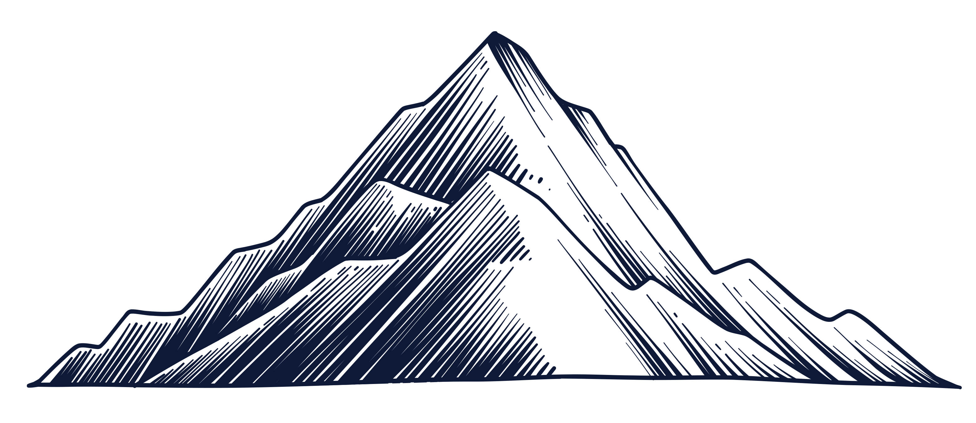

RESOLUTION

FALLING ACTION

PROBLEM

EXPOSITION

BEGINNING

BEGINNING

MIDDLE

END

PLOT

MOUNTAIN

DIAGRAM

