2

3

4

MOVIE PLOT DIAGRAM

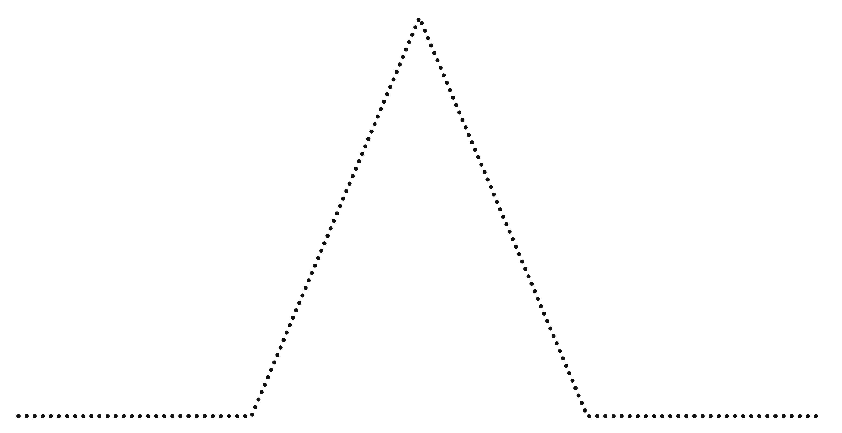

5

1

RESOLUTION

FALLING ACTION

CLIMAX

RISING ACTION

EXPOSITION

