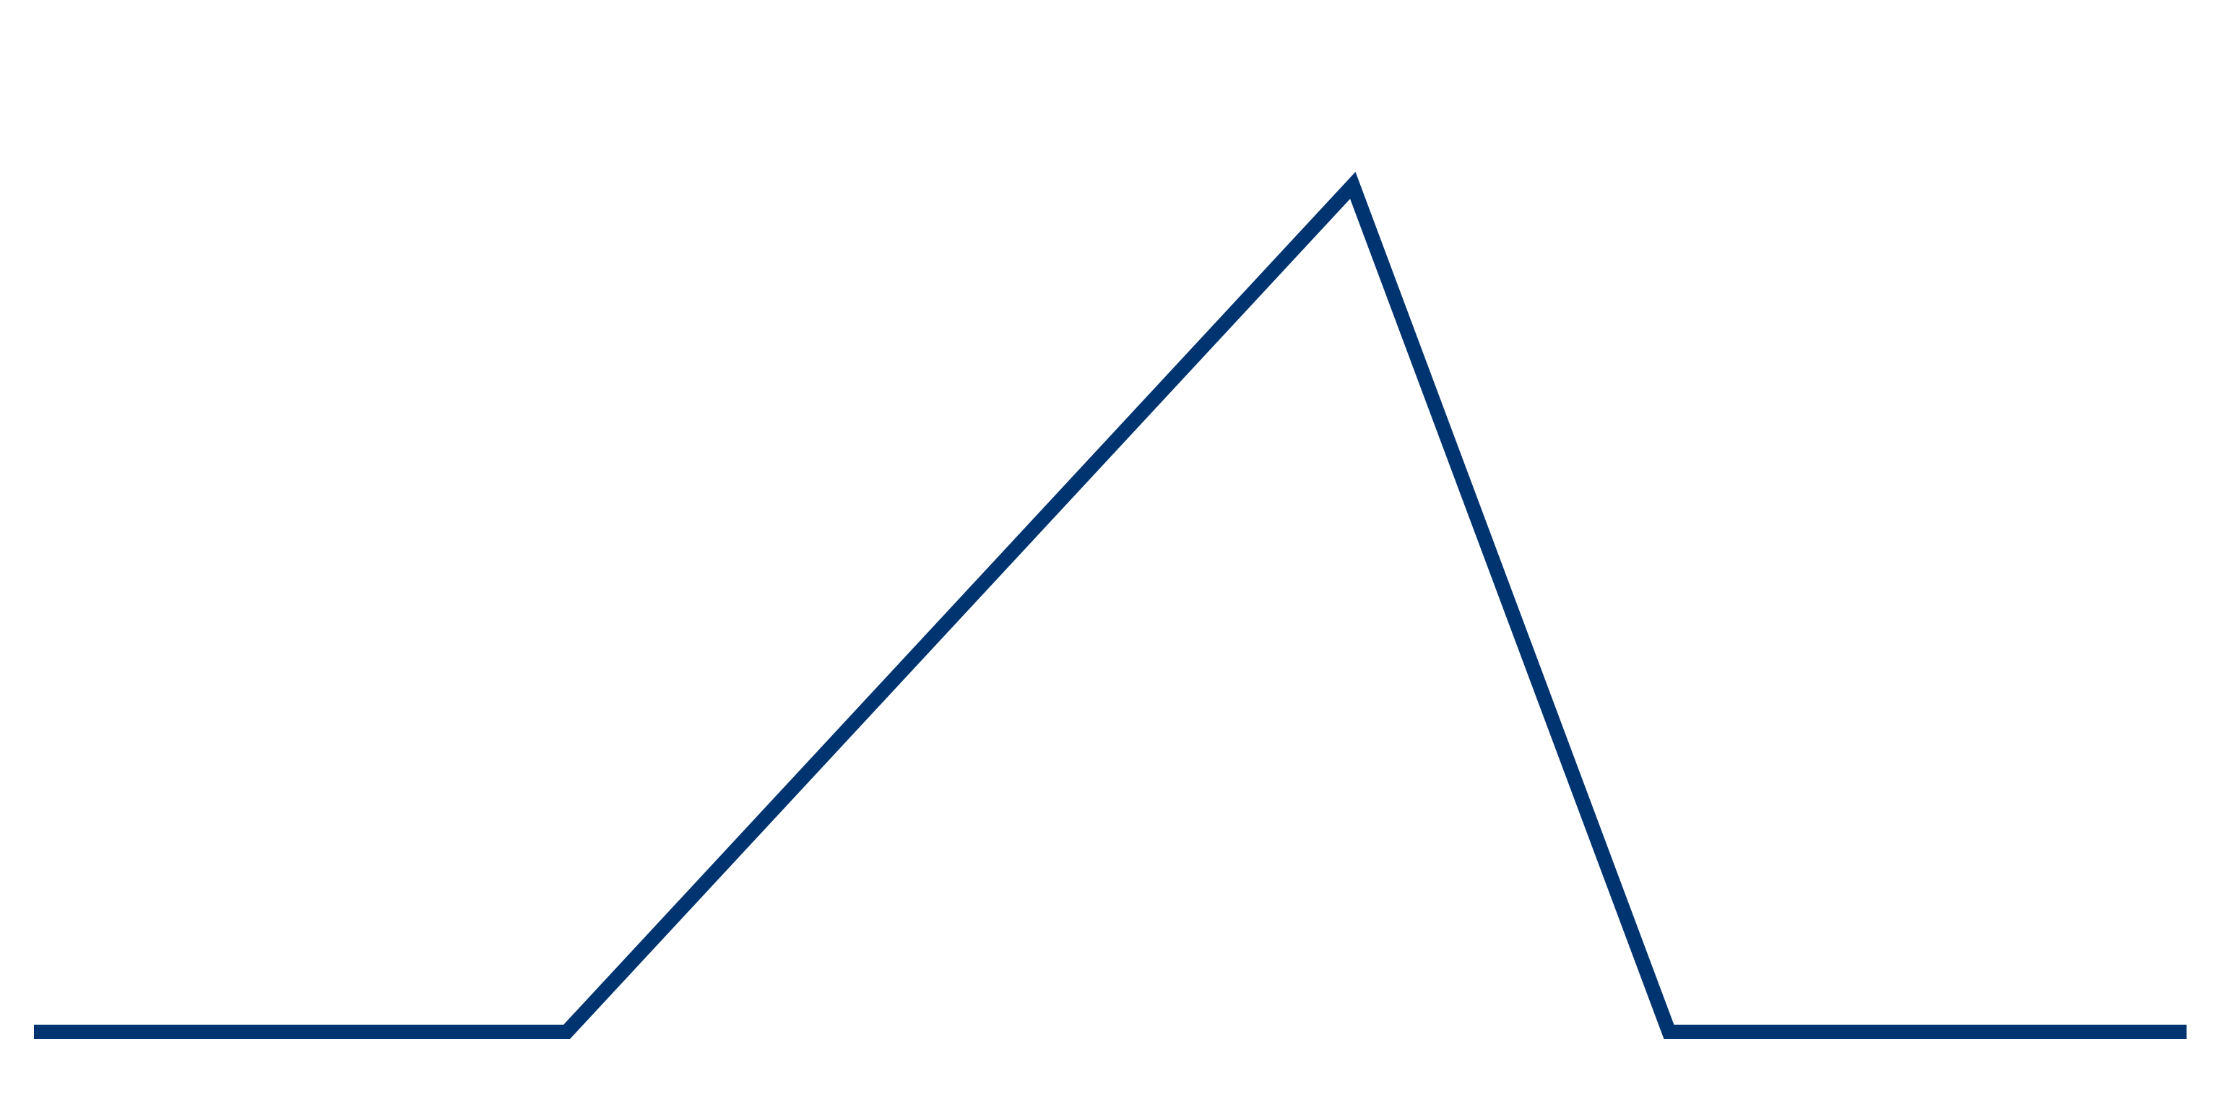

RESOLUTION

FALLING ACTION

RISING ACTION

CONFLICT

END

MIDDLE

BEGINNING

EXPOSITION

MOVIE PLOT DIAGRAM