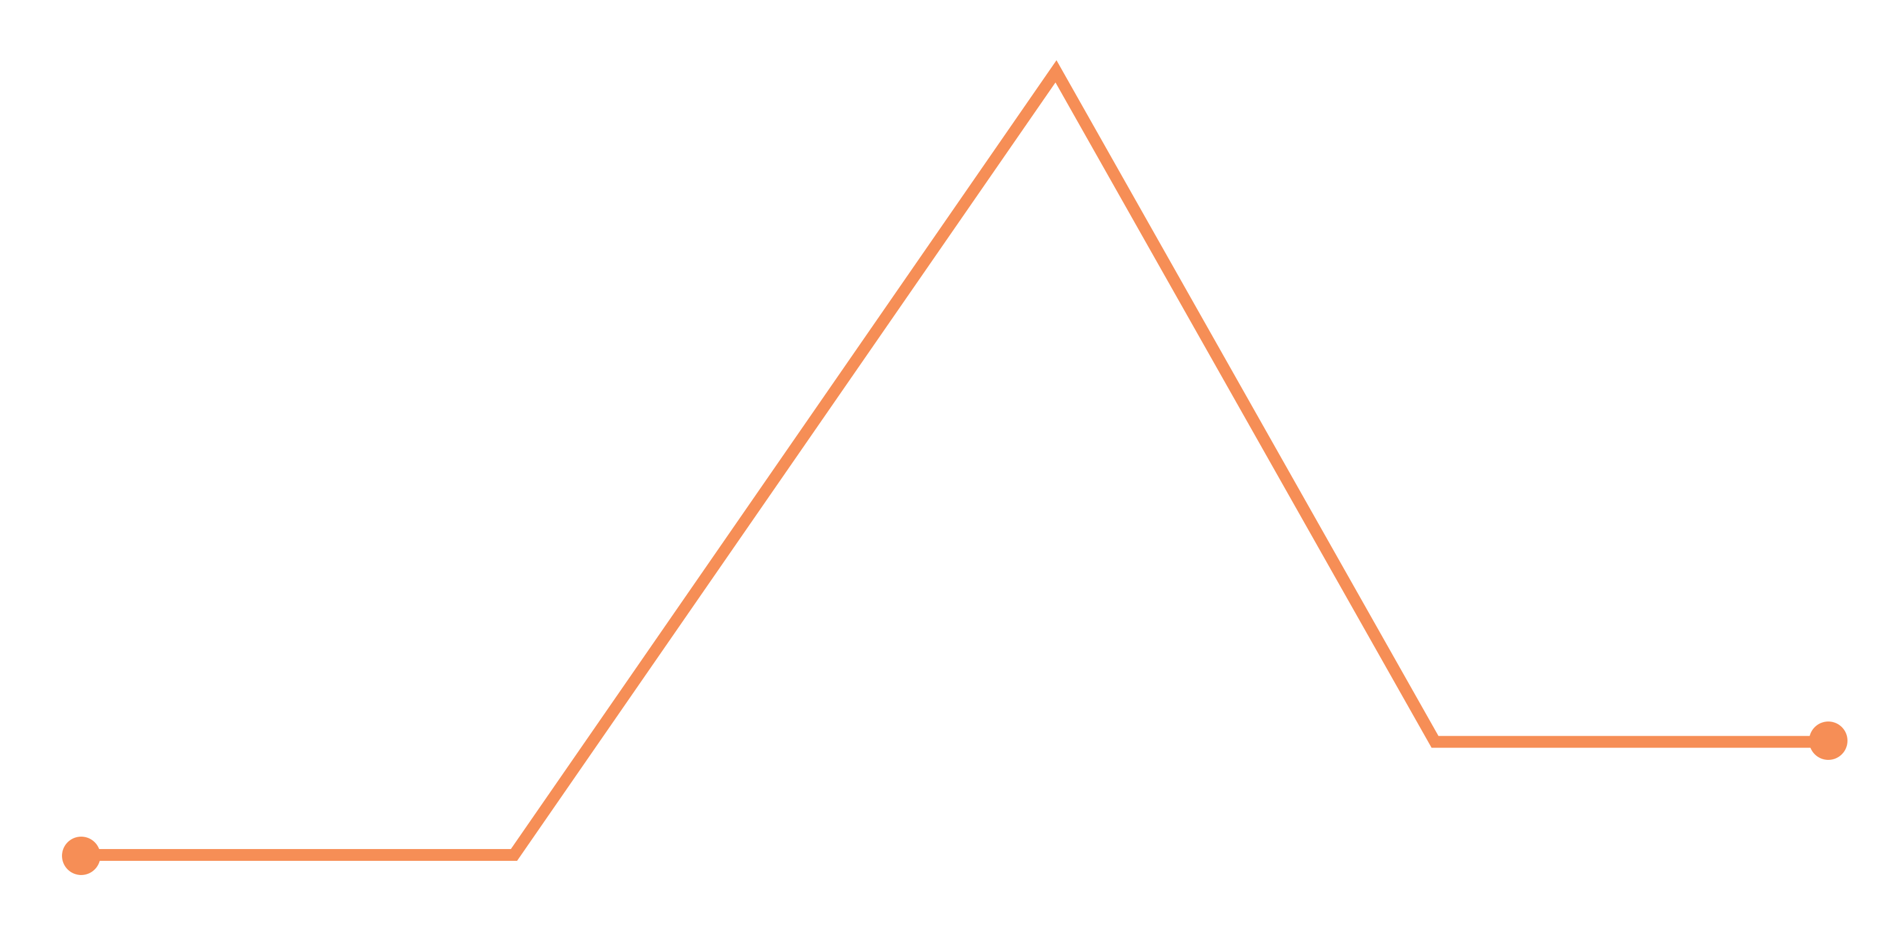

BOOK

PLOT DIAGRAM

RESOLUTION

FALLING ACTION

CLIMAX

RISING ACTION

CONFLICT

EXPOSITION

FALLING ACTION

RESOLUTION

EXPOSITION

CLIMAX

CONFLICT

RISING ACTION

