5

4

3

2

1

Book Plot

Diagram

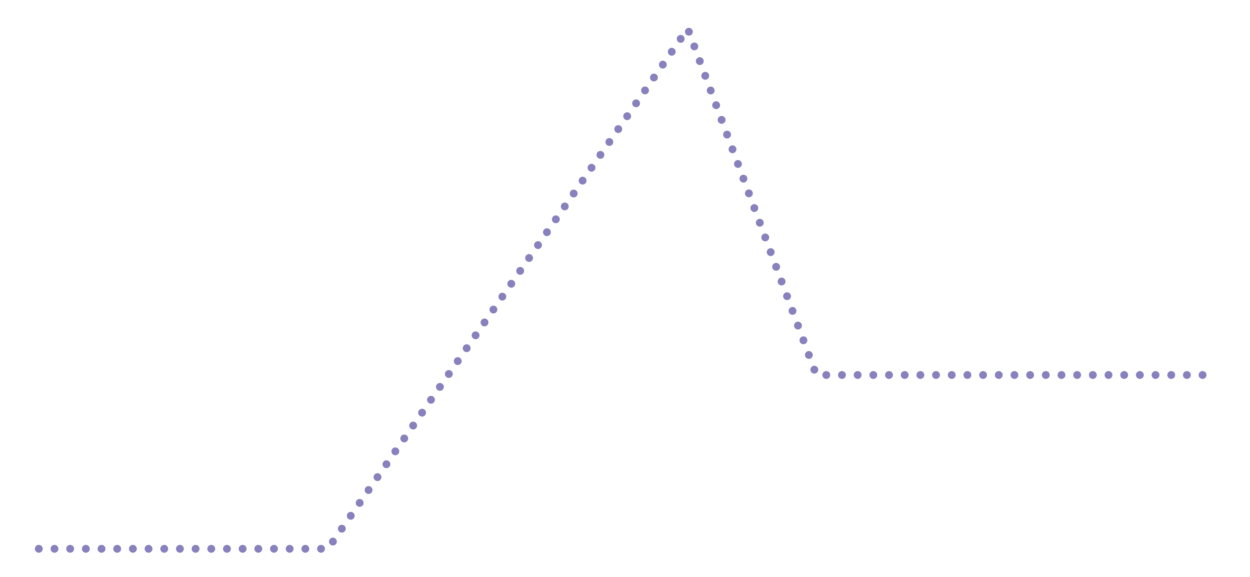

RESOLUTION

FALLING ACTION

CLIMAX

RISING ACTION

EXPOSITION

