 |  |  | 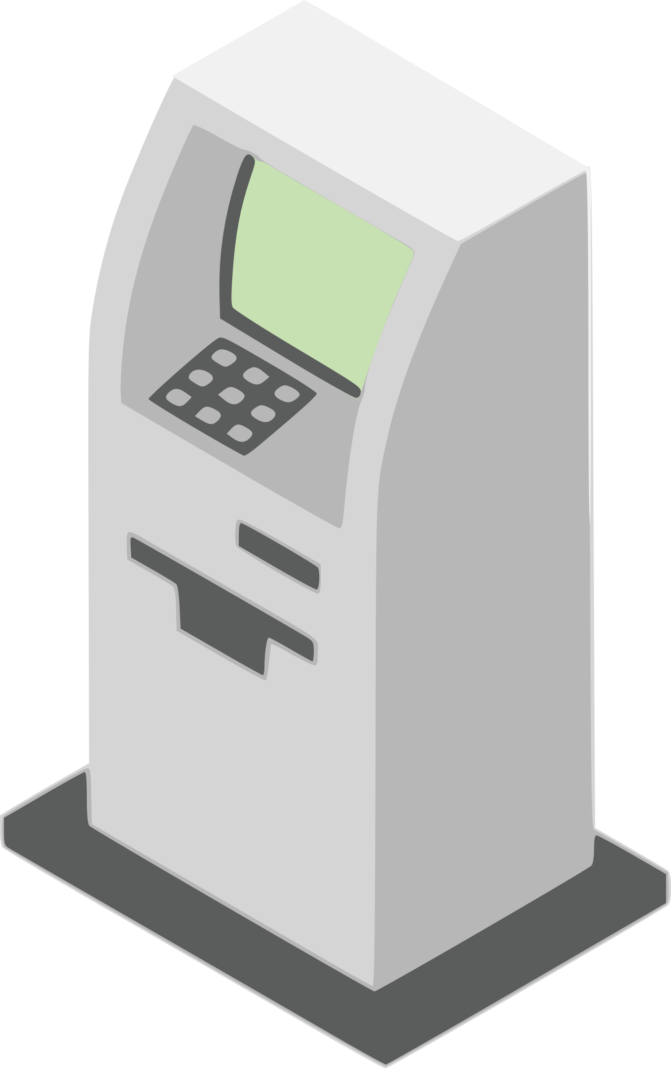
 |  |  | PRODUCT WORK BREAKDOWN STRUCTURE
 |  |  | HARDWARE |  |  |  |  | AUTOMATION |  |  |  |  | SOFTWARE
 |  |  | Conveyors and motors |  |  |  |  | PLC configuration |  |  |  |  | Main screen and buttons
 |  |  | $8,250.00 |  |  |  |  | $2,500.00 |  |  |  |  | $5,000.00
 |  |  | Jul 17 - Aug 22 |  |  |  |  | Aug 10 - Aug 15 |  |  |  |  | Sep 01 - Sep 14
 |  |  | PCBs and mother board |  |  |  |  | Programming |  |  |  |  | SQL database
 |  |  | $11,250.00 |  |  |  |  | $2,900.00 |  |  |  |  | $1,500.00
 |  |  | Jul 23 - Aug 15 |  |  |  |  | Aug 20 - Sep 02 |  |  |  |  | Sep 07 - Sep 15
 |  |  | Plastic housing and frame |  |  |  |  | Data exchange |  |  |  |  | VPN connection
 |  |  | $1,500.00 |  |  |  |  | $600.00 |  |  |  |  | $500.00
 |  |  | Aug 03 - Sep 02 |  |  |  |  | Sep 03 - Sep 04 |  |  |  |  | Sep 16 - Sep 17
 |  |  | Cables and wires |  |  |  |  | Tests |  |  |  |  | Setup and upgrades
 |  |  | $600.00 |  |  |  |  | $1,000.00 |  |  |  |  | $2,400.00
 |  |  | Aug 18 - Sep 03 |  |  |  |  | Sep 05 - Sep 10 |  |  |  |  | Sep 18 - Sep 21
 |  |  |  |  |  |  |  |  |  |  |  |  | © TemplateLab.com

