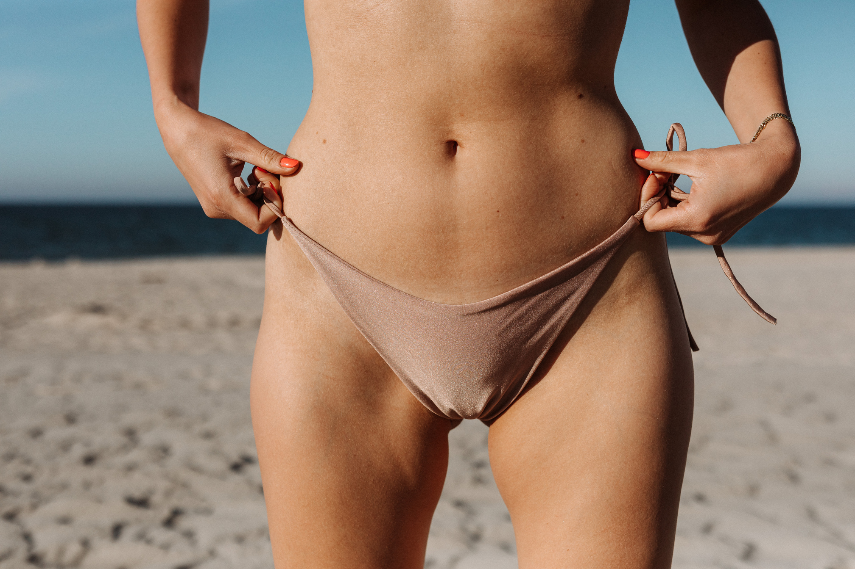

READ MORE

MAY 2025

SUMMER

NEWSLETTER

Dear valued clients,

Summer is here and we hope you're all enjoying the sun, sand, and surf! We wanted to update you on our latest collections and share some exciting news.



NEW ARRIVALS

Check out our latest bikini collections, featuring bold prints, vibrant colors, and stylish designs. We've added new styles and sizes to suit every body type, so you can find the perfect bikini for your summer adventures. Whether you're hitting the beach, lounging by the pool, or jetting off to a tropical destination, we've got you covered.



SEE MORE

SUMMER SALE

Looking for a great deal? Don't miss our summer sale, featuring discounts on select items from our collections. Get up to [Percentage or dollar amount] off your favorite bikinis and accessories, and stock up for the rest of the season. Hurry, these deals won't last forever!



SEE MORE

www. templateLAB.com