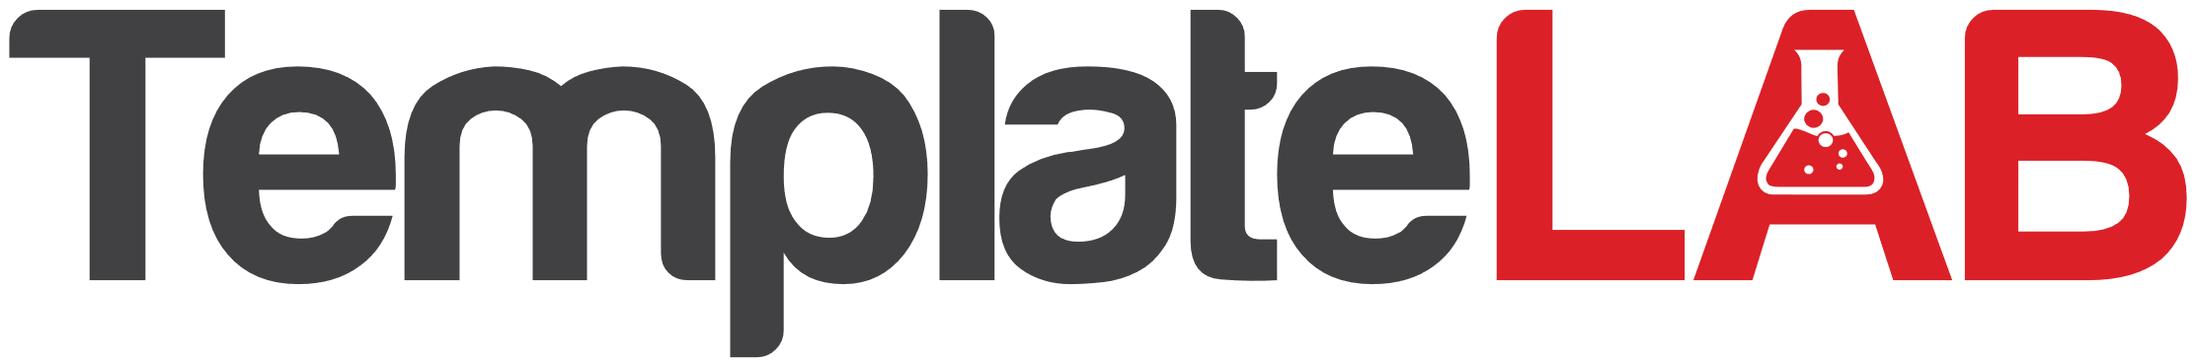

Staff newsletter

Employee Recognition and Awards

We are proud to recognize the following employees for their outstanding performance and contributions to our company:

* Employee of the Month: John Doe (Marketing)
* Rookie of the Year: Sarah Lee (Sales)
* Leadership Award: Michael Johnson (Operations)

Congratulations to all of the winners! We appreciate your hard work and dedication.

Company News and Updates

In this section, we provide updates and news about the company. This month, we're excited to announce:

* Our company's revenue has increased by 20% compared to the same period last year.
* We've signed a new contract with XYZ Corporation, a major player in our industry.
* Our company will be participating in the upcoming industry conference, where we will showcase our latest products and services.

Employee Wellness and Development

We care about our employees' well-being and development. In this section, we provide resources and tips to help our staff stay healthy and advance their careers. This month, we're focusing on:

* Mental Health Awareness: We provide free counseling services and resources to help employees manage stress and improve their mental health.
* Professional Development: We offer training programs and mentorship opportunities to help employees enhance their skills and advance their careers.