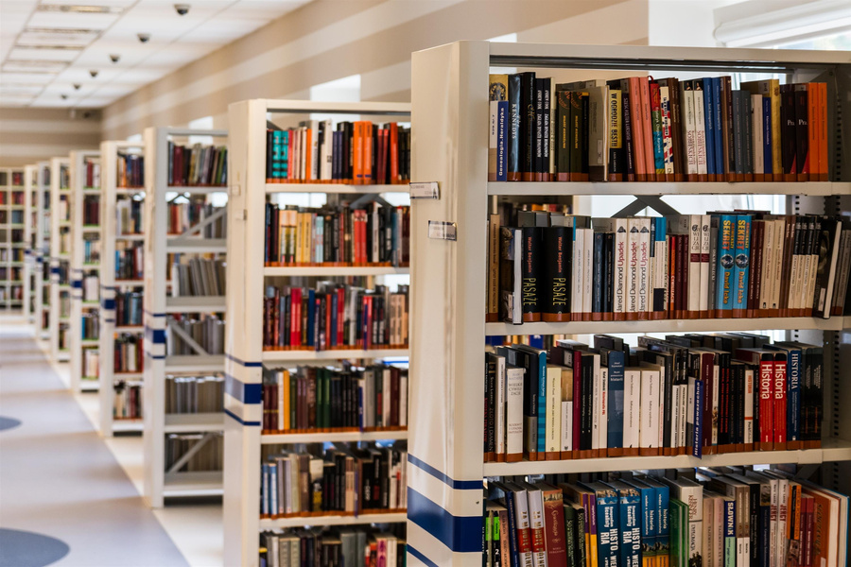

School

newsletter

Library News

Reminders

Events

We're excited to announce that our school library is now open every day during lunch and after school until 4 pm. Our librarian is available to help students find books, work on research projects, or just relax and read. In addition, we have a fantastic collection of books, including new releases, graphic novels, and non-fiction titles. Come and check out all the resources our library has to offer!

May. 17

May. 20

Quality educational webinars

Check the health of all students

May. 24

Art and Picture day

May. 30

Science fair

Please set aside some of your money to prepare for a tour to the museum in the even semester

Join a volunteer organization to help others