**january - 2023**

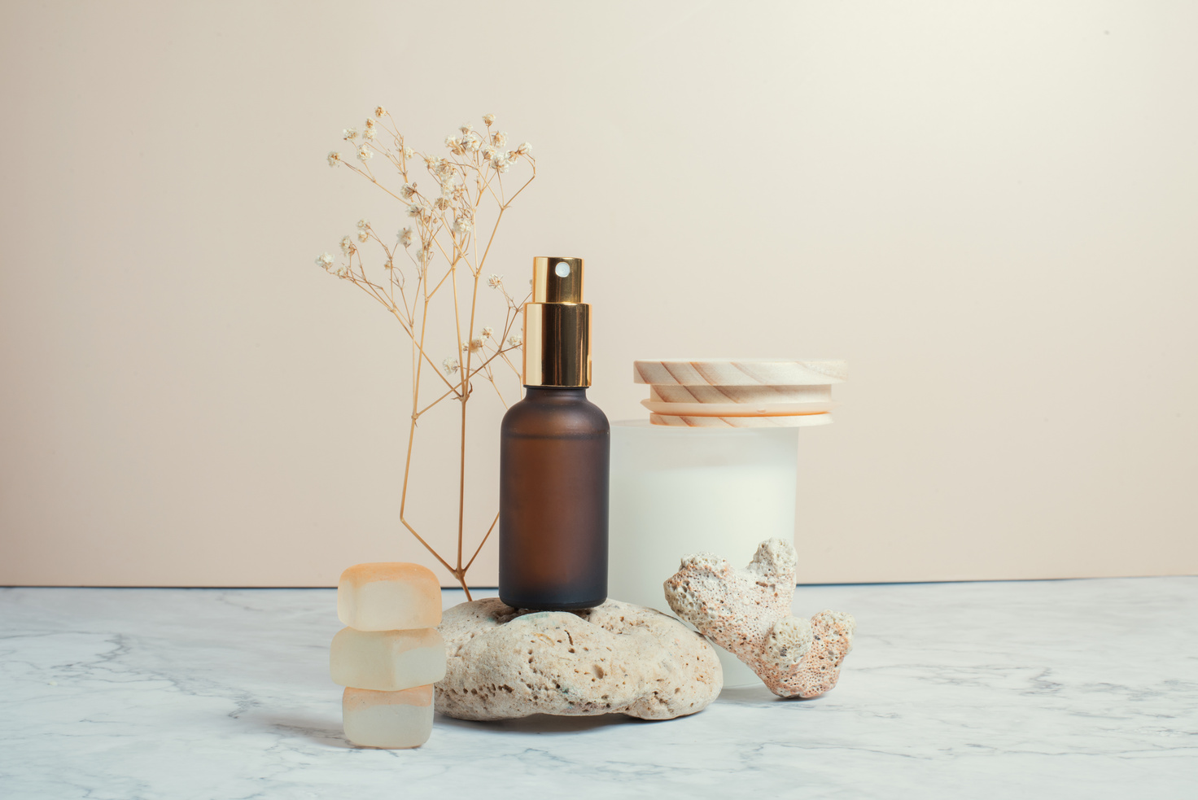

**our latest product**

Going back to nature is one of the best ways to maintain healthy skin. This exclusive product is suitable for those of you who want to treat your skin in a natural but effective way.

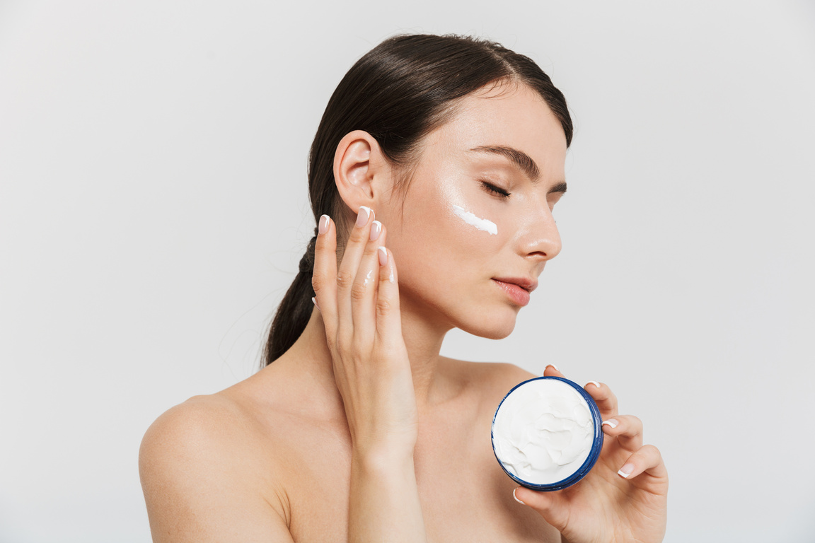

**MONTHLY NEWSLETTER**

**COMPANY NAME**

www.companyname.com

contact@companyname.com



**SHOP NOW**

**New Organic Skincare Product**

For that, we are organic skincare that brings the goodness of nature. This skincare contains ingredients derived from organic plants grown and cultivated by us.



**SHOP NOW**

