

We have several exciting community events planned for the upcoming months. On Saturday, March 20th, we will be hosting a spring clean-up event. This is a great opportunity to meet your neighbors and help beautify our community. We will be cleaning up common areas, trimming bushes and trees, and picking up litter. Please bring your gardening gloves and tools if you have them. Refreshments will be provided, and we hope to see you there.

In addition, we will be hosting a neighborhood block party on Saturday, April 17th. This is a great opportunity to socialize with your neighbors, meet new people, and enjoy some food and drinks. We encourage you to bring your family and friends along.

**Community Events**

**HOA newsletter**

**FEB. 2029 •  VOL. I2**

**The Ultimate Guide to Beechtown Village Properties**

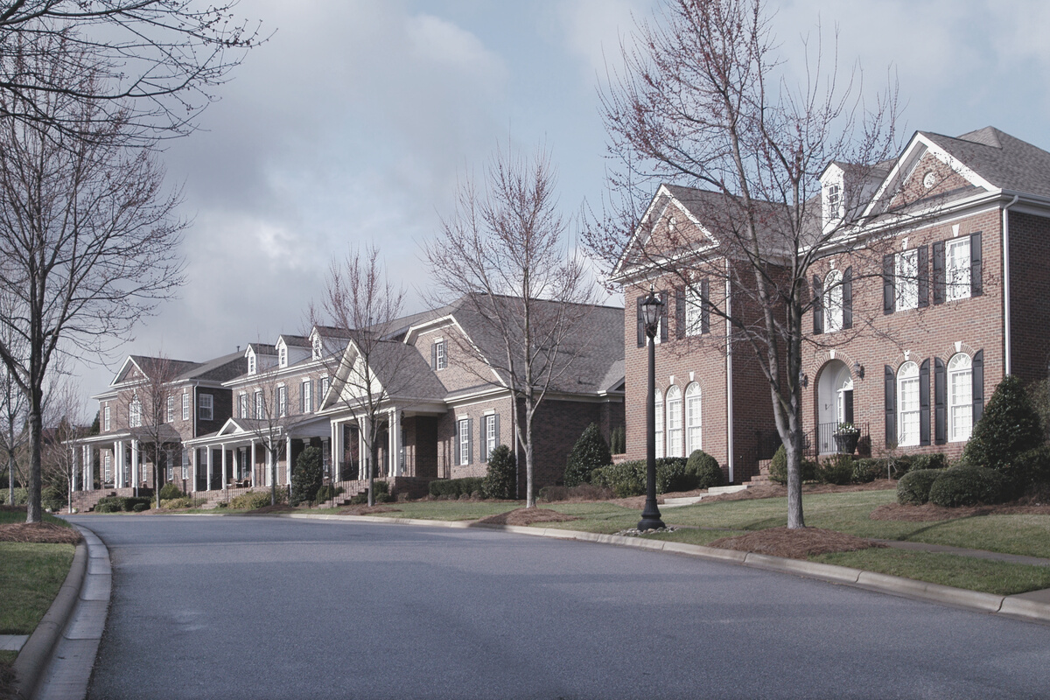

We are always looking for volunteers to help with community events and projects. If you have any skills or talents that you would like to share with our community, please let us know. We are currently looking for volunteers to help with our spring clean-up event, block party, and landscaping projects.

*If you have any questions or concerns, please do not hesitate to reach out to us. Thank you for being a part of our community, and we look forward to seeing you at our upcoming events.*

**Volunteer Opportunities**

Our board has been working hard to ensure that our community is well-maintained and that our residents are satisfied with their living experience. We have recently completed several projects, including repaving the parking lot, installing new lighting, and upgrading the landscaping in common areas. We are also in the process of reviewing our policies and procedures to ensure that they are up-to-date and in line with best practices.

We would like to remind our residents that the HOA is responsible for maintaining common areas only. If you have any concerns regarding your individual property, please reach out to a professional contractor or repair service.

**Board Updates**