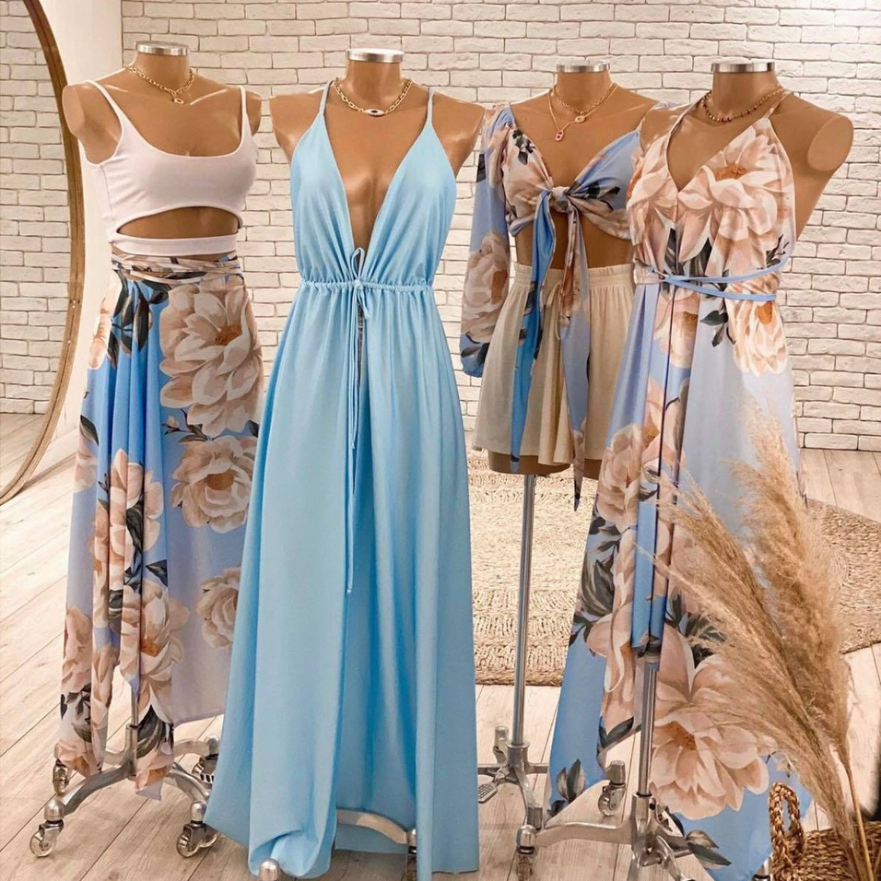

SHOP NOW

Delivering newsletters through email is one of the best ways to build a strong

NAME



SHOP NOW

Delivering newsletters through email is one of the best ways to build a strong

NAME



SHOP NOW

Delivering newsletters through email is one of the best ways to build a strong

NAME

fashion newsletter

NEW ARRIVAL

COLLECTION

NEW COLLECTION

@templateLAB



SHOP NOW

Delivering newsletters through email is one of the best ways to build a strong

NAME



SHOP NOW

Delivering newsletters through email is one of the best ways to build a strong

NAME



SHOP NOW

Delivering newsletters through email is one of the best ways to build a strong

NAME



SHOP NOW

Delivering newsletters through email is one of the best ways to build a strong

NAME



SHOP NOW

Delivering newsletters through email is one of the best ways to build a strong

NAME