John | John graduated from high school with honors and will be attending XYZ University in the fall
Saral | Sarah started a new job as a graphic designer at ABC Company
Tom | Tom and his family went on a camping trip to Yosemite National Park and had a great time exploring the outdoors
Emily | Emily celebrated her 10th birthday with a pool party and all her friends had a blast
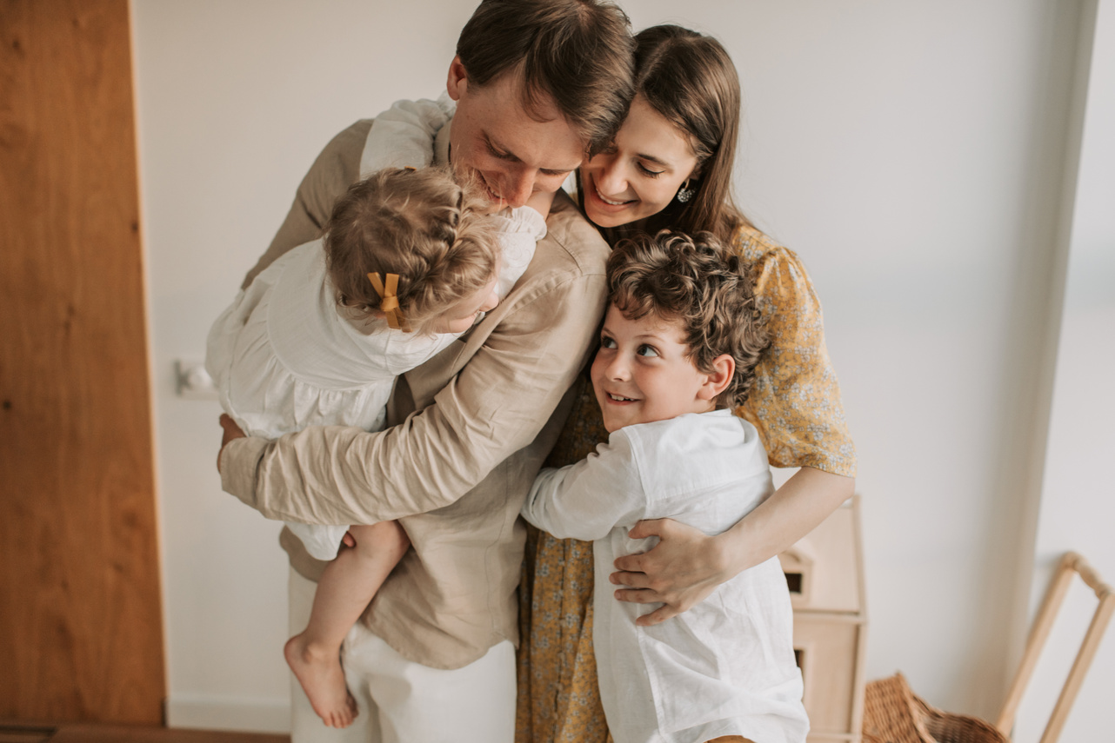
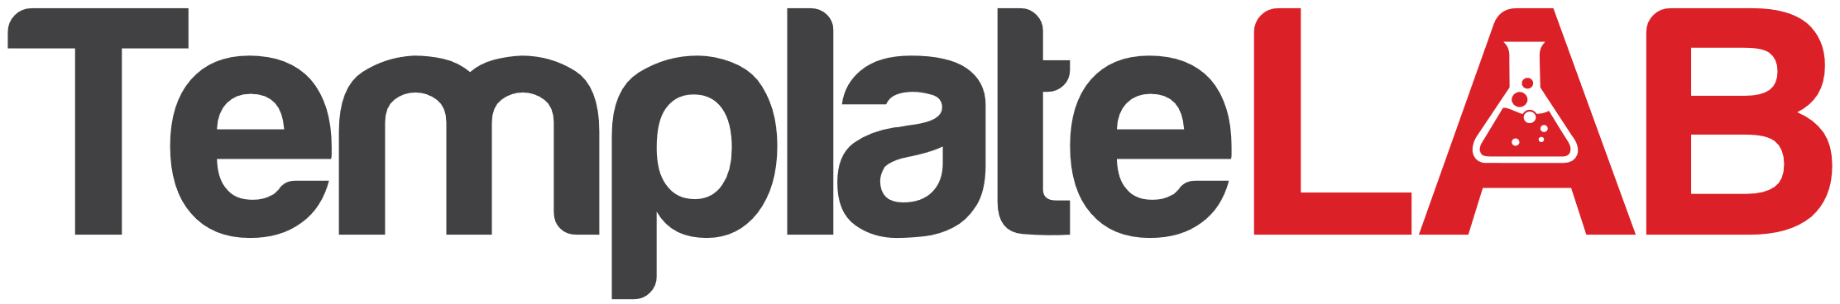
Family newsletter
We're excited to announce an upcoming event for our family! On July 4th, we'll be hosting a family BBQ and fireworks display at the park. It's a great opportunity for us all to come together and celebrate our love for each other and our country. We'll have plenty of food, drinks, and activities for everyone to enjoy, including a cornhole tournament, water balloon toss, and face painting for the kids. As the sun goes down, we'll light up the night sky with an amazing fireworks display. Don't miss out on the fun! Be sure to mark your calendars and RSVP to let us know you'll be there. We can't wait to see you all there!
RECIPES
Upcoming Events
JULY 2029
This month, we have lots of exciting news to share with you, including updates on our family members and upcoming events.
1 - Grandma's Potato Salad
Ingredients: Potatoes, eggs, celery, onion, mayonnaise, mustard, vinegar, salt, pepper
2 - Uncle Bill's BBQ Ribs
Ingredients: Pork ribs, BBQ sauce, brown sugar, salt, pepper, garlic powder, onion powder
3 - Aunt Sue's Strawberry Shortcake
Ingredients: Fresh strawberries, angel food cake, whipped cream, sugar

