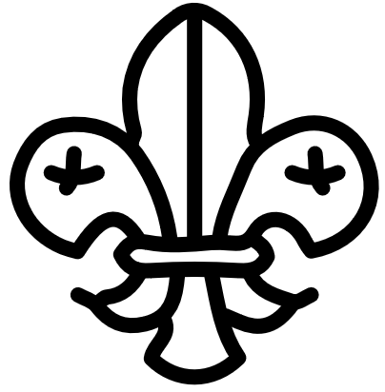

SCOUT ACHIEVEMENTS

We celebrate the achievements of our Cub Scouts. Congratulations to the following scouts for earning their badges and awards:

* Bobcat Badge: John Doe, Jane Smith, and Tim Johnson
* Wolf Badge: Alex Brown and Sarah Lee
* Bear Badge: Michael Davis and Emily Taylor
* Webelos Badge: David Kim and Samantha Chen
* Arrow of Light: Matthew Lee and Jessica Wang

Upcoming Events

Mark your calendars for these upcoming Cub Scout events:

* Campout: Our next campout is on [date]. We will be camping at [location] and participating in [activity]. This is a great opportunity for scouts to practice their outdoor skills and bond with their fellow scouts.
* Pinewood Derby: Our Pinewood Derby race will be held on [date]. Scouts will build and race their own wooden cars. It's a fun and competitive event for scouts and families.
* Service Project: We will be participating in a community service project on [date]. This is a great opportunity for scouts to give back to their community and learn the value of service.

