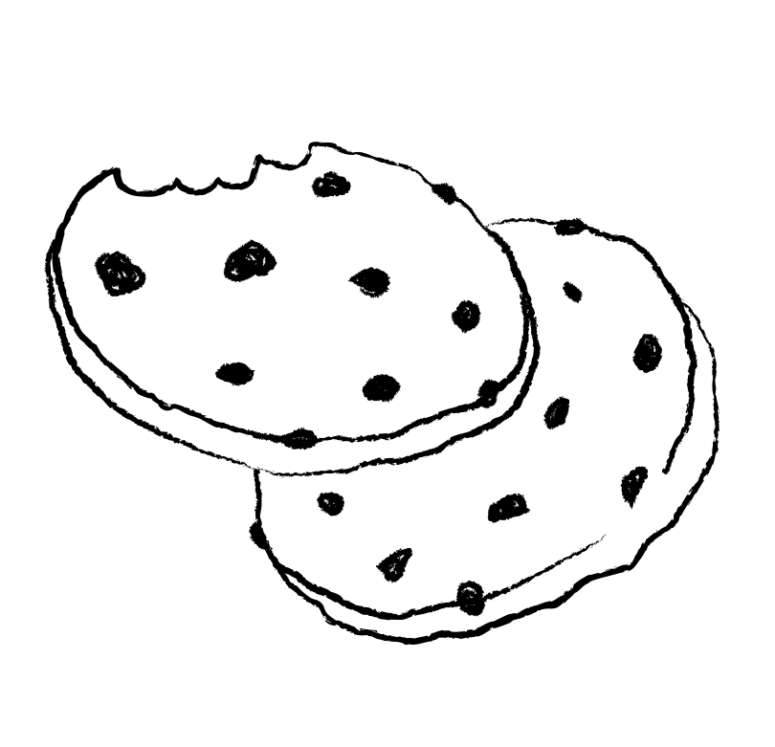

Start!

Great job

Keep going

Awesome

GREAT

ALMOST THERE

GOAL!

SALES GOAL

Girl Scout Cookies

