

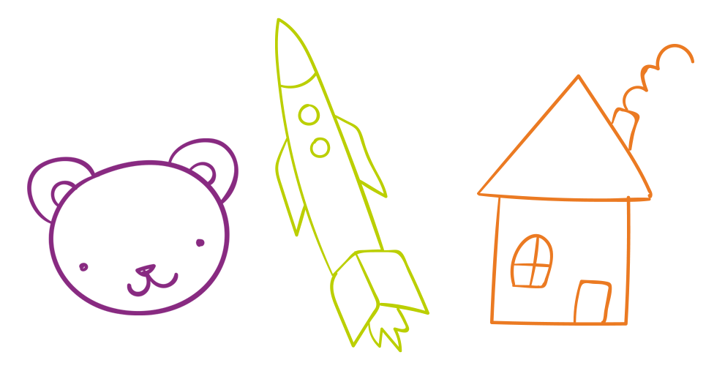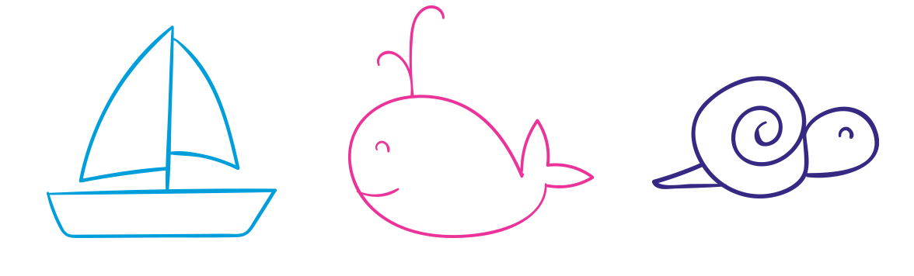

THU

WED

SUN

SAT

FRI

TUE

MON

I didn’t talk back

I didn’t yell or scream

I helped feed the dog

I used please and thank you

I helped my sister with her homework

I helped mom cook dinner

I shared my snacks with my sister

I clean up my room

**BEHAVIORS**

Ashley’s

**BEHAVIOR CHART**