

**02**

**03**

**03**

**04**

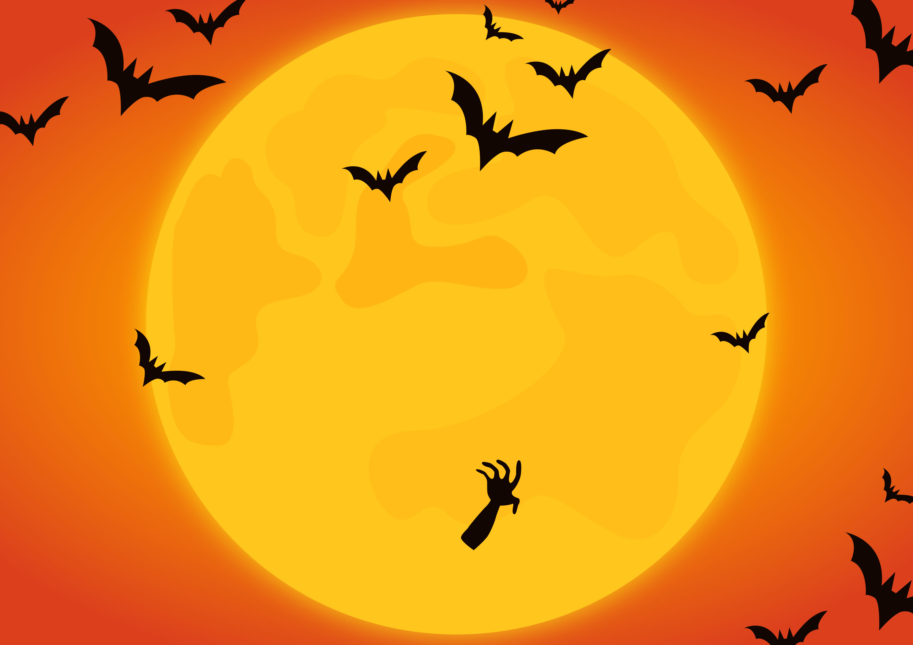

**20**

**13**

**23**

THE ADDAMS FAMILY

IT'S THE GREAT PUMPKIN CHARLIE BROWN

NIGHTMARE ON ELM STREET

**32**



NAME A POPULAR HALLOWEEN MOVIE

SCREAM

HOCUS POCUS

FRANKENSTEIN

HALLOWEEN

FRIDAY THE 13TH