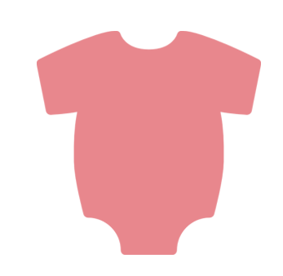

WHAT IS THE BEST TASTING

BABY FOOD FLAVOR?



**05**

**09**

**12**

APRICOT

PEARS

CARROTS

**15**

**23**

BANANA

**32**

APPLE

PEACHES

