c

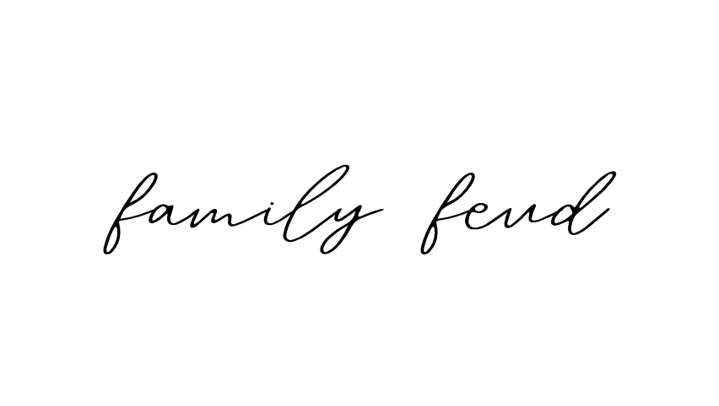

1. Name something you might find at a baby shower

2. Name a popular baby shower gift

3. What's a common baby shower game?

4. Name something you might see on a baby shower cake

2. Name a popular baby shower gift

5. Name a common theme for a baby shower

6. What is a must-have baby item?

7. Name a famous cartoon baby

8. Name something a new parent might be afraid of

9. Name something parents do to soothe a crying baby

10. What might parents do once the baby finally falls asleep?

**POINT**

*100 random people were surveyed and the top answers are on the board. Try to guess the number one answer. Points will be scored for each answer that is on the board. Person with the highest score wins!*

**BABY SHOWER**

1. Name something you might find at a baby shower.

* Gifts (35)
* Cake (25)
* Balloons (20)
* Baby games (10)
* Decorations (10)

2. Name a popular baby shower gift

* Diapers (35)
* Clothes (30)
* Stroller (15)
* Toys (10)
* Baby bottles (10)

3. What's a common baby shower game?

* Guess the baby food (25)
* Diaper changing race (20)
* Guess the baby's weight/date of birth (20)
* Baby item memory game (20)
* Measure the mom-to-be's belly (15)

4. Name something you might see on a baby shower cake

* Baby booties (30)
* "It's a boy/girl" (25)
* Baby bottle (20)
* Stork (15)
* Baby's name (10)

5. Name a common theme for a baby shower

* Animals (25)
* "It's a boy/girl" (25)
* Nursery rhymes (20)
* Stars and moon (15)
* Flowers (15)

**ANSWER SHEET**

6. What is a must-have baby item?

* Diapers (35)
* Crib (30)
* Baby clothes (20)
* Car seat (10)
* Baby bottles (5)

7. Name a famous cartoon baby

* Baby from 'Family Guy' (Stewie) (30)
* Tommy from 'Rugrats' (25)
* Baby from 'The Simpsons' (Maggie) (20)
* Boss Baby (15)
* Pebbles from 'The Flintstones' (10)

8. Name something a new parent might be afraid of

* Not getting enough sleep (30)
* Baby getting sick (25)
* Diaper changing (20)
* Not hearing the baby cry (15)
* Feeding the baby incorrectly (10)

9. Name something parents do to soothe a crying baby.

* Rocking the baby (30)
* Feeding the baby (25)
* Singing a lullaby (20)
* Changing the baby's diaper (15)
* Giving the baby a pacifier (10)

10. What might parents do once the baby finally falls asleep?

* Sleep (40)
* Watch TV/Relax (25)
* Clean the house (20)
* Eat (10)
* Read (5)