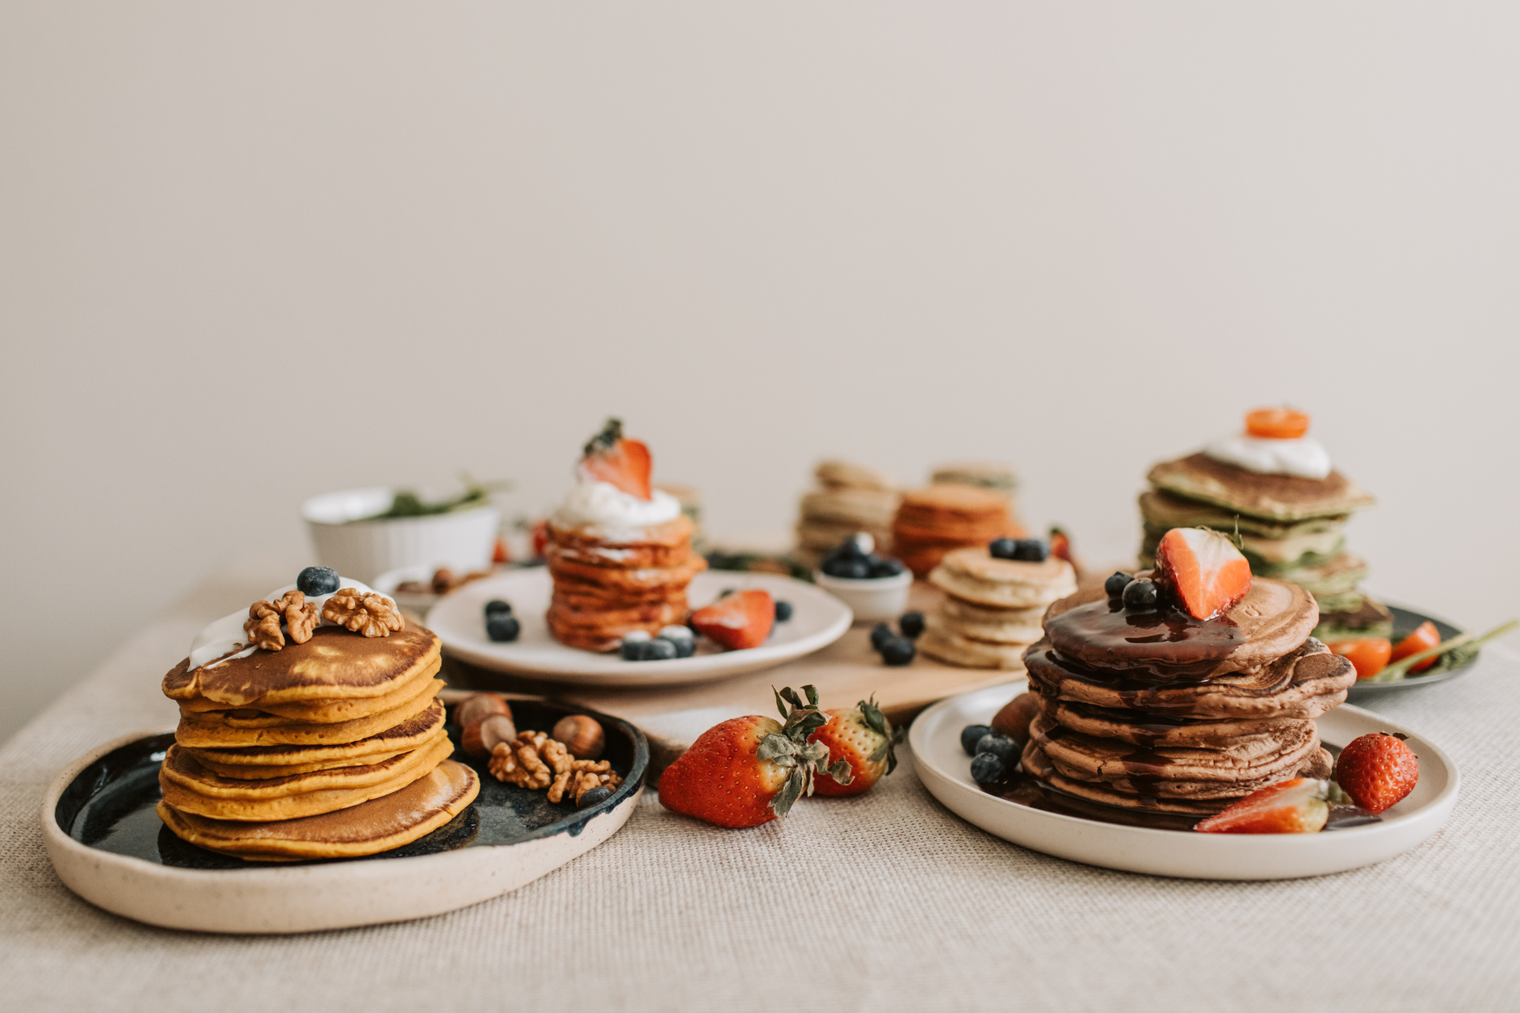

Recipes

PANCAKE

3

Ingredients

1 1/2 cups all-purpose flour

3 1/2 teaspoons baking powder

1/2 teaspoon salt

2 tablespoons granulated sugar

1 1/4 cups milk

1 large egg

3 tablespoons unsalted butter, melted

Cooking spray or additional butter for greasing the pan

Directions

* In a bowl, whisk together flour, baking powder, salt, and sugar.
* In a separate bowl, whisk together milk, egg, and melted butter.
* Combine the wet and dry ingredients, stirring until just combined. A few lumps are okay.
* Preheat a non-stick skillet or griddle over medium heat. Grease the cooking surface with cooking spray or a small amount of butter.
* Pour 1/4 cup of batter onto the skillet for each pancake. Cook until bubbles form on the surface, then flip and cook the other side until golden brown.
* Repeat with the remaining batter, adding more cooking spray or butter as needed to prevent sticking.
* Serve the Pancakes warm with your favorite toppings such as maple syrup, fresh fruits, or whipped cream.



SERVINGS

TIME

CALORIES

DIFFICULTY

2

30 min

Easy

1231 kcal

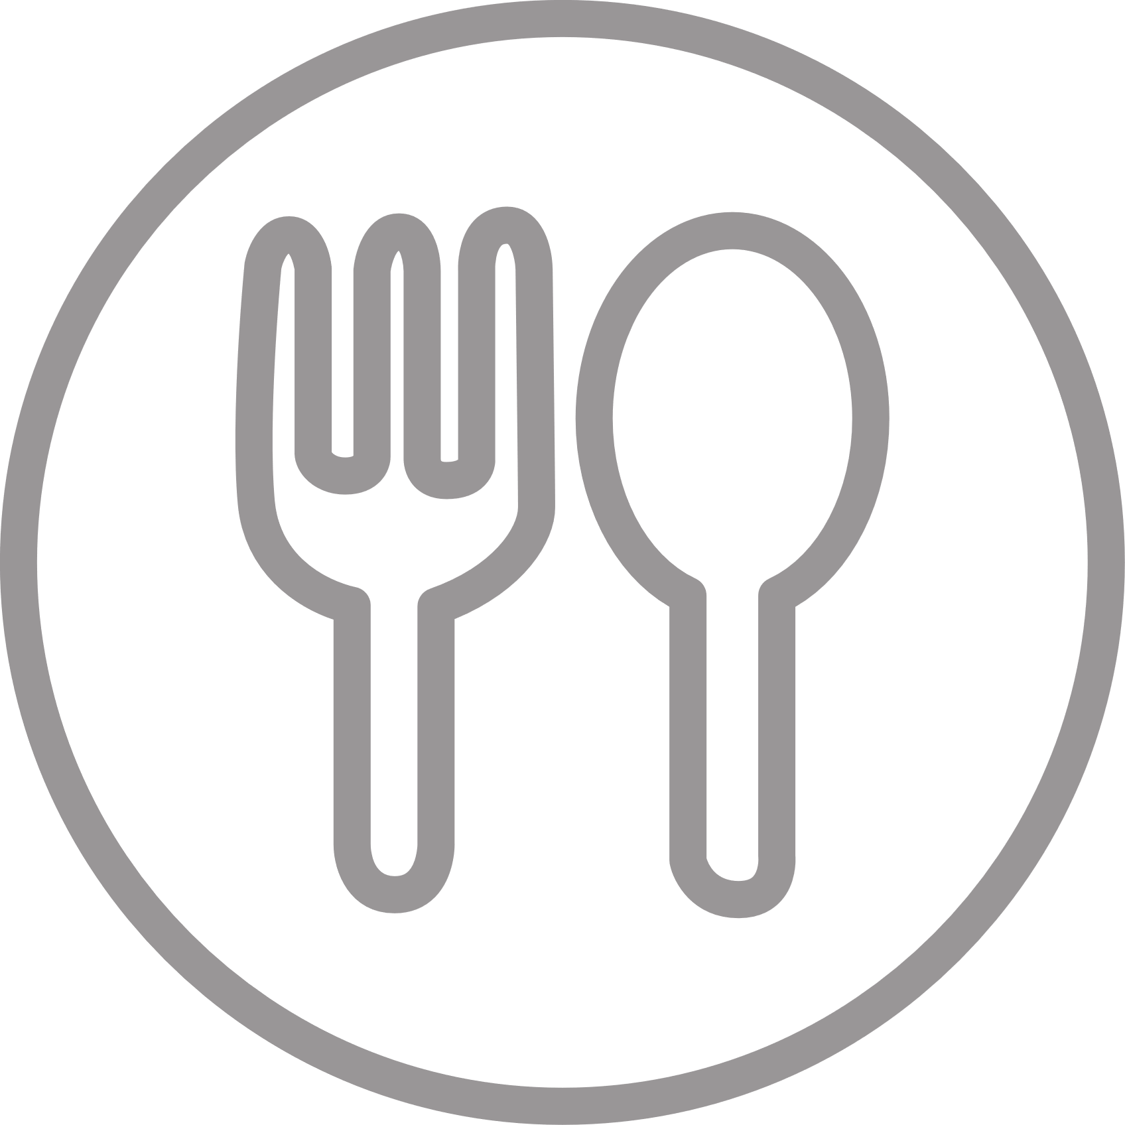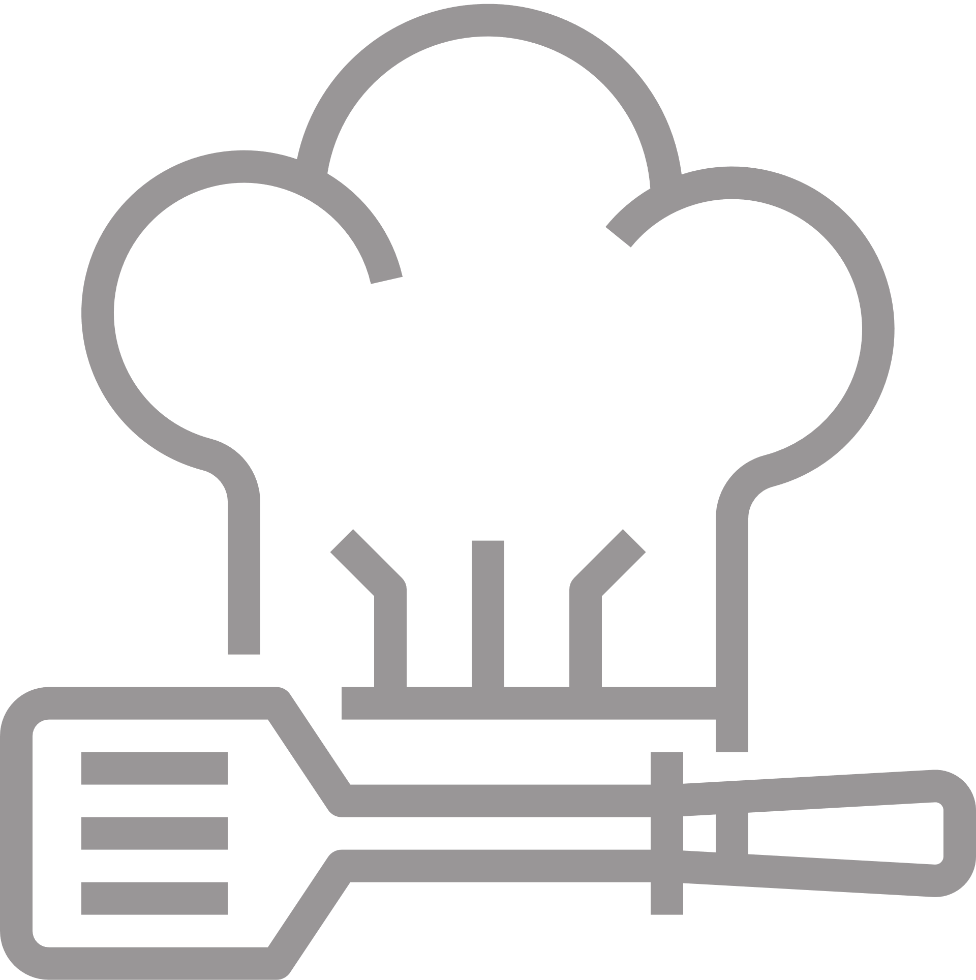

Tips:

For extra flavor, you can add a teaspoon of vanilla extract or a sprinkle of ground cinnamon to the batter.

If you prefer thinner pancakes, you can add a little more milk to the batter to achieve the desired consistency.

