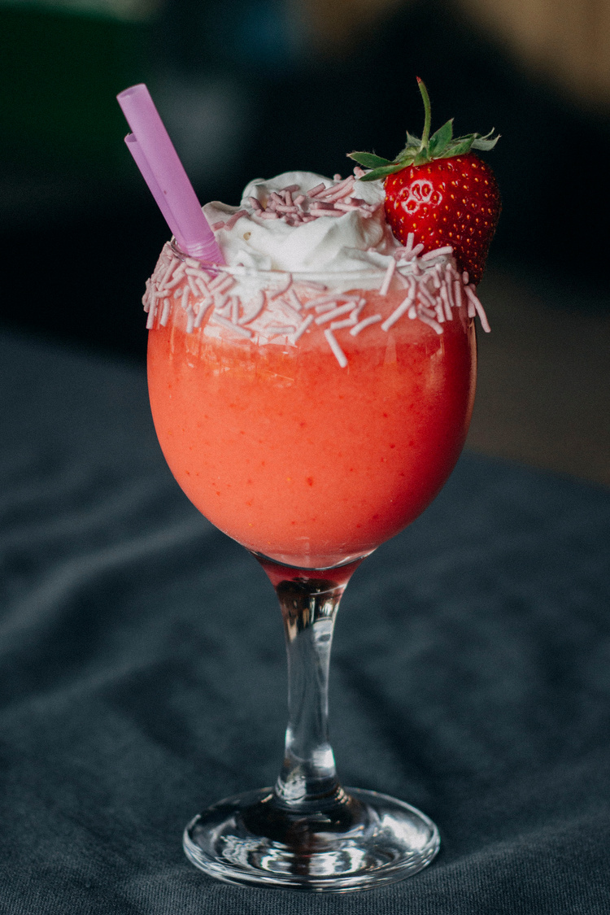

Strawberry Smoothie

A quick, healthy delight with ripe strawberries, creamy banana, and yogurt. Perfect for an invigorating start to your day or a refreshing midday treat.

2 cups fresh strawberries

1 banana

1 cup yogurt

1/2 cup milk

1-2 tablespoons honey or sugar

**Ingredients :**

Serves: 2

Preparation Time: 5 Minutes

Total Time: 5 Minutes



Clean the strawberries and remove the stems. Peel the banana.

Put the strawberries, banana, yogurt, milk, and sweetener if using, into a blender. Blend until smooth.

Pour into glasses and serve immediately.

1.

2.

3.

**Procedure :**

Use frozen strawberries or add a few ice cubes for a colder smoothie.

Substitute the strawberries with other fruits for different flavors.

**Tips:**

